AGrandtech SCP V2.0
Confidential
Oct., 2016

Table of Contents
1. SCP Architecture 4
1.1 Network elements IN features 4
2. Triggers 5
2.1 Static Triggers 5
2.1.1 Originating Call 5
2.1.2 Terminating Call 5
2.2 Dynamic Triggers 5
2.2.1 Originating Call 5
2.2.2 Terminating Call 6
2.3 Triggers for SMS 7
3. Messages 7
4. Call Scenarios 8
4.1 General Description 8
4.2 Originating PPS Call Setup (No Pre-Call Warning) 8
4.2.1 Summary 9
4.2.2 Signaling Process Flow 10
4.2.3 Message Parameters 10
4.3 Originating PPS Call (Pre-Call Warning) 12
4.3.1 Summary 12
4.3.1.1 Signaling Process Flow 14
4.3.1.2 Message Parameters 15
4.4 Originating PPS Call Not Allowed 17
4.4.1 Summary 18
4.4.1.1 Signaling Process Flow 19
4.4.1.2 Message Parameters 19
4.5 Terminating PPS Call 21
4.5.1 Summary 21
4.5.2 Signaling Process Flow 22
4.5.3 Message Parameters 22
4.6 Terminating PPS Call Not Allowed 25
4.6.1 Summary 25
4.6.1.1 Signaling Process Flow 25
4.6.1.2 Message Parameters 25
4.7 SSF-Initiated Call Termination (Maximum Call Duration) 26
4.7.1 Summary 26
4.7.2 Signaling Process Flow 27
4.7.3 Message Parameters 27
4.8 SCP-Initiated Call Termination (Balance Exhausted) 27
4.8.1 Summary 27
4.8.2 Signaling Process Flow 28
4.8.3 Message Parameters 28
4.9 Originating/Terminating PPS with Condtional CF at the MSC 28
4.9.1 Summary 28
4.9.2 Signaling Process Flow 29
4.9.3 Message Parameters 29
4.10 Direct Call to IVR - Inquiry 33
4.10.1 Summary 33
4.10.1.1 Signaling Process Flow 34
4.10.1.2 Message Parameters 34
4.11 Direct Call to IVR - Recharge 36
4.11.1 Summary 36
4.11.1.1 Signaling Process Flow 37
4.11.1.2 Message Parameters 37
5. SMS Scenarios 40
5.1 Originating PPS SMS Succeed 40
5.2 Originating PPS SMS failed (No balance) 41
6. Network Dependent Data 42
6.1 Service Key 42
6.2 ActivityTest Timer Value 42
6.3 Coding of Location Information 42
6.4 maxCallPeriodDuration 42
6.5 Definition of Elementary Message ID 43
6.6 assitingSSPIPRoutingAddress 43

Purpose
This document is intended for the use by AGrandtech LITECORE GSM and WCDMA system customers to understand the procedures and messages provided by LITECORE GSM IN Prepaid Service. It is a reference for LITECORE GSM Prepaid roaming or inter-working with other Prepaid Networks. It is also used to determine that if the existing SSF or SCF can work with LITECORE GSM SSF/SCF. It describes LITECORE IN Prepaid Service call and SMS triggers and flows. All procedures are invoked by LITECORE SCF SSF and SRF. The document describes all of the CAMEL Phase 2/3* TDPs (Trigger Detection Points) and EDPs (Event Detection Points) that are required in the switch GSMSSF (GSM Service Switching Function) to provide Prepaid Service. It also describes the Prepaid Service call flows and each CAP (CAMEL Application Protocol) message and its key parameters that need to be supported in the GSMSSF.

SCP Architecture
Following figure shows SCP architecture.
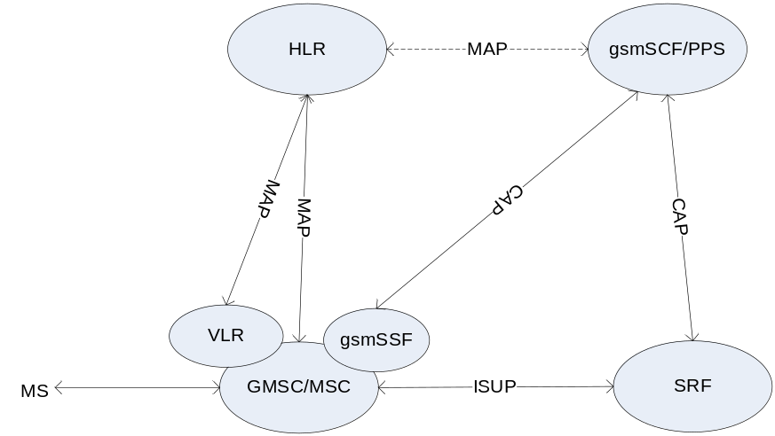

Not internal IP but external IP is applied to play voice announcement and collect user press information.
The MAP interface between SCF and HLR is not implemented yet.

Network elements IN features
Following table lists out all network elements features with IN Prepaid Service related.
Element | Features
HLR | Stores O/T-CSI, SMS-CSI, GPRS-CSI
VLR | Stores O-CSI,. SMS-CSI
GMSC/MSC | CSI trigger IN call  Prefix trigger IN call  Trunk trigger IN call (incoming call goes to PPS)
PPS | Prepaid service
SRF | Play Annoucement, Collect DTMF key-press

Triggers

Static Triggers

Originating Call
CAMEL based OPPS (Originating Prepaid Service) is invoked by the setting of a static trigger in the GSMSSF when the subscriber registers. Specifically, it is expected that the HLR will return to the VLR the standard O-CSI (Originating CAMEL Service Information) as part of the registration process. Specifically, a TDP-R is set for the prepaid subscriber at the collected_info PIC (DP2) that refers to the Prepaid Service GSMSCF (GSM Service Control Function.) At this point, the GSMSSF will send an InitialDP CAP message to the GSMSCF with the Event Type BCSM set to CollectedInfo and the Service Key set to Prepaid Service. The GSMSSF will suspend the call processing in the switch waiting for further instructions from the GSMSCF.

Terminating Call
CAMEL based TPPS (Terminating Prepaid Service) is invoked by the setting of a static trigger in the GSMSSF when the subscriber registers. Specifically, it is expected that the HLR will return to the GMSC the standard T-CSI (Terminating CAMEL Service Information) as part of the registration process. Specifically, a TDP-R is set for the prepaid subscriber at the terminating_attempt_authorized PIC (DP12) that refers to the Prepaid Service GSMSCF (GSM Service Control Function.) At this point, the GSMSSF will send an InitialDP CAP message to the GSMSCF with the Event Type BCSM set to TerminatingAttemptAuthorized and the Service Key set to Prepaid Service. The GSMSSF will suspend the call processing in the switch waiting for further instructions from the GSMSCF.

Dynamic Triggers

Originating Call
In response to the InitialDP message from the GSMSSF, the OPPS GSMSCF will arm a number of EDPs for that particular call. OPPS is designed to arm all of the EDP’s it uses as EDP-Ns. EDP-Ns tell the GSMSSF to notify the GSMSCF if the event occurs, but it then continues with its processing, i.e. the GSMSSF does not wait for instructions from the GSMSCF. Listed below are the EDP’s set by the OPPS GSMSCF and the associated call leg they are set for.
Event | Information Element | Value
 | Event Type | oAnswer
 | Monitor Mode | NotifyAndContinue
 | Leg ID | (2) – Called Party
 | Event Type | oDisconnect
 | Monitor Mode | NotifyAndContinue
 | Leg ID | (1) – Calling Party
 | Event Type | oDisconnect
 | Monitor Mode | Interrupted
 | Leg ID | (2) – Called Party
 | Event Type | oAbandon
 | Monitor Mode | NotifyAndContinue
 | Leg ID | (1) – Calling Party
 | Event Type | oRouteSelectFailure
 | Monitor Mode | NotifyAndContinue
 | Leg ID | (1) – Calling Party
 | Event Type | oCalledPartyBusy
 | Monitor Mode | Interrupted
 | Leg ID | (2) – Called Party
 | Event Type | oNoAnswer
 | Monitor Mode | Interrupted
 | Leg ID | (2) – Called Party

Note: LegId is relevant for oDisconnect only.

Terminating Call
In response to the InitialDP message from the GSMSSF, the TPPS GSMSCF will arm a number of EDPs for that particular call. TPPS is designed to arm all of the EDP’s it uses as EDP-Ns. EDP-Ns tell the GSMSSF to notify the GSMSCF if the event occurs, but it then continues with its processing, i.e. the GSMSSF does not wait for instructions from the GSMSCF. Listed below are the EDP’s set by the TPPS GSMSCF and the associated call leg they are set for.
Event | Information Element | Value
 | Event Type | tAnswer
 | Monitor Mode | NotifyAndContinue
 | Leg ID | (2) – Called Party
 | Event Type | tDisconnect
 | Monitor Mode | NotifyAndContinue
 | Leg ID | (1) – Calling Party
 | Event Type | tDisconnect
 | Monitor Mode | Interrupted
 | Leg ID | (2) – Called Party
 | Event Type | tAbandon
 | Monitor Mode | NotifyAndContinue
 | Leg ID | (1) – Calling Party
 | Event Type | tCalledPartyBusy
 | Monitor Mode | Interrupted
 | Leg ID | (2) – Called Party
 | Event Type | tNoAnswer
 | Monitor Mode | Interrupted
 | Leg ID | (2) – Called Party

Triggers for SMS
There are some triggers for Prepaid SMS.
Event | Information Element | Value
 | Event Type | sms-CollectedInfo (Static)
 | Monitor Mode | Interrupted
 | Leg ID | (1) – Calling Party
 | Event Type | o-smsFailure (Dynamic)
 | Monitor Mode | Interrupted
 | Leg ID | (1) – Calling Party
 | Event Type | o-smsSubmitted (Dynamic)
 | Monitor Mode | Interrupted
 | Leg ID | (1) – Calling Party

Messages
Listed below are the CAMEL CAP messages used by LITECORE CAMEL based Prepaid Service
Messages for Prepaid Call
- ActivityTest
- ActivityTest ack
- ApplyCharging
- ApplyChargingReport
- AssistRequestInstructions
- Connect
- Continue
- DisconnectForwardConnection
- EstablishTemporaryConnection
- EventReportBCSM
- InitialDP
- PlayAnnouncement
- PromptandCollectUserInformation
- PromptandCollectUserInformation ack
- ReleaseCall
- RequestReportBCSMEvent
- SpecializedResourceReport

Messages for Prepaid SMS
- ContinueSMS
- EventReportSMS
- InitialDPSMS
- ReleaseSMS
- RequestReportSMSEvent

Call Scenarios
The following Prepaid call scenarios are described:
- Originating PPS Call (No pre-call warning)
- Originating PPS Call (Pre-call warning)
- Originating PPS Call Not Allowed
- Terminating PPS Call
- Terminating PPS Call Not Allowed
- SSF- Initiated Call Termination (Max Call Duration)
- SCP-Initiated Call Termination (Balance Exhausted)
- Originating/Terminating Prepaid subscriber with CF
- Direct Call to Customer Care - Inquiry
- Direct Call to Customer Care - Recharge

General Description
All CAMEL messages are formatted in accordance with CAMEL references. In the following sections, ladder diagrams are used to depict the time sequence of messages between the units of the network. A blue solid line is used to denote a CAMEL message.
For CAMEL messages, the TCAP dialog primitive is shown above the message line to indicate the lifetime of the dialog. Below the line, CAMEL operations are shown as TC-INVOKE operations carried within the TCAP dialog message.
LITECORE supports one method of communicating with IP’s: EstablishTemporaryConnection (ETC) for external IP’s (gsmSRF). An external IP is defined as one that is external to the SSP. SCP interact with extern IP to direct the IP to Play Announcements or to Play and Collect User Information.

Originating PPS Call Setup (No Pre-Call Warning)
In this scenario, the subscriber initiates a call when his account has sufficient balance and is in a valid state. There is no need to use an IP to play an announcement and the call can proceed immediately. The SCP interacts with the SSP to be notified of answer and disconnect conditions in order to charge for the call.

Summary
A TDP-R is set for the prepaid subscriber at the collected_info PIC (DP2). When the subscriber makes a call, the trigger fires and the SSP sends an InitialDP message to the SCP.
When the SCP receives the InitialDP message, it first analyzes the calling party number to determine the subscriber’s account. If the account is valid, it then performs further analysis to determine if the subscriber is allowed to make calls, is authorized to call the destination address, and if the subscriber’s balance is sufficient to permit the call.
When the call is authorized and there is no need to play a pre-call warning announcement (for example, for low balance), the SCP sends the RequestReportBCSMEvent, ApplyCharging and Continue message to the SSP. The RequestReportBCSMEvent arms triggers for when the call is answered or terminated. The SCP sends an ApplyCharging message with the maxCallPeriodDuration and releaseIfdurationExceeded parameters set to instruct the MSC to release the call when the maximum call duration is reached and to play a warning tone prior to release.
The SSP then continues with normal call establishment until the called party answers the call. The SCP begins an ActivityTest timer (T_{at}), whose expiration causes an ActivityTest message to be periodically sent to the SSP. This is used to ensure that the dialog is still active at the SSP.
When the call is answered, the oAnswer DP is triggered in the SSP and an EventReportBCSM message is sent to the SCP. At this point, the SCP begins charging for the call and starts the “maximum call length” timer based on the subscriber’s balance and the tariff for the call. The ActivityTest message continues to be sent periodically throughout the life of the call. If continuous two ActivityTest messages missed, SCP will stop charging the call and terminate the dialog with the SSF.
After a call has reached the active state and the either party disconnects, the oDisconnect trigger that was armed during call setup is reached. This causes the SSP to send an EventReportBCSM notification and ApplyChargingReport message with the CallActive parameter set to false to the SCP. If the MiscCallInfo indicates the trigger was armed as interrupted, the SCP sends a Continue message to the SSP. Otherwise the SSP continues disconnect processing without further instructions from the SCP. The SCP ends charging for the call.

Signaling Process Flow
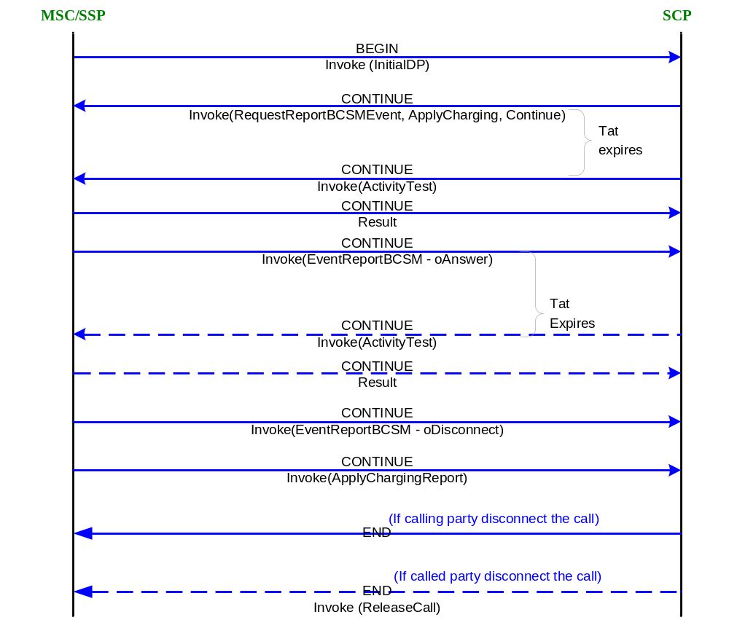

Message Parameters
Note: Throughout the document; only parameters of interest to the Service implementation are shown in the message tables.
InitialDP DP2 MO(A-B) | Information Element | Value
 | Service Key | Network Dependent – 0.
 | Calling Party Number | Subscriber’s MSISDN
 | Event Type BCSM | CollectedInfo (DP2)
 | Called Party BCD Number | Dialed Number
 | LocationNumber | Identification of the subscriber’s location
 | Calling Party’s Category | Type of calling party e.g. operator, pay phone, ordinary subscriber.
 | Call Reference Number | VMSC Call Reference Number
 | MSC Address | E164 address of serving VMSC
 | Bearer Capability | Type of bearer capability
 | High Layer Compatibility | Type of high layer compatibility

RequestReport BCSMEvent | Information Element | Value
 | Sequence
 | Event Type | oAnswer
 | Monitor Mode | NotifyAndContinue
 | Leg ID | (2) – Called Party
 | Event Type | oDisconnect
 | Monitor Mode | NotifyAndContinue
 | Leg ID | (1) – Calling Party
 | Event Type | oDisconnect
 | Monitor Mode | Interrupted
 | Leg ID | (2) – Called Party
 | Event Type | oAbandon
 | Monitor Mode | NotifyAndContinue
 | Leg ID | (1) – Calling Party
 | Event Type | oCalledPartyBusy
 | Monitor Mode | Interrupted
 | Leg ID | (2) – Called Party
 | Event Type | oNoAnswer
 | Monitor Mode | Interrupted
 | Leg ID | (2) – Called Party
 | Event Type | RouteSelectFailure
 | Monitor Mode | NotifyAndContinue
 | Leg ID | (2) – Called Party

Continue | Information Element | Value
 | -

ApplyCharging | Information Element | Value
 | MaxCallPeriodDuration | As calculated by PPS, max value=90000 (9000seconds)
 | ReleaseIfdurationExceeded | Warning before release (if maxCallPeriodDuration<90000, then this parameter is provided, otherwise this parameter is not provided)
 | PartyToCharge | Leg1

EventReport BCSM | Information Element | Value
 | Event Type BCSM | oAnswer
 | MiscCallInfo | Notification

ActivityTest | Information Element | Value
 | -

EventReport BCSM | Information Element | Value
 | Event Type BCSM | oDisconnect
 | Event Specific Information BCSM | Release Cause
 | LegID | ReceivingSideID
 | MiscCallInfo | Notification or Interrupt

ApplyCharging-Report | Information Element | Value
 | CallActive | False

ReleaseCall | Information Element | Value
 | Cause | Normal Clearing

Originating PPS Call (Pre-Call Warning)
In this scenario, the subscriber initiates a call when he has a low balance or when his account in near to expires. In order to warn the subscriber of this condition, the SCP first requests the SSP to connect the subscriber to an IP so that a warning announcement can be played.

Summary
A TDP-R is set for the prepaid subscriber at the collected_info PIC (DP2). When the subscriber makes a call, the trigger fires and the SSP sends an InitialDP message to the SCP.
When the SCP receives the InitialDP message, it first analyzes the calling party number to determine the subscriber’s account. If the account is valid, it then performs further analysis to determine if the subscriber is allowed to make calls, is authorized to call the destination address, and if the subscriber’s balance is sufficient to permit the call.
When the call is authorized and the subscriber’s balance is below the threshold at which a pre-call warning announcement is played, the SCP sends a RequestReportBCSMEvent message and an EstablishTemporaryConnection message to the SSP. The RequestReportBCSMEvent message sets a trigger to detect if the subscriber abandons the call during the warning announcement. The EstablishTemporaryConnection message directs the SSP to connect the subscriber via a voice circuit to the LITECORE SRF
After the pre-call warning has been played to the subscriber, the IP notifies the SCP that the announcement has been played. The SCP then instructs the SSP to release the IP connection by sending a DisconnectForwardConnection message.
The SCP then sends the RequestReportBCSMEvent, ApplyCharging and Continue message to the SSP. The RequestReportBCSMEvent arms triggers for when the call has been answered or terminated. The SCP sends an ApplyCharging message with the maxCallPeriodDuration and releaseIfdurationExceeded parameters set to instruct the MSC to release the call when the maximum call duration is reached and to play a warning tone prior to release.
The SSP then continues with normal call establishment. The SCP begins an ActivityTest timer (T_{at}), whose expiration causes an ActivityTest message to be periodically sent to the SSP. This is used to ensure that the dialog is still active at the SSP.
When the call is answered, the oAnswer trigger is hit in the SSP and an EventReportBCSM message is sent to the SCP. At this point, the SCP begins charging for the call and starts the “maximum call length” timer based on the subscriber’s balance and the tariff for the call. The ActivityTest message continues to be sent periodically throughout the life of the call.
After a call has reached the active state and the either party disconnects, the oDisconnect trigger that was armed during call setup is reached. This causes the SSP to send an EventReportBCSM notification and ApplyChargingReport message with the CallActive parameter set to false to the SCP. If the MiscCallInfo indicates the trigger was armed as interrupted, the SCP sends a Continue message to the SSP. Otherwise the SSP continues disconnect processing without further instructions from the SCP. The SCP ends charging for the call.

Signaling Process Flow
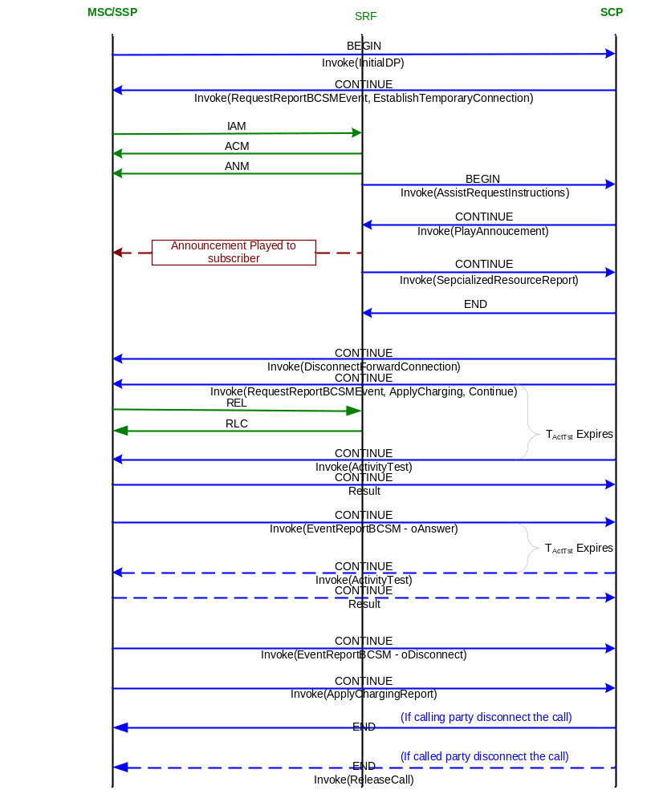

Message Parameters
InitialDP DP2 MO | Information Element | Value
 | Service Key | Network Dependent, 0 for normal in LITECORE
 | Calling Party Number | Subscriber’s MSISDN
 | Event Type BCSM | CollectedInfo (DP2)
 | Called Party BCD Number | Dialed Number
 | LocationNumber | Identification of the subscriber’s location
 | Calling Party’s Category | Type of calling party e.g. operator, pay phone, ordinary subscriber.
 | Call Reference Number | VMSC Call Reference Number
 | MSC Address | E164 address of serving VMSC
 | Bearer Capability | Type of bearer capability
 | High Layer Compatibility | Type of high layer compatibility

RequestReport BCSMEvent | Information Element | Value
 | Sequence
 | Event Type | oAbandon
 | Monitor Mode | NotifyAndContinue
 | Leg ID | (1) – Calling Party
 | Event Type | oDisconnect
 | Monitor Mode | NotifyAndContinue
 | Leg ID | (1) – Calling Party

EstablishTemporaryConnection | Information Element | Value
 | AssistingSSPIPRoutingAddress | Address of IP + SCF ID + Correlation ID (Hex B as a decollator)

AssistRequest-Instructions | Information Element | Value
 | CorrelationID | As sent in ETC messagse

PlayAnnouncement | Information Element | Value
 | Element Message ID | Includes language class and voice ID
 | Number of Repeatitions | 1 (In total twice)
 | Interval | 1 second

Specialized Resource Report | Information Element | Value
 | -

Disconnect Forward Connection | Information Element | Value
 | -

RequestReport BCSMEvent | Information Element | Value
 | Sequence
 | Event Type | oAnswer
 | Monitor Mode | NotifyAndContinue
 | Leg ID | (2) – Called Party
 | Event Type | oDisconnect
 | Monitor Mode | NotifyAndContinue
 | Leg ID | (1) – Calling Party
 | Event Type | oDisconnect
 | Monitor Mode | Interrupted
 | Leg ID | (2) – Called Party
 | Event Type | oCalledPartyBusy
 | Monitor Mode | Interrupted
 | Leg ID | (2) – Called Party
 | Event Type | oNoAnswer
 | Monitor Mode | Interrupted
 | Leg ID | (2) – Called Party
 | Event Type | RouteSelectFailure
 | Monitor Mode | NotifyAndContinue
 | Leg ID | (2) – Called Party

ApplyCharging | Information Element | Value
 | MaxCallPeriodDuration | As calculated by PPS, max value=90000 (9000seconds)
 | ReleaseIfdurationExceeded | Warning before release (if maxCallPeriodDuration<90000, then this parameter is provided, otherwise this parameter is not provided)
 | PartyToCharge | Leg1

Continue | Information Element | Value
 | -

EventReport BCSM | Information Element | Value
 | Event Type BCSM | oAnswer
 | MiscCallInfo | Notification

ActivityTest | Information Element | Value
 | -

EventReport BCSM | Information Element | Value
 | Event Type BCSM | oDisconnect
 | Event Specific Information BCSM | Release Cause
 | LegID | ReceivingSideID
 | MiscCallInfo | Notification or Interrupt

ApplyCharging-Report | Information Element | Value
 | CallActive | False

ReleaseCall | Information Element | Value
 | Cause | Normal Clearing

Originating PPS Call Not Allowed
This scenario covers situations in which the subscriber is not permitted to make a call. Examples of this can be because the subscriber’s account is not in a correct state, the called number is not permitted for the class of service or because the subscriber’s balance is too low or the account expires. In this case, the SCP directs the SSP to connect the subscriber to an IP in order to play an announcement describing the situation. After that, the SCP directs the SSP to release the call.

Summary
A TDP-R is set for the prepaid subscriber at the collected_info PIC (DP2). When the subscriber makes a call, the trigger fires and the SSP sends an InitialDP message to the SCP.
When the SCP receives the InitialDP message, it first analyzes the calling party number to determine the subscriber’s account. If the account is valid, it then performs further analysis to determine if the subscriber is allowed to make calls, is authorized to call the destination address, and if the subscriber’s balance is sufficient to permit the call.
If any of the authorization checks fail, the SCP sends a RequestReportBCSMEvent message and an EstablishTemporaryConnection message to the SSP. The RequestReportBCSMEvent message sets a trigger to detect if the subscriber abandons the call during the announcement. The EstablishTemporaryConnection message directs the SSP to connect the subscriber via a voice circuit to SRF.
After the connection to the IP is made, the SCP directs the IP to play the call not allowed announcement to the caller. While this announcement is being played, the SCP activates a guard timer, T_{SCF-SSF}. If this timer expires, the SCP sends a ResetTimer message to the SSP to cause it to reinitialize its T_{SSF} timer. This will be repeated each T_{SCF-SSF} until the temporary connection is released.
After the announcement has finished playing, the IP function notifies the SCP function that the announcement has been played. The SCP then sends a DisconnectForwardConnection message to disconnect the IP connection and a ReleaseCall message to the SSP. When the ReleaseCall message is received, the SSP then terminates the call.

Signaling Process Flow
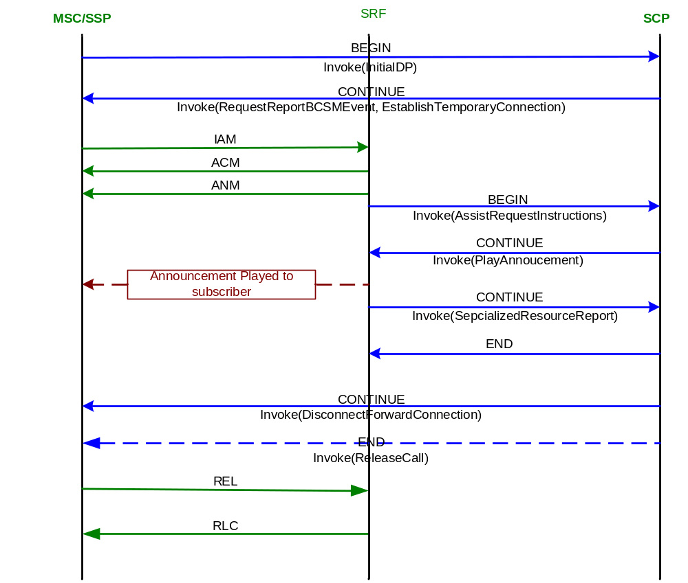

Message Parameters
InitialDP DP2 MO(A-B) | Information Element | Value
 | Service Key | Network Dependent (PPS Parameter) – to be provided by network operator.
 | Calling Party Number | Subscriber’s MSISDN
 | Event Type BCSM | CollectedInfo (DP2)
 | Called Party BCD Number | Dialed Number
 | LocationNumber | Identification of the subscriber’s location
 | Calling Party’s Category | Type of calling party e.g. operator, pay phone, ordinary subscriber.
 | Call Reference Number | VMSC Call Reference Number
 | MSC Address | E164 address of serving VMSC
 | Bearer Capability | Type of bearer capability
 | High Layer Compatibility | Type of high layer compatibility

RequestReport BCSMEvent | Information Element | Value
 | Sequence
 | Event Type | oAbandon
 | Monitor Mode | NotifyAndContinue
 | Leg ID | (1) – Calling Party
 | Event Type | oDisconnect
 | Monitor Mode | NotifyAndContinue
 | Leg ID | (1) – Calling Party

EstablishTemporaryConnection | Information Element | Value
 | AssistingSSPIPRoutingAddress | Address of IP + SCF ID + Correlation ID

AssistRequest-Instructions | Information Element | Value
 | CorrelationID | As sent in ETC messagse

PlayAnnouncement | Information Element | Value
 | Element Message ID | Includes language class and voice ID
 | Number of Repeatitions | 1 (In total twice)
 | Interval | 1 second

Specialized Resource Report | Information Element | Value
 | -

Disconnect Forward Connection | Information Element | Value
 | -

ReleaseCall | Information Element | Value
 | Cause | CALL_REJECTED

Terminating PPS Call
In this scenario, a call to the subscriber is made when his account has sufficient balance and is in a valid state. The SCP interacts with the SSP to be notified of answer and disconnect conditions in order to charge for the call.

Summary
A TDP-R is set for the prepaid subscriber at the terminating_attempt_authorized PIC (DP12). When the MSC receives a call for the subscriber, the trigger fires and the SSP sends an InitialDP message to the SCP.
When the SCP receives the InitialDP message, it first analyzes the called party number to determine the subscriber’s account. If the account is valid, it then performs further analysis to determine if the subscriber’s balance is sufficient to receive the call.
When the call is authorized, the SCP sends the RequestReportBCSMEvent, ApplyCharging and Continue message to the SSP. The RequestReportBCSMEvent arms triggers for when the call is answered or terminated. The SCP sends an ApplyCharging message with the maxCallPeriodDuration and releaseIfdurationExceeded parameters set to instruct the MSC to release the call when the maximum call duration is reached and to play a warning tone prior to release.
When the call is answered, the tAnswer DP is triggered in the SSP and an EventReportBCSM message is sent to the SCP. At this point, the SCP begins charging for the call and starts the “maximum call length” timer based on the subscriber’s balance and the tariff for the call. The ActivityTest message continues to be sent periodically throughout the life of the call.
After a call has reached the active state and the either party disconnects, the oDisconnect trigger that was armed during call setup is reached. This causes the SSP to send an EventReportBCSM notification and ApplyChargingReport message with the CallActive parameter set to false to the SCP. If the MiscCallInfo indicates the trigger was armed as interrupted, the SCP sends a Continue message to the SSP. Otherwise the SSP contiues disconnect processing without further instructions from the SCP.
The SCP ends charging for the call and responds to the SSP with an empty TCAP END to end the control relationship.

Signaling Process Flow
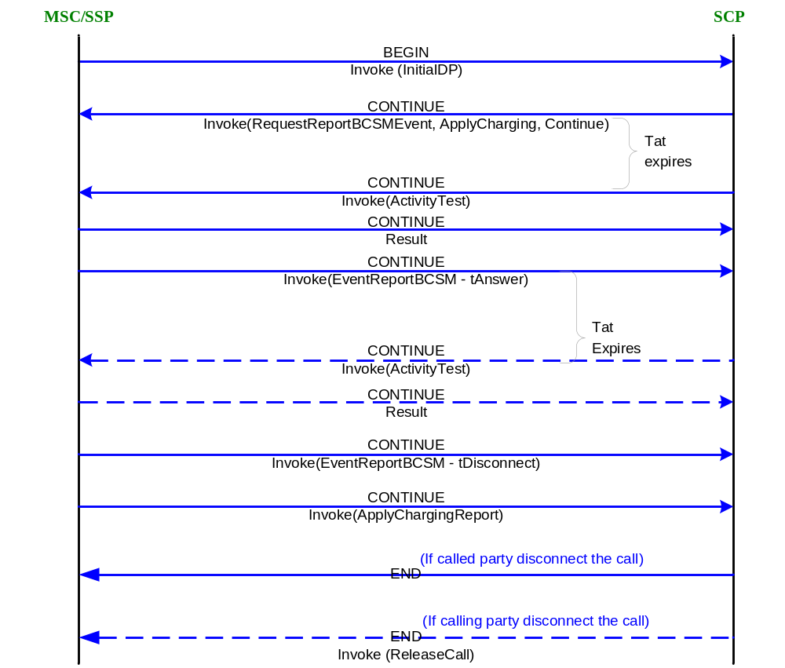

Message Parameters
InitialDP DP12 MT | Information Element | Value
 | Service Key | Network Dependent, 0 for normal call.
 | Calling Party Number | Calling MSISDN
 | Event Type BCSM | terminating_attempt_authorized (DP12)
 | Called Party Number | Subscriber ID (MSISDN)
 | LocationNumber | Identification of the calling party location
 | LocationInformation | Information regarding location of the called MS.
 | Calling Party’s Category | Type of calling party e.g. operator, pay phone, ordinary subscriber.
 | Call Reference Number | GMSC Call Reference Number
 | Original Called Party ID | Dialed digits if the call has met call forwarding on the route to the gsmSSF.
 | RedirectionInformation | Forwarding related information such as redirection counter. If available.
 | RedirectingPartyID | Directory Number the call was redirected from. MSISDN of PPS subscriber. If available.
 | MSC Address | E164 address of serving GMSC
 | Bearer Capability | Type of bearer capability
 | High Layer Compatibility | Type of high layer compatibility
 | Subscriber State | Indicates the status of the mobile subscriber. The states are: CAMEL Busy, Network Determined Not Reachable, Assumed Idle, or Not provided from VLR.

RequestReport BCSMEvent | Information Element | Value
 | Sequence
 | Event Type | tAnswer
 | Monitor Mode | NotifyAndContinue
 | Leg ID | (2) – Called Party
 | Event Type | tDisconnect
 | Monitor Mode | NotifyAndContinue
 | Leg ID | (1) – Calling Party
 | Event Type | tDisconnect
 | Monitor Mode | Interrupted
 | Leg ID | (2) – Called Party
 | Event Type | tAbandon
 | Monitor Mode | NotifyAndContinue
 | Leg ID | (1) – Calling Party
 | Event Type | tCalledPartyBusy
 | Monitor Mode | Interrupted
 | Leg ID | (2) – Called Party
 | Event Type | tNoAnswer
 | Monitor Mode | Interrupted
 | Leg ID | (2) – Called Party

Continue | Information Element | Value
 | -

ApplyCharging | Information Element | Value
 | MaxCallPeriodDuration | As calculated by PPS
 | ReleaseIfdurationExceeded | Warning before release
 | PartyToCharge | Leg2

EventReport BCSM | Information Element | Value
 | Event Type BCSM | tAnswer
 | MiscCallInfo | Notification

ActivityTest | Information Element | Value
 | -

EventReport BCSM | Information Element | Value
 | Event Type BCSM | tDisconnect
 | Event Specific Information BCSM | Release Cause
 | LegID | ReceivingSideID
 | MiscCallInfo | Notification or Interrupt

ApplyCharging-Report | Information Element | Value
 | CallActive | False

ReleaseCall | Information Element | Value
 | Cause | NORMAL_CALL_CLEARING (16)

Terminating PPS Call Not Allowed
This scenario covers situations in which the subscriber is not permitted to receive a call. Examples of this can be because the subscriber’s account is not in a correct state or because the subscriber’s balance is too low. In this case, the SCP directs SSF to release the call. SSF will sends Tone before release the call.

Summary
A TDP-R is set for the prepaid subscriber at the terminating_attempt_authorized PIC (DP12). When the MSC receives a call for the subscriber, the trigger fires and the SSP sends an InitialDP message to the SCP.
When the SCP receives the InitialDP message, it first analyzes the called party number to determine the subscriber’s account. If the account is valid, it then performs further analysis to determine if the subscriber’s balance is sufficient to receive the call.
If any of the authorization checks fail, the SCP sends a ReleaseCall with cause of INCOMING_CALLS_BARRED message to the SSP to release the call.

Signaling Process Flow
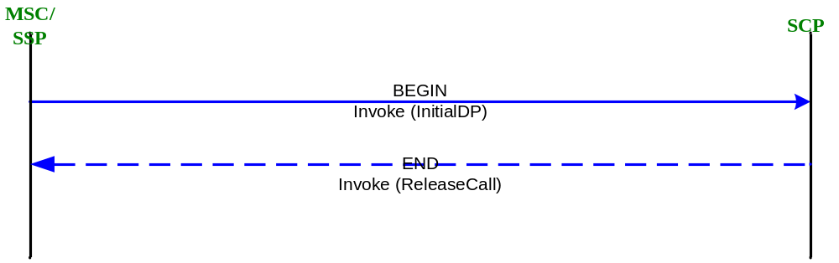

Message Parameters
InitialDP DP12 MT | Information Element | Value
 | Service Key | Network Dependent, 0 for normal call.
 | Calling Party Number | calling party DN
 | Event Type BCSM | terminating_attempt_authorized (DP12)
 | Called Party Number | SubscriberID (MSISDN)
 | LocationNumber | Identification of the calling party location
 | LocationInformation | Information regarding location of the called MS.
 | Calling Party’s Category | Type of calling party e.g. operator, pay phone, ordinary subscriber.
 | Call Reference Number | GMSC Call Reference Number
 | Original Called Party ID | Dialed digits if the call has met call forwarding on the route to the gsmSSF.
 | RedirectionInformation | Forwarding related information such as redirection counter. If available.
 | RedirectingPartyID | Directory Number the call was redirected from. MSISDN of PPS subscriber. If available.
 | MSC Address | E164 address of serving GMSC
 | Bearer Capability | Type of bearer capability
 | High Layer Compatibility | Type of high layer compatibility
 | Subscriber State | Indicates the status of the mobile subscriber. The states are: CAMEL Busy, Network Determined Not Reachable, Assumed Idle, or Not provided from VLR.

ReleaseCall | Information Element | Value
 | Cause | INCOMING_CALLS_BARRED

SSF-Initiated Call Termination (Maximum Call Duration)
This scenario covers the situation in which the Network terminates a call because the call has exceeded the maximum call length.

Summary
After a call has reached the active state, the Activity Test procedure, continues until the maximum call length is reached. Before the maximum call length is reached, the SSP plays a warning tone to the subscriber as indicated by the ApplyCharging messages previously sent by the SCP. When the maximum call duration is reached the SSP disconnects the call and sends an ApplyChargingReport message to the SCP. The ApplyChargingReport message terminates SCP processing.

Signaling Process Flow
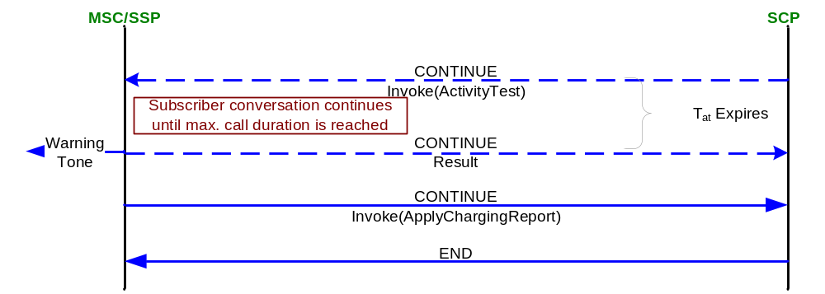

Message Parameters

ApplyCharging-Report | Information Element | Value
 | CallActive | False

SCP-Initiated Call Termination (Balance Exhausted)
This scenario covers the situation in which the network does not terminate a call as instructed in the ApplyCharging message in a timely fashion. In this case, as a save guard, the call is terminated by the SCP because the subscriber’s balance has reached the minimum allowed or because it has exceeded the maximum call length.

Summary
After a call has reached the active state, the Activity Test procedure, described in Section 4.2.1, continues until the subscriber’s balance is exhausted or the maximum call length is reached. At that point, the SCP directs the SSP to disconnect the call by sending a ReleaseCall message. When the ReleaseCall message is received, the SSP then terminates the call.

Signaling Process Flow
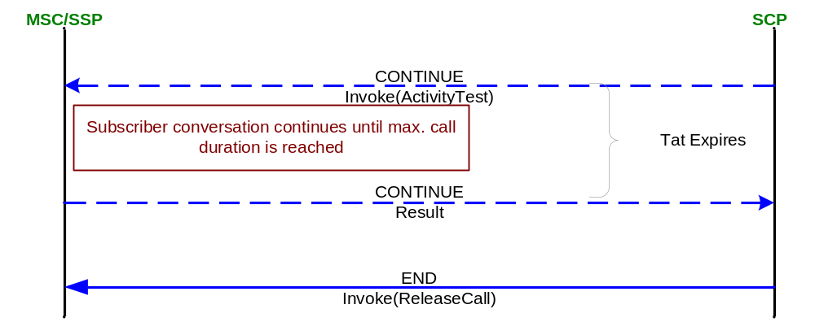

Message Parameters
ActivityTest | Information Element | Value
 | -

ReleaseCall | Information Element | Value
 | Cause | NORMAL_CALL_CLEARING (16)

Originating/Terminating PPS with Condtional CF at the MSC
In this scenario, the subscriber (B-party) has CF on Busy, No Answer enabled, receives a call, the CF condition is met and CF is handled in the MSC.

Summary
A TDP-R is set for the prepaid subscriber in the GMSC at the terminating_attempt_authorized PIC (DP12). When the GMSC receives a call for the subscriber, the trigger fires and the SSP sends an InitialDP message to the SCP, establishing a T(A-B) control relationship.
When the SCP receives the InitialDP message, it first analyzes whether or not the InitialDP indicates a forwarded call as described in Error! Reference source not found.. If no CF pending condition exists, the SCP analyzes the called party number to determine the subscriber’s account. If the account is valid, it then performs further analysis to determine if the subscriber’s balance is sufficient to receive the call.
When the call is authorized, the SCP sends the RequestReportBCSMEvent and Continue message to the SSP. The RequestReportBCSMEvent arms triggers for when the call is answered or terminated or is not completed to the B-party due to the Busy or No Answer condition.
If the call encounters a CF condition due to subscriber Busy or No Answer in the MSC, the MSC creates a new O(B-C) relationship for the forwarded call. As the PPS subscriber is also an Originating subscriber, a TDP-R is set for the prepaid subscriber at the collected_info PIC (DP2). When the forwarded call is executed, the trigger fires and the SSP will send an InitialDP message to the SCP.
When the SCP receives the InitialDP message, it analyzes the type of call. If the Redirection Information parameter is present, it is a forwarded call. If a Redirecting Party ID is present the SCP uses this information to determine the status of the PPS account. If the account is valid, further analysis takes place.
If the Forwarding Party (PPS subscriber) is authorized to call the destination address, and if the subscriber’s balance is sufficient to permit the call, the SCP sends the RequestReportBCSMEvent and Continue and message to the SSP. If the forwarded call is chargeable, the SCP also sends an ApplyCharging message with maxCallPeriodDuration and releaseIfdurationExceeded parameters. The RequestReportBCSMEvent arms triggers for when the call is answered or terminated.
The SSP then continues with normal call establishment until the called party answers the call. The SCP begins an ActivityTest timer (T_{ActTest}), whose expiration causes an ActivityTest message to be periodically sent to the SSP. This is used to ensure that the dialog is still active at the SSP.
When the forwarded call is answered, the oAnswer DP is triggered for the O(B-C) relationship and the tAnswer DP is triggered for the T(A-B) relationship. For each DP, an EventReportBCSM message is sent to the SCP. At this point, the SCP may begin charging for the call. The ActivityTest message continues to be sent periodically throughout the life of the forwarded call.

Signaling Process Flow

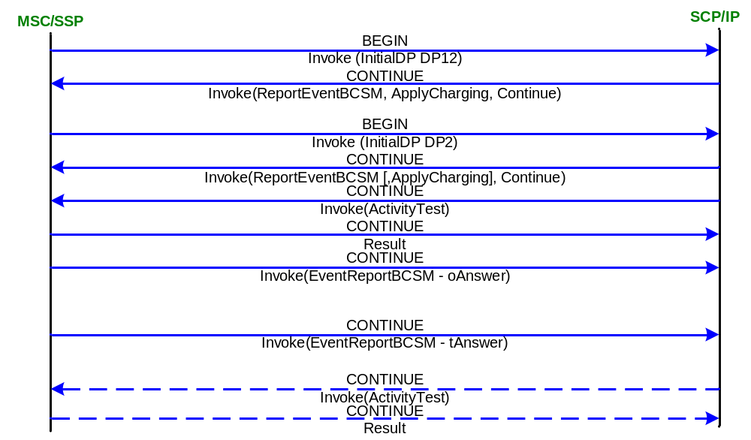

Message Parameters
InitialDP DP12 MT(A-B) | Information Element | Value
 | Service Key | Network Dependent (PPS Parameter) – to be provided by network operator.
 | Calling Party Number | Calling Party DN
 | Event Type BCSM | terminating_attempt_authorized (DP12)
 | Called Party Number | Subscriber ID (MDISDN)
 | LocationNumber | Identification of the calling party location
 | LocationInformation | Information regarding location of the called MS.
 | Calling Party’s Category | Type of calling party e.g. operator, pay phone, ordinary subscriber.
 | Call Reference Number | GMSC Call Reference Number
 | Original Called Party ID | Dialed digits if the call has met call forwarding on the route to the gsmSSF.
 | RedirectionInformation | Forwarding related information such as redirection counter. If available.
 | RedirectingPartyID | Directory Number the call was redirected from. MSISDN of PPS subscriber. If available.
 | Bearer Capability | Type of bearer capability
 | High Layer Compatibility | Type of high layer compatibility
 | Subscriber State | Indicates the status of the mobile subscriber. The states are: CAMEL Busy, Network Determined Not Reachable, Assumed Idle, or Not provided from VLR.
 | MSC Address | Address of the GMSC

RequestReport BCSMEvent MT(A-B) | Information Element | Value
 | Sequence
 | Event Type | tAnswer
 | Monitor Mode | NotifyAndContinue
 | Leg ID | (2) – Called Party
 | Event Type | tDisconnect
 | Monitor Mode | NotifyAndContinue
 | Leg ID | (1) – Calling Party
 | Event Type | tDisconnect
 | Monitor Mode | Interrupted
 | Leg ID | (2) – Called Party
 | Event Type | tAbandon
 | Monitor Mode | NotifyAndContinue
 | Leg ID | (1) – Calling Party
 | Event Type | tCalledPartyBusy
 | Monitor Mode | Interrupted
 | Leg ID | (2) – Called Party
 | Event Type | tNoAnswer
 | Monitor Mode | Interrupted
 | Leg ID | (2) – Called Party

ApplyCharging MT(A-B) | Information Element | Value
 | MaxCallPeriodDuration | As calculated by PPS
 | ReleaseIfdurationExceeded | Warning before release
 | PartyToCharge | Leg2

Continue | Information Element | Value
 | -

InitialDP DP2 MF(B-C) | Information Element | Value
 | Service Key | Network Dependent (PPS Parameter) – to be provided by network operator.
 | Calling Party Number | Calling Party Number
 | Event Type BCSM | CollectedInfo (DP2)
 | Called Party Number | Forwarded To Number
 | LocationNumber | Identification of the Calling Party location
 | Calling Party’s Category | Type of calling party e.g. operator, pay phone, ordinary subscriber.
 | Call Reference Number | GMSC Call Reference Number
 | Bearer Capability | Type of bearer capability
 | High Layer Compatibility | Type of high layer compatibility
 | RedirectionInformation | Forwarding related information such as redirection counter.
 | RedirectingPartyID | Directory Number the call was redirected from. MSISDN of PPS subscriber.
 | MSC Address | For CF calls, address of the forwarding MSC
 | GMSC Address | For CF calls, address of the GMSC.

RequestReport BCSMEvent MF(B-C) | Information Element | Value
 | Sequence
 | Event Type | Oanswer
 | Monitor Mode | NotifyAndContinue
 | Leg ID | (2) – Called Party
 | Event Type | Odisconnect
 | Monitor Mode | NotifyAndContinue
 | Leg ID | (1) – Calling Party
 | Event Type | Odisconnect
 | Monitor Mode | Interrupted
 | Leg ID | (2) – Called Party
 | Event Type | OAbandon
 | Monitor Mode | NotifyAndContinue
 | Leg ID | (1) – Calling Party
 | Event Type | oCalledPartyBusy
 | Monitor Mode | Interrupted
 | Leg ID | (2) – Called Party
 | Event Type | ONoAnswer
 | Monitor Mode | Interrupted
 | Leg ID | (2) – Called Party

ApplyCharging MF(B-C) | Information Element | Value
 | MaxCallPeriodDuration | As calculated by PPS
 | ReleaseIfdurationExceeded | No warning before release
 | PartyToCharge | Leg1

EventReport BCSM MF(B-C) | Information Element | Value
 | Event Type BCSM | OAnswer
 | MiscCallInfo | Notification

EventReport BCSM MT(A-B) | Information Element | Value
 | Event Type BCSM | TAnswer
 | MiscCallInfo | Notification

ActivityTest | Information Element | Value
 | -

Direct Call to IVR - Inquiry
This scenario deals with the situation in which a service provider has published an access number for inquiring account. In this case, the subscriber dials the access number and the SCP directs the SSP to connect the call to the IP so that the account information (balance, expire day, last call info.) announcement can be played.

Summary
A TDP-R is set for the prepaid subscriber at the collected_info PIC (DP2). When the subscriber makes a call, the trigger fires and the SSP sends an InitialDP message to the SCP. In this scenario, the called number is inquiry access number.
When the SCP receives the InitialDP message, it first analyzes the calling party number to determine the subscriber’s account. If the account is valid, it then performs further analysis to determine if the subscriber is allowed to make calls to inquiry his account.
When the call is authorized, the SCP sends a RequestReportBCSMEvent message and an EstablishTemporaryConnection message to the SSP. The RequestReportBCSMEvent message sets a trigger to detect if the subscriber abandons the call during the warning announcement. The EstablishTemporaryConnection message directs the SSP to connect the subscriber via a voice circuit to the SRF in order to play the account informing to the subscriber.
After the announcement has been played to the subscriber, the IP notifies the SCP that the announcement has been played. The SCP then instructs the SSP to release the IP connection by sending a DisconnectForwardConnection message.
The SCP then sends ReleaseCall message to SSF to terminate the call.

Signaling Process Flow
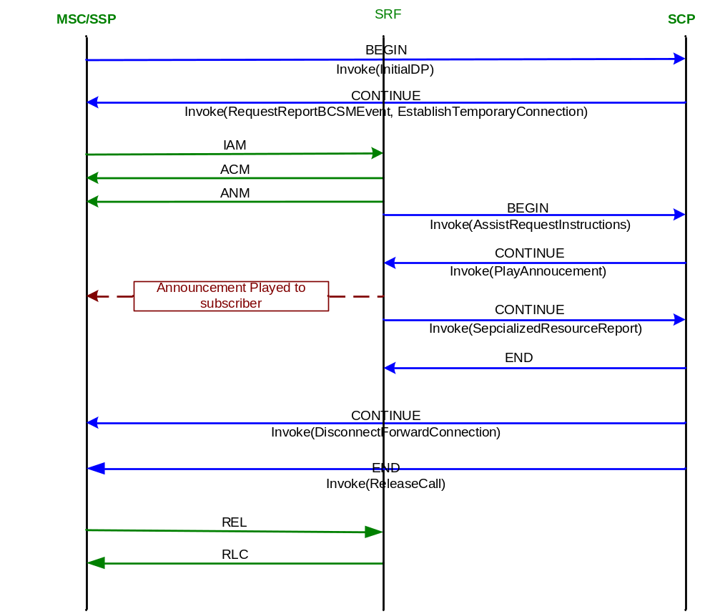

Message Parameters
InitialDP | Information Element | Value
 | Service Key | Network Dependent (PPS Parameter) – to be provided by network operator.
 | Calling Party Number | Subscriber’s MSISDN
 | Event Type BCSM | CollectedInfo (DP2)
 | Called Party BCD Number | Dialed Number
 | LocationNumber | Identification of the subscriber’s location
 | Calling Party’s Category | Type of calling party e.g. operator, pay phone, ordinary subscriber.
 | Call Reference Number | VMSC Call Reference Number
 | MSC Address | E164 address of serving VMSC
 | Bearer Capability | Type of bearer capability
 | High Layer Compatibility | Type of high layer compatibility

RequestReport BCSMEvent | Information Element | Value
 | Sequence
 | Event Type | oAbandon
 | Monitor Mode | NotifyAndContinue
 | Leg ID | (1) – Calling Party
 | Event Type | oDisconnect
 | Monitor Mode | NotifyAndContinue
 | Leg ID | (1) – Calling Party

EstablishTemporaryConnection | Information Element | Value
 | AssistingSSPIPRoutingAddress | Address of IP + SCF ID + Correlation ID (Hex B as a decollator)

AssistRequest-Instructions | Information Element | Value
 | CorrelationID | As sent in ETC messagse

PlayAnnouncement | Information Element | Value
 | Element Message ID | Includes language class and voice ID
 | Number of Repeatitions | 1 (In total twice)
 | Interval | 1 second

Specialized Resource Report | Information Element | Value
 | -

Disconnect Forward Connection | Information Element | Value
 | -

ReleaseCall | Information Element | Value
 | Cause | NORMAL_CALL_CLEARING (16)

Direct Call to IVR - Recharge
This scenario deals with the situation in which a service provider has published an access number for recharging account. In this case, the subscriber dials the access number and the SCP directs the SSP to connect the call to the SRF so that account information announcement can be played and DMTF keypress information is collected to SCP. .

Summary
A TDP-R is set for the prepaid subscriber at the collected_info PIC (DP2). When the subscriber makes a call, the trigger fires and the SSP sends an InitialDP message to the SCP. In this scenario, the called number is the recharge service number.
When the SCP receives the InitialDP message, it first analyzes the calling party number to determine the subscriber’s account. If the account is valid, it then performs further analysis to determine which functions the subscriber is allowed to use.
When the call is authorized, the SCP sends a RequestReportBCSMEvent message and an EstablishTemporaryConnection message to the SSP. The RequestReportBCSMEvent message sets a trigger to detect if the subscriber abandons the call during the IVR session. The EstablishTemporaryConnection message directs the SSP to connect the subscriber via a voice circuit SRF.
First SCP sends PlayAnnouncement message to SRF to notify the subscriber the account information. After the information has been played, then SCP sends PlayAnnoucementAndCollectUserInfo (PCUI) message to SRF to collect the recharge card password. The end digit for the PCUI is #.
When # is pressed, SRF sends all DTMF keys to SCP in the PCUI response message. Then SCP checks the collected information to see whether it is a valid recharge card password.
If the password is invalid and the subscriber has tried thrice, then the call will be cut. If the subscriber tried less than thrice, then SCP will direct SRF to collect new password.
If the password is valid, then SCP sends voice like “The card value is recharged to your account” and then sends DisconnectTemporaryConnection to direct SSF to release the IP connection. After that, SCP send ReleaseCall to terminate the call.

Signaling Process Flow
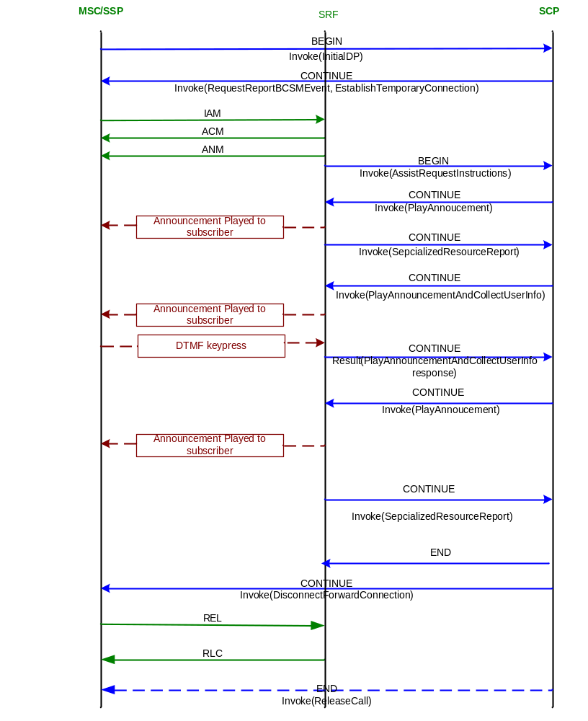

Message Parameters
InitialDP | Information Element | Value
 | Service Key | Network Dependent (PPS Parameter) – to be provided by network operator.
 | Calling Party Number | Subscriber’s MSISDN
 | Event Type BCSM | CollectedInfo (DP2)
 | Called Party BCD Number | Dialed Number (Access Number)
 | LocationNumber | Identification of the subscriber’s location
 | Calling Party’s Category | Type of calling party e.g. operator, pay phone, ordinary subscriber.
 | Call Reference Number | VMSC Call Reference Number
 | MSC Address | E164 address of serving VMSC
 | Bearer Capability | Type of bearer capability
 | High Layer Compatibility | Type of high layer compatibility

RequestReport BCSMEvent | Information Element | Value
 | Sequence
 | Event Type | oAbandon
 | Monitor Mode | NotifyAndContinue
 | Leg ID | (1) – Calling Party
 | Event Type | oDisconnect
 | Monitor Mode | NotifyAndContinue
 | Leg ID | (1) – Calling Party

EstablishTemporaryConnection | Information Element | Value
 | AssistingSSPIPRoutingAddress | Address of IP + SCF ID + Correlation ID
 | ServiceInteractionIndicatorTwo | Bothway thruconnect

AssistRequest-Instructions | Information Element | Value
 | CorrelationID | As sent in ETC messagse

PlayAnnouncement | Information Element | Value
 | Element Message ID | Includes language class and voice ID
 | Number of Repeatitions | 1 (In total twice)
 | Interval | 1 second

Specialized Resource Report | Information Element | Value
 | -

Prompt And Collect User Information | Information Element | Value
 | informationToSend | Message ID, optional - VariableParts
 | collectedInfo | interDigitTimeOut  maximumNbOfDigits  interruptableAnnInd  endOfReplyDigit
 | disconnectFromIPForbidden | TRUE or FALSE depending on Service Logic

Prompt And Collect User Information Response | Information Element | Value
 | digitsResponse | Digits

Disconnect Forward Connection | Information Element | Value
 | -

ReleaseCall | Information Element | Value
 | Cause | NORMAL_CALL_CLEARING (16)

SMS Scenarios
Following Prepaid SMS scenarios are described:
- Originating PPS SMS succeed
- Originating PPS SMS failed (No balance)
A TDP-R is set for the prepaid subscriber at the sms_collected_info (smsDP1). When the subscriber sends MO SMS, the trigger fires and the SSP sends an InitialDPSMS messge to the SCP. The cause always is 111 (Protocol error, unspecified).

Originating PPS SMS Succeed
In this scenario, the Prepaid subscriber initiates a short message when he has enough balance and his account is in normal state.
When the SCP receives the InitialDPSMS message, it first analyzes the calling party number to determine the subscriber’s account. If the account is valid and has enough balance, then the request is authorized. SCP sends ReqeustReportSMSEvent arsm triggers for when the short message is submitted or failed. The SCP sends a ContinueSMS to let SSP continue with normal short message.
When the mo sms is submitted to SMSC, then SSF sends EventReportSMS with EDP=o-smsSubmitted as it’s armed. Then SCP sends ReleaseSMS to terminate the dialog.
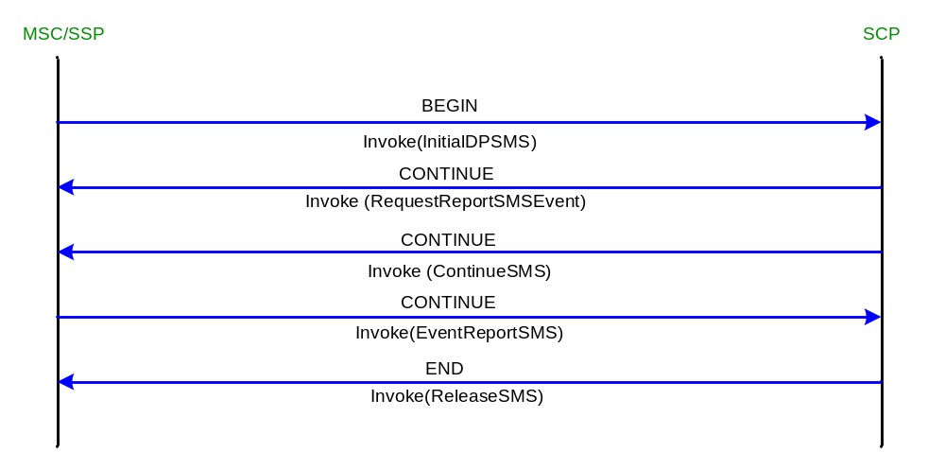

InitialDPSMS | Information Element | Value
 | Destination Subscriber Number | MSISDN
 | Calling Party Number | MSISDN
 | Event Type | SMS Collected Info. (1)
 | IMSI | IMSI
 | Location Info. in MSC | MCC+MNC+LAC+CID (is used for location based billing)
 | Service Key | 0

RequestReportSMSEvent | Information Element | Value
 | Event Type SMS | osmsFailure
 | Monitor Mode | Interrupted
 | Event Type SMS | osmsSubmitted
 | Monitor Mode | Interrupt

ReportEventSMS | Information Element | Value
 | Event Type SMS | osmsSubmitted
 | Monitor Mode | Interrupt

ReleaseSMS | Information Element | Value
 | Cause | 111 (protocol error)

Originating PPS SMS failed (No balance)
In this scenario, the Prepaid subscriber initiates a short message but he doesn’t have enough balance.
When the SCP receives the InitialDPSMS message, it first analyzes the calling party number to determine the subscriber’s account. If the account’s balance is not sufficient to permit the short message then SCP sends ReleaseSMS to terminate the dialog.
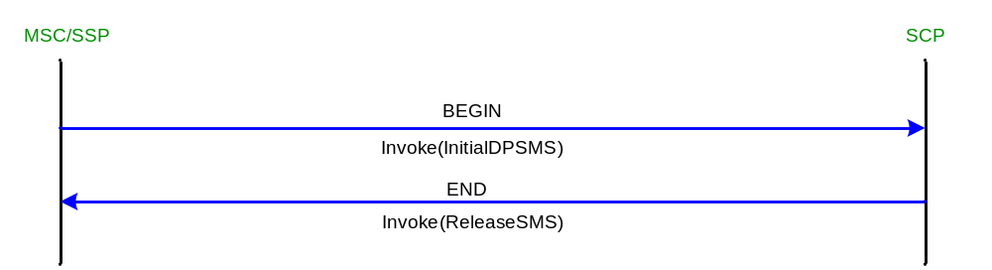

InitialDPSMS | Information Element | Value
 | Destination Subscriber Number | MSISDN
 | Calling Party Number | MSISDN
 | Event Type | SMS Collected Info. (1)
 | IMSI | IMSI
 | Location Info. in MSC | MCC+MNC+LAC+CID (is used for location based billing)
 | Service Key | 0

ReleaseSMS | Information Element | Value
 | Cause | 111 (protocol error)

Network Dependent Data

Service Key
The service key value, used in the InitialDP message to identify the service being invoked, should be set to the same value as that parameterized at the DP in the SSP.
There are two Service Keys designed for LITECORE PPS:
Service Key = 1: is designed for GPRS charging, for this case, the call duration is cal. by GGSN and sent to SCF with ApplyCharingReport.
Service Key = 0: is designed for all other Prepaid service except above service.

ActivityTest Timer Value
The length of the ActivityTest timer, T_{at}, is determined by PPS. This should be set to as large a period as possible for the SSP in order to reduce signaling traffic during a call connection. The value range is 1-20 seconds and the value is hard coded as 18 seconds in LITECORE PPS.

Coding of Location Information
The LocationNumber field in the InitialDP/InitialDPSMS messages provides information about the location of the subscriber. Normally, this contains the MCC/MNC/LAC and cell ID from which the subscriber is calling or sends the short message; however, any value that provides the location of the subscriber can be supplied, provided that it is consistent with the setup of the location values placed in the PPS database. If location-based billing is not used, it is optional.
For MT Prepaid call, the location information is also provided by SSF which is sent in SRI_Response MAP message by HLR. HLR gets the location information from VLR by ProvideSubscriberInformation message. SCP/PPS doesn’t release AnyTimeInterrogation message to get the subscriber information.

maxCallPeriodDuration
This parameter specifies the period of time for which a can progress before an ApplyCharginReport shall be sent to the SCF.
In LITECORE PPS, the maximum value of maxCallPeriodDuration is set to 90000 (9000 seconds) even the subscriber has more money. If the subscriber has money to make a call more than 9000 seconds, then another parameter releaseIfDurationExceeded is not provided. So, during a call more than 9000 seconds, more than 1 ApplyCharging are sent to SSF.

Definition of Elementary Message ID
The Elementary Message ID parameter of the PlayAnnouncement and PlayAndCollectUserInformation operations contains the Announcement ID to be played by the IP function. The LITECORE Prepaid Service supports multiple Languages. The CAMEL standard does not provide for a means to define language as a message parameter. How announcements in different languages are played must be defined on a project basis. LITECORE codes the Elementary Message Id parameter as below.
The definition of Elementary Message ID Example
Byte4-3 | Byte2-1
Language Class | Announcement ID
Language Class is defined by SRF (SRF supports 5 languages).

assitingSSPIPRoutingAddress
To connect the subscriber via s voice circuit to the LITECORE SRF, SCF sends a ETC (EstablishTemporaryConnection ) message to SSF, then SSF sends IAM to SRF.
The gsmSRF address is included in the parameter assistingSSPIPRoutingAddress. In LITECORE design, the assistingSSPIPRoutingAddress also includes correlationID and scfID. A hex B is added between SRF address and correlationID , correlationID and scfID.
Even the SCF sends gsmSRF address correlationID and scfID in .separate fields, LITECORE CCF will combine the three fields into called party number of IAM which is sent to LITECORE gsmSRF.
LITECORE MSS is in a dual-plain structure, the scfID is divided into 2 segments for both PPSs. The range 0000 – 4000 is assigned for PPS-0, 4000 and above is assigned for PPS-1. SRF can send the AssistRequest to the proper PPS according to the scfID.

The LocationNumber field contains a value that expresses the subscriber’s location. This is normally the cell ID, but can be any value that identifies the location.

