Scope of Work – Mobile Postpaid
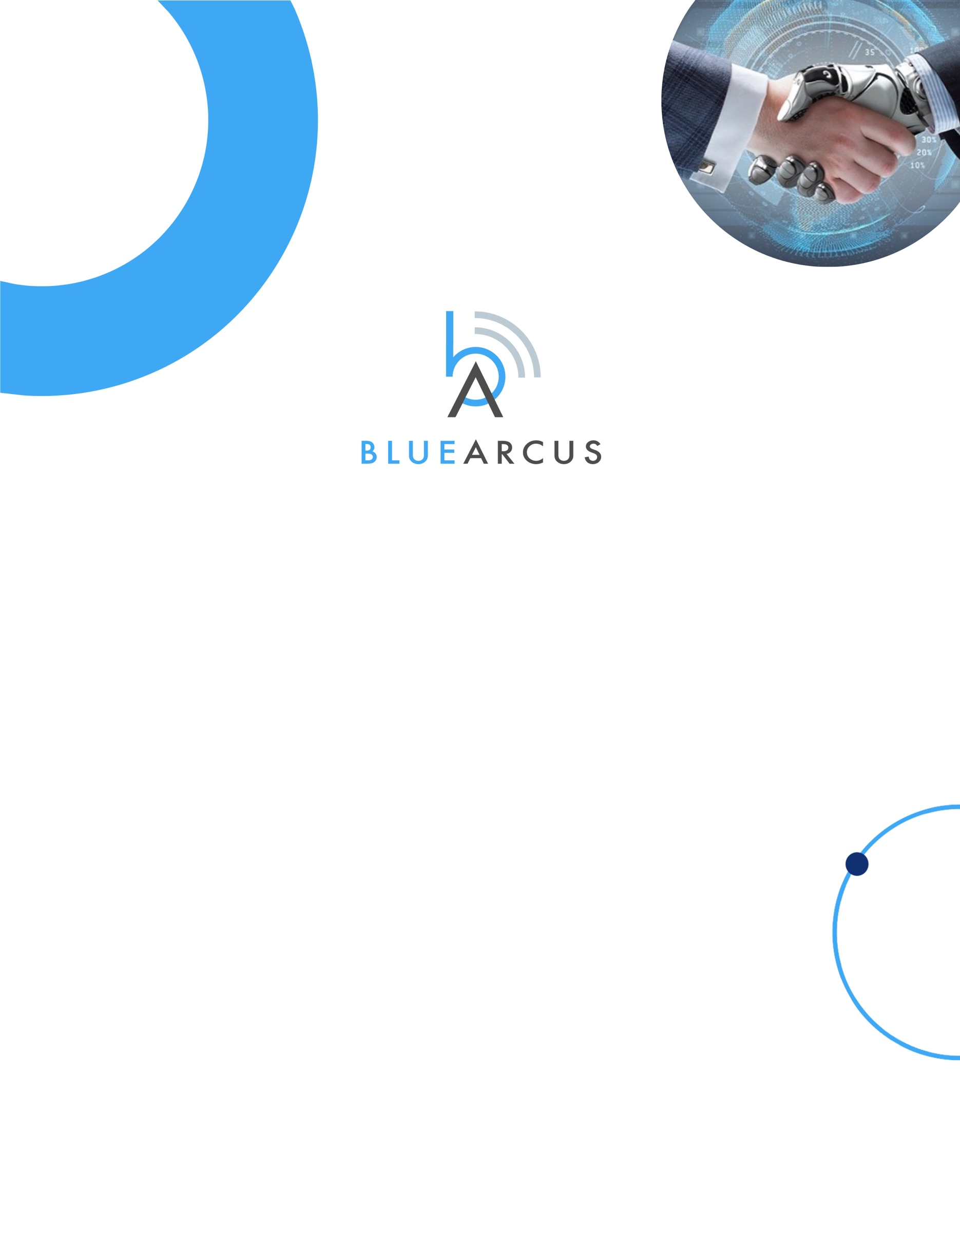
Norfolk Telecom

Document Version: v1.0
Date of Release: 25 FEB 2025
Blue Arcus Technologies © 2025

Table of Contents

Task, Responsibility Matrix & Projected Timelines

Final Acceptance & Sign-Off

05
SoW Sign-Off

02
Purpose

Key Stakeholders
04
03
01
- Purpose

The purpose of this Statement of Work (SoW) is to define the objectives, deliverables, responsibilities, and timeline for the implementation of Mobile Postpaid Requirements. The document serves as a formal agreement between Norfolk Telecom and Blue Arcus Technologies.

Deliverables

S. No | Deliverables | Description | Blue Arcus | Norfolk | Tentative Timelines
1 | Mobile Postpaid Service under Existing Customer ID | Mobile Postpaid Service should be able to be created under the existing Customer ID, where the customer already has ADSL & PSTN Postpaid Services. The Customer ID should be retained and reassigned to the same customer when they subscribe to services again with Telecom | Responsible | Support | 7 Days
2 | Single Invoice for all Three Postpaid Services & Billing Flow | All three postpaid services (ADSL, PSTN & Mobile) should be billed under a single invoice and Billing process flow same as existing one. | Responsible | Support | 19 Days
3 | Max Debt, Credit Limit & Grace Period Features | The features related to Max Debt; Credit Limit & Grace Period are not required to be implemented. | Support | Responsible | 7 Days
4 | Part Payments for Finalized Invoice | Once the final invoice is generated with the final outstanding balance, the customer should have the option to pay partly (in instalments) rather than in full. Part payments should be recorded under their Customer ID. Payments should be accepted through all available payment options (Postpaid Payments, Postpaid Bulk Payments, and Postpaid Finalized Account Records). | Responsible | Support | 8 Days
5 | Service On-Hold Feature | Service On-Hold process is same as the current flow in ADSL & PSTN | NA | NA | NA
6 | Action after default monthly data benefit used up | After the monthly benefit (200GB) usage, the customer can continue to use data services and will be billed extra for that additional usage per MB when the invoice generates. | Responsible | Support | NA

Key Stakeholders

These are the people who will participate in the project.

ROLE | Blue Arcus | Norfolk
Program Manager | Dhilip | Simon
Technical Engineer | Yasaswi | TBD
Customer Support | Manish | TBD

SoW Sign-Off

The undersigned has/have read, understand(s), and agree(s) to the terms and conditions herein.

IN WITNESS WHEREOF, the parties have executed this Agreement as of the date first above written.

Blue Arcus Technologies, Inc. |  | Norfolk Telecom
NAME |  | NAME
Designation |  | Designation
Date: |  | Date:

Final Acceptance & Sign-off Sheet

This is to confirm that all the SoW Items has been delivered. All the installation, configuration, and integration has been executed successfully and is verified by the representative of Norfolk Telecom and BLUE ARCUS TECHNOLOGIES.

Norfolk
Name | Signature | Date (DD/MM/YY)
Name | Signature | Date (DD/MM/YY)

Blue Arcus
Name | Signature | Date (DD/MM/YY)
Name | Signature | Date (DD/MM/YY)

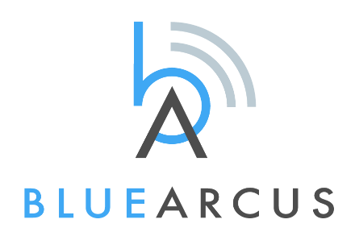
BLUE ARCUS TECHNOLOGIES
USA | India | Indonesia | Philippines | Australia

Know more about our Products and Services.
www.bluearcus.com | marketing@bluearcus.com | +1 65044 00651



