Scope of work and Service Description
Document Version 4.3

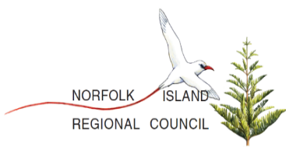


Norfolk telecom
Network Upgrade

Document History
Rev | Date | Author | Details
1.0 | 28 December 2019 | Eman Dupa | Initial Release – Draft
2.0 | 10 January 2020 | Arlin Carlos | Added the table of contents, changes made in the format and changes made from sign off to approvals.
2.1 | 15 January 2020 | Eman Dupa | Corrected comments from project team.  Added missed items as reviewed by project team
3 | 20 January 2020 | Eman Dupa | Added NT inputs, Invoice sample, Tariff, Plans and Bundles
3.1 | 03 February 2020 | Eman Dupa | Updated the Plans and bundles with latest release
4.0 | 18 February 2020 | Arlin Carlos | Made some changes in the table of contents and standardize the formats.
4.1 | 18 May 2020 | Daisyrie Sangalang | Updated Section 6.3.3 Plan and Bundles  Updated Section 6.4.1 and 6.4.2 Mobile and Web Self Care; change top-up to add credits, remove item #1 for voucher top-up
4.2 | 25 May 2020 | Daisyrie Sangalang | Updated Section 5.3.1 PSTN attaching excel file for PSTN and ADSL Subs details  Updated Section 6.1.3 Adding Spiels  Updated Section 6.3.3 Plans and Bundles  Updated Section 6.3.6 Sample New Invoice  Updated Section 6.5 Report Samples
Approvals
Company | Name | Designation | Signature | Date
Norfolk Telecom | Mick Donohoe | Technical Implementation Lead
Norfolk Telecom | Brian McKenzie | Project Manager
Norfolk Island Regional Council (NIRC) | Alistair Innes-Walker | Manager – Commercial Services
Speed Cast | John Arthur | Overall Program Manager
Blue Arcus | Eman Dupa | Technical Project Manager

Table of Contents
1 Scope of the Document 4
2 Executive Summary 4
3 Concurrences 4
4 Responsibility Matrix 6
5 Network Overview 9
5.1 Power System 12
5.1.1 Procured Power Equipment 12
5.1.2 Mains Tapping Requirement Dimension 13
5.2 Transmission and IP Network 14
5.2.1 Mobile Network Site Connections 14
5.2.2 Transmission Network Diagram 14
5.3 Fixed-Line Network 15
5.3.1 PSTN 15
5.3.2 Existing DSL 15
5.4 Radio Access Network 16
5.4.1 Site List 16
5.5 Core Network 16
5.5.1 Summary of Information 17
6 BOSS System 18
6.1 CRM 18
6.1.1 User List 18
6.1.2 Subscriber Details 18
6.1.3 Spiels 18
6.2 Ticketing 22
6.3 Billing 23
6.3.1 Asset Details 23
6.3.2 Subscriber Lifecycle 24
6.3.3 Plans and Bundles 25
6.3.4 Tariff Rates 30
6.3.5 Bill Information 36
6.3.6 Considerations 36
6.3.7 Voucher Management 71
6.3.8 Payment Channels 71
6.4 Self-care 71
6.4.1 Web Self-Care 71
6.4.2 Mobile Self-Care 72
6.5 Reports 74
6.5.1 Finance Revenue Report Sample 75
6.5.2 Finance Payment Statistics Report Sample 76
6.5.3 Finance Total Monthly Product Revenue Report Sample 77
6.5.4 Finance Billing Cycle Revenue Report Sample 78
6.5.5 Operation Traffic Report Sample 79
6.5.6 Operation Customer CDR Report Sample 79
6.5.7 Operation Subscriber Report Sample 80
6.5.8 Sales and Marketing Top Users Report Sample 81
6.5.9 Sales and Marketing Bundle Purchase Report Sample 81
6.6 Aesthetics 81
6.6.1 Color Scheme 81
6.6.2 Logo 81

- Scope of the Document
This document describes agreed items based on previous discussion and workshop concurrences between project proponent and vendor in accordance with the project contract for Norfolk Telecom network upgrade. This document includes service description for the new 3G/4G Mobile Network (RAN and Core), New Fixed-line entity deployment (MSAN and Soft switch), Existing DSL integration to unified billing (offline) and Business and Operating Support System (BOSS)

Unless an item is expressly flagged as a variation, if there are any discrepancies between this document and the main Agreement and its Annexures then the latter shall prevail.

- Executive Summary
The following will be the scope of work to be deployed:
- Radio Access Network – deployment of 8 mobile sites with three sector Dual Band Antenna (3G and 4G), 3 repeater Site and 2 sets Multiband Tower Mounted Amplifier (MTMA), each for 3G and 4G or whatever necessity it may fulfil
- 3G and 4G Core
- SMSC
- Circuit Switch Fall-back with Volte
- MSAN Replacement Upgrade
- PSTN Soft Switch Replacement Upgrade
- Integration of new PSTN service to new Unified Billing system (BOSS)
- Migration of current PSTN accounts to new Unified Billing system (BOSS)
- Integration of Existing DSL to new Unified Billing System (BOSS)
- Migration of Current DSL accounts to new Unified Billing system (BOSS)
- Integration of International Voice Service to new International voice link
- Integration of SMSC to new International A2P and P2P SMS link
- Integration for Inbound Roaming
- Transmission Backhaul Upgrade
- Power Upgrade (Main Exchange, Anson Bay and Mobile Sites)
- BOSS Deployment (CRM, Billing, Self-care)

- Concurrences
(as discussed during workshop)
This table shows agreed changes and concurrences from Norfolk Telecom Management

Item | Description | Status
P2P and A2P Link | Need for new P2P and A2P link for International SMS | Agreed
Rectifier Requirement for Anson Bay | Power Requirement for Remote Redundant Servers for Anson Bay | Agreed
Migration Procedures | Procedure for cutoff during ready for service of services  *Agreed to migrate and bring to commercial use New PSTN service the same time as RFS of Mobile(3G/4G) service. Upon cutoff, 2g service will be decommissioned.  *Information dissipation strategy to subscriber will be handled by NT. | Agreed
New International Voice Gateway Link | Need for a new International voice gateway for Mobile and PSTN. This initiative will eliminate migration procedure of voice during cutoff. | Agreed
Additional Krone Requirement for the New MSAN | Assessed requirement of 154pcs of standard krone Australian type during workshop  * Will be provided by BA free of charge | Agreed
Transmission Network and Backhaul final setup | Revised and agreed connectivity for transmission backhaul. Information available on Transmission part within this document. | Agreed
Puffa Site reallocation to Main Exchange | Agreed during workshop to reallocate Puffa site to Main Exchange | Agreed
Repeater Locations | Planning for repeater location to pacify coverage gaps will be decided after implementation of mobile sites to maximize coverage priority | Agreed
Mobile Roaming | Required service of inbound roaming | Agreed
Mains Power Tapping | Power requirement for Tapping between rectifier and Mains for main and mobile site will be handled by NT power representative | Agreed
Mobile IP network gateway | Switch/Router for Mobile Network Entities will be setup by NT | Agreed
Sim Card Procurement | Initial sim card will be procured by SCBA via NIRC P.O. | Agreed
Account Balance Setup | It was discussed and approve to have only account balance and no wallet balance on subscriber prepaid credits | Agreed

- Responsibility Matrix

Below table contains scope and responsible party involved in each task. Any comments or deviations will be noted on comments section.
Fixed Line - PSTN
Scope | Responsible Party | Remarks
Hardware Delivery | SC-BA Oversight
*MSAN | Keymile
*Soft switch | Redcom
Rackspace Provisioning | SC/BA- NT
Physical Installation - MSAN | Keymile - SC/BA
* Mounting
* Cabling
* Grooming
Physical Installation - Soft switch | Redcom SC/BA
* Mounting
* Cabling
* Grooming
Power Tapping - Rectifier System | SC/BA - Eaton
Scope | Responsible Party | Remarks
Configuration - MSAN | Keymile - SC/BA
Configuration - Soft switch | Redcom - SC/BA
Service Commissioning MSAN | Keymile - SC/BA
MSAN – MDF connection | NT - Keymile
Service Commissioning Soft switch | Redcom - SC/BA
Integration MSAN-Soft switch | Keymile - Redcom SC/BA
Integration - Soft switch to SBC | Redcom - SCBA (AudioCodes)
FAT | SC/BA -TN
Training and Handover | Redcom - Keymile -SC/BA - TN

Fixed - Line / Existing DSL
Scope | Responsible Party | Remarks
IP Routing | NT - SCBA
CDR Push | NT
Mediation GW configuration | SCBA
CDR Parsing for Billing | SCBA
Charging Data verification | SCBA - NT
Billing Integration | SCBA
FAT | NT - SCBA
Training and Handover | SCBA - NT

Power System
Scope | Responsible Party | Remarks
Hardware Delivery | SC-BA Oversight
*Rectifier System | Eaton
* Batteries | Eaton
Rectifier Setup – Main Exchange | Eaton - SC/BA
Rectifier Setup – Remote Site | SC/BA -NT
Battery Bank Setup – Remote Site | SC/BA -NT
AC Mains Provisioning | NT
Rectifier to Mains Tapping | NT - Eaton
Hardware to Rectifier Tapping | SC/BA - Eaton
FAT | SC/BA- NT
Training and Handover | SC/BA - Eaton - TN

Backhaul and Transmission

Transmission
Scope | Responsible Party | Remarks
Power Tapping | SC/BA
Installation and Mounting of HW (Switches) | SC/BA
Switch Configurations | TXRX/SCBA
Back Haul Testing | TXRX/SCBA
Back Haul Provisioning | NT/TXRX/SCBA
Optimizing | TXRX/SCBA
FAT | NT/SCBA
Training & Handover | TXRX/SCBA/NT

IP Infrastructure
Scope | Responsible Party | Remarks
Internal IP Network Design | SCBA
Mob GW Provisioning | NT
VPN Connections | NT/TXRX
External IP Routing | NT
Internal IP management | SC/BA
VLAN Provisioning | TXRX/NT
End to End IP Connectivity test | SC/BA/NT
Firewall rules and blocking | NT
Network Hardenin | SC/BA/NT

Radio Access Network
Scope | Responsible Party | Remarks
Delivery | SCBA
Materials Check and Audit | NT - SCBA
Site Preparation and Civil Works | NT
*Pole Readiness
* Shelter Readiness
Hauling and Materials onsite | NT - SCBA
AMB (Mounting Brackets) mounting and Installation
Antenna Mounting | SCBA - NT
Radio Unit Mounting | SCBA - NT
CPRI and Power Layout | SCBA - NT
Feeder Cable Installation | SCBA - NT
GPS Installation | SCBA - NT
Scope | Responsible Party | Remarks
Baseband Unit Installation | SCBA - NT
Labeling and Grooming | SCBA - NT
Power Tapping ( BBU and RRU) | SCBA - NT
Baseband Unit Configuration and Commissioning | SCBA
Pre Drive Test | SCBA - NT
RF Coverage Report and Review | SCBA - NT
Optimization | SCBA - NT
Post Drive Test | SCBA - NT
Site Acceptance | SCBA - NT

Mobile Core Network
Scope | Responsible Party | Remarks
Server Installation and Mounting | SCBA
Server Power Tapping | SCBA
Network Cabling | SCBA
Grooming | SCBA
Core Setup and Configuration | SCBA
Service Commissioning | SCBA
System Integration | SCBA - NT
Internal UAT | SCBA
Optimization and finetuning | SCBA
FAT | NT-SCBA
Training and Handover | SCBA-NT

Business and Operating Support System (BOSS)
Scope | Responsible Party | Remarks
Server Installation and Mounting | SCBA
Server Power Tapping | SCBA
Network Cabling | SCBA
Grooming | SCBA
Boss Setup and Configuration | SCBA
Service Commissioning | SCBA
System Integration | SCBA - NT
Internal UAT | SCBA
Optimization and fine-tuning | SCBA
FAT | NT-SCBA
Training and Handover | SCBA-NT

- Network Overview

Below is an overview of the proposed network showing connections to different network technology.
Notes:
- Wi-Fi and Captive Portal integration is not included in the scope of work
- Offline DSL Billing - integration will be via CDR parsing using push/pull method to be converted to billing system readable format for charging process.
- There is no CRM integration for automatic provisioning, decommissioning and blocking of users in existing DSL due to lack of API from existing DSL backend.
- PSTN will have an offline billing setup (Post-paid)
- New International Voice and SMS gateway will be provisioned for the proposed new system.
- International SMS will be connected to New SMSC
- International Voice will be integrated between new Soft switch and IGW (International Gateway)
- 3G and Volte international calls will be routed to Soft switch for traffic redirection to international Voice Gateway.
- Both GGSN and PGW (3g and 4g Data) will be the user data traffic gateway.
- Network will be capable of 3G calls via Circuit Switch Fall Back (CSFB) and Voice Over LTE (VoLTE)
- Core will be deployed with a remote redundant setup.

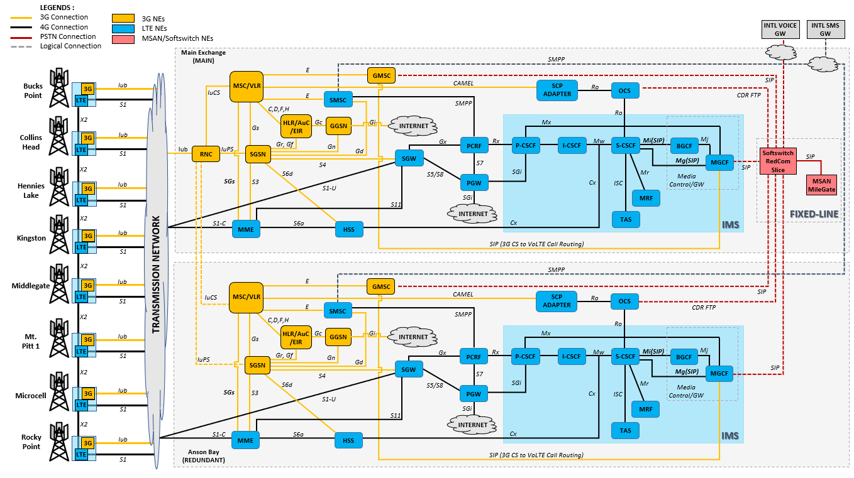

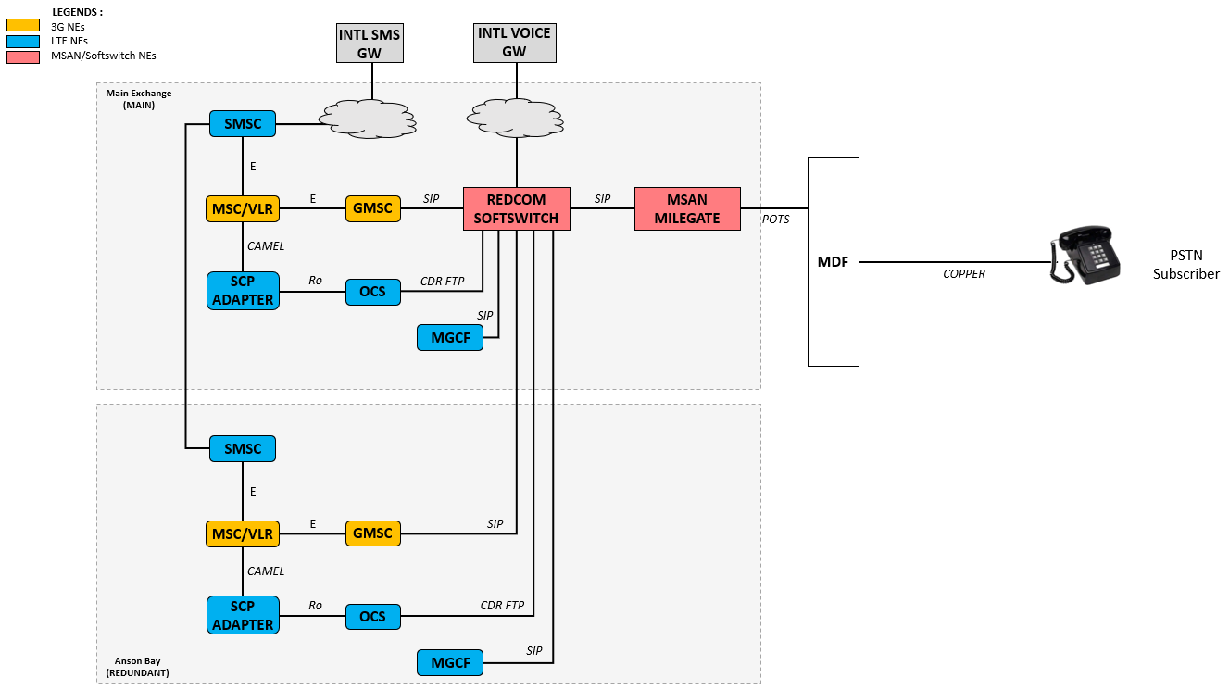
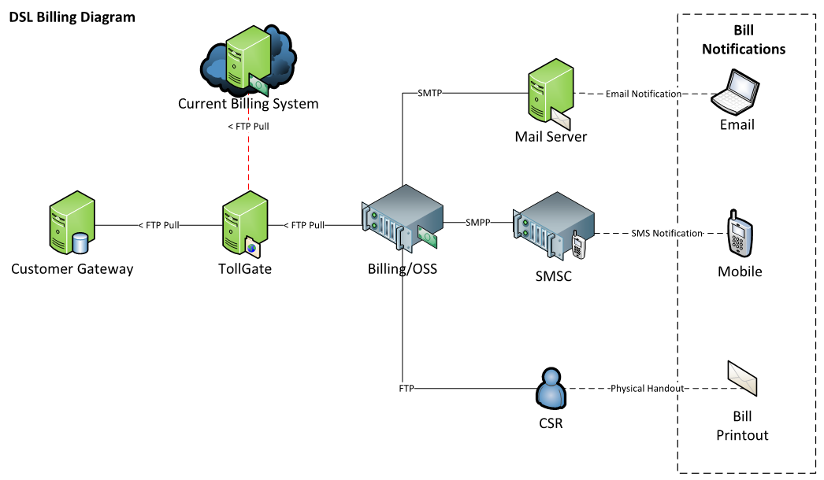

- Above image shows element integration for the Existing DSL billing. Different outputs can be expected for bill notification.

  - Power System
    - Procured Power Equipment
Power system intended for Puffa Site is under Huawei and is external cabinet rectifier system which will be reallocated for Anson Bay equipment. (Power + Cabinet (APM5930)

Power System (Eaton) | Model No | QTY
Main Exchange (Rectifier System for 18KW Load for the NEW EQUIPMENT)
DC Items
- 600*600*2000 Cabinet with 43U 19" rack space, blank panels, excluding | DV2-000-1711 | 1
battery shelves
- APS12-321 (with SC200 & IOB, +ve E), Ethernet Comms, Capable of | APS12-321 | 1
12*2kW rectifiers, Direct Feed DC Busbars, 400A LVD, 3P AC MCB
- 2kW 48Vdc high efficient rectifier, 9, expandable to 12 | APR48-ES | 9
- 1RU Rectifier blanks | RMB1U-00 | 3
- 3U 19" 12+12 DC Distribution 18mm 6-63 Amp capable | DCD3-310-07 | 2
- 18mm mcbs 6-63Amp, 24 per distribution | MCBs | 50
AC Inverter Items
- 1U 19" chassis for max 1 or 2*800 or 1200watt parallel inverters | INV-SS-2-1U | 1
- INVERTER INV-4810E, 1.0KVA, 48V, 240VAC, 2 per | INV-4810E | 2
- ACD,1.5U, 1x16A input, 1x16A output, up to 5 ways output, N&E Bar and Link [OP] | ACD15M-00 | 9
Remote Sites (Rectifier System + Batteries for 2KW Load for the NEW EQUIPMENT)
DC Items
- 600*600*1250 Cabinet with 2* batteries shelves, battery cables and 10RU 19" space | DV2-EBC2X-10 | 7
- APS3-321 (with SC200 & IOB, +ve E), Ethernet Comms, Capable of | APS3-321-6028 | 7
3* 2kW rectifiers, 2x125A Chint Batt MCB+aux with 200A LVD, 1 ph 3m
AC loom, 10* DC distribution 18mm combbus, excludes load MCBs
- 2kW 48Vdc high efficient rectifier, 1 per, expandable to 3 | APR48-ES | 7
- 18mm 6-63Amp, nominal 10 per APS3 | MCBs | 70
- Thin Plate Pure Lead AGM Battery 12V 150Ah, Leoch PLH150FT, Threaded | 993-01150-02 | 56
M8(T11) insert with M6 Front Terminal Adaptor - includes copper bar, 2 strings
at 48V per site=300ah=7hr@2kW load
AC Inverter Items
- 00W 48V to 230Vac inverter, modified sinewave, | ISI-500-248C | 8

    - Mains Tapping Requirement Dimension
Site | Mains AC MCB | Rectifier to Mains  Cable Length | Cable Size
Main Exchange | 2x 60A | 2x 20 M | AWG 6 (4mm)
Anson Bay | 2x 60A | 2x 20 M | AWG 6 (4mm)
Bucks Point | 1 x 15 A | 1 x 6 M | AWG 10 (2.5mm)
Collins Head | 1 x 15 A | 1 x 6 M | AWG 10 (2.5mm)
Middle Gate | 1 x 15 A | 1 x 6 M | AWG 10 (2.5mm)
Kingston | 1 x 15 A | 1 x 6 M | AWG 10 (2.5mm)
Rocky | 1 x 15 A | 1 x 6 M | AWG 10 (2.5mm)
Mt. Pitt | 1 x 15 A | 1 x 6 M | AWG 10 (2.5mm)
Hennies Lake | 1 x 15 A | 1 x 6 M | AWG 10 (2.5mm)

  - Transmission and IP Network
    - Mobile Network Site Connections
Site | Coming from | Switch | Fiber Back Haul | Fiber Ports needed | Ports Needed Copper
Bucks Point | Exchange | 2960 | 1 | 1 | 2
Collins Head | Exchange | 2960 | 1 | 1 | 2
Middle Gate | Exchange | 2960 | 1 | 1 | 2
Kingston | Exchange | 2960 | 1 | 1 | 2
Rocky Point | Exchange | 2960 | 1 | 1 | 2
Mt Pitt | Exchange | 2960 | 1 | 1 | 3
Hennies Lake | Air fiber to Anson via Mt Pitt Ubiquity | 2960 |  | 1 | 3
Main Exchange |  | 2x Nexus, 1x 3650 | N/A | 1 | 2

    - Transmission Network Diagram
Below diagram shows the latest changes discussed during workshop. All sites except for Hennies Lake (using Air Fibre via Mt. Pitt) will be having a direct fibre connection to Main Exchange
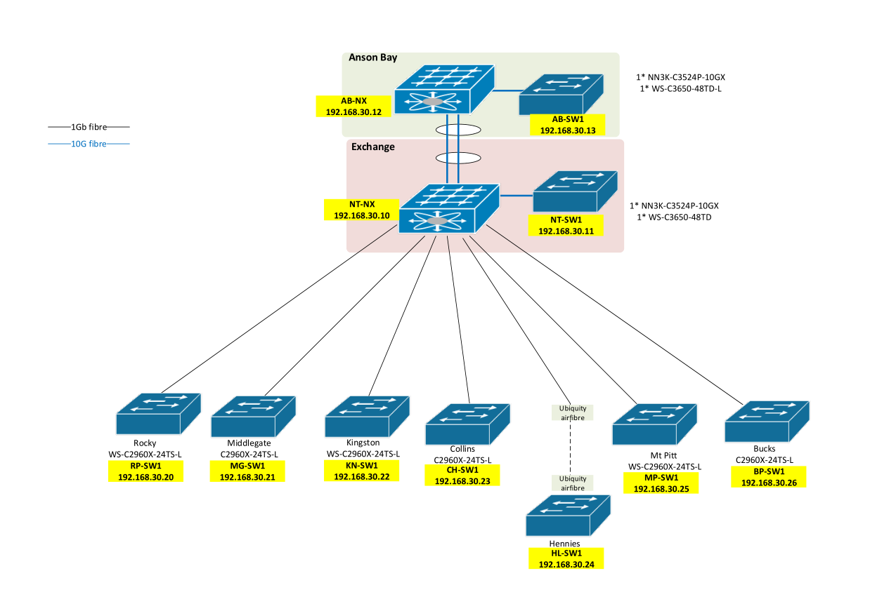

  - Fixed-Line Network
    - PSTN
This part will contain current subscriber information and description for PSTN to be provided by NT. This would be the Subscriber landline numbers mapped to Subscriber information (Name, Age, Address and whatever information is available)
** Any additional information needed from all parties will be discussed and provided accordingly and would reflect on handover documents.
- AXE Database subscriber was already provided via mail trail “Norfolk Redcom Minutes” with filename “Subscriber connected to AXE 090120.xlsx”
- Latest subscriber Details and mapping will be provided upon migration
- Below is the latest PSTN records provided by NT

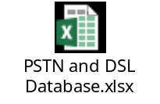

    - Existing DSL
This part will contain current subscriber information and description for the existing DSL to be provided by NT. (Contains circuit number mapped to subscriber information (Name, Age, Address and whatever information is available)
- Latest subscriber Details and mapping will be provided upon migration
- Object attached under 5.3.1 also contains current DSL subscriber database

Below is a sample existing DSL CDR with Header
Date(DD/MM/YYY) (HH:MM:SS) | Circuit No | DL (Bytes) | UL (Bytes)
02/12/2019 23:59:58 | IA001 | 867116626 | 148154003
02/12/2019 23:59:58 | IA003 | 0 | 0
02/12/2019 23:59:58 | IA004 | 138884608 | 148493312
02/12/2019 23:59:58 | IA010 | 165427046 | 14995639
02/12/2019 23:59:58 | IA011 | 405374697 | 47705338
02/12/2019 23:59:58 | IA012 | 572685876 | 49968841
02/12/2019 23:59:58 | IA013 | 0 | 0
02/12/2019 23:59:58 | IA015 | 63309592 | 5683800
02/12/2019 23:59:58 | IA016 | 561407896 | 69018888
02/12/2019 23:59:58 | IA019 | 237147776 | 12522339
02/12/2019 23:59:58 | IA020 | 53212785 | 7914622
02/12/2019 23:59:58 | IA022 | 115640762 | 10107725
02/12/2019 23:59:58 | IA023 | 106314 | 84915
02/12/2019 23:59:58 | IA025 | 326942253 | 664287797

  - Radio Access Network
    - Site List
Below is the Agreed Site List for RAN deployment
- Repeater location will be assessed and proposed by RF team after conducting a pre drive test once mobile sites is radiating.

Site | 4G | 3G | Sector | Notes
Main Exchange | Band 28 700 MHz | Band 8 900 MHz | 3
Bucks Point | Band 28 700 MHz | Band 8 900 MHz | 3
Collins Head | Band 28 700 MHz | Band 8 900 MHz | 3
Middle Gate | Band 28 700 MHz | Band 8 900 MHz | 3
Kingston | Band 28 700 MHz | Band 8 900 MHz | 3 | With TMA
Rocky | Band 28 700 MHz | Band 8 900 MHz | 3
Mt. Pitt | Band 28 700 MHz | Band 8 900 MHz | 3
Hennies Lake | Band 28 700 MHz | Band 8 900 MHz | 3

Technology | LTE 700 | WCDMA 900
Bandwidth | 20 MHz | 5 MHz
Band | 28 | 8
Number of Carriers | 1 | 1
Output Power per carrier | 2X40 (W) | 20 W

  - Core Network
- Below table shows acquired Core License.
No | Item | Sub License
1 | Evolved Packet Core EPC | 4500
2 | Home Subscriber Server HSS | 4500
3 | IMS (Redundant) with OTT App White label for NT | 4500
4 | SMSC (Redundant) | 4500
5 | VMS - | 4500
6 | 3G Core | 4500
7 | SGSN and GGSN for 3G Data (Redundant) | 4500

    - Core Summary of Information

Numbering Format | +6723 2XXXX | +6723 5XXXX
Numbering Format | Land Line | Mobile
SMSC | 672350020
Data APN 1 | NINET.NF
Data APN 2 | NT.internet
IMS APN | IMS
Network Name | Norfolk Telecom
Emergency Numbers | 911 | 955 | 922 | 955
Emergency Numbers | Emergency | Fire Station | Police | ERS
PLMN | 50510
MCC | 505
MNC | 10
Network Name | Norfolk Telecom

VOLTE Parameters
Name: | Contents:
IMS private user identity | IMSI@ims.mnc010.mcc505.3gppnetwork.org
Home Network Domain Name | ims.mnc010.mcc505.3gppnetwork.org
IMS public user identity | sip:IMSI@ims.mnc010.mcc505.3gppnetwork.org
IMSI Range (current)
IMSI Range Start: 505100100000001
IMSI Range End: 505100100023326
ICCID Range
8967210010000#####*F
where Z = last 7 digit of the IMSI
MSRN | 672359000 to 672359099

GT Information
No | Global Title | Example | To be used
1 | MSC | 672340001 | 50010
2 | SSF | 672340002
3 | VLR | 672340003 | 50010
4 | HLR | 672340004 | 50010
5 | AUC | 672340005 | 50010
6 | OCS | 672340006
7 | SMSC | 672350020 | 50020
8 | SGSN | 672340007

- BOSS System
  - CRM
    - User List
- This part will contain User List with Name, Email, Mobile No. Designation and Access Level (Admin/Operator/Viewer)
- We will implement default user hierarchy and can be populated upon request on real-time.
    - Subscriber Details
- This part will contain Subscriber details needed during on boarding for DSL, PSTN and Mobile Network (Prepaid and Post-paid). Subscriber information will be visible on CRM subscriber provisioning page where costumer info will be required. Some fields can be optional or compulsory.
- Out of the box configuration will be utilized, additional details needed can be added upon request
    - Spiels
Spiels can be subjected to change and configurable anytime. Below are the default spiels that can be utilized.
Action | Spiel Type | Actual Spiel
Welcome Email | Email | Dear [CUSTOMER NAME],  Welcome and thank you for subscribing to the fast and reliable 4G LTE.  Your Web Selfcare UserId is: [SERVICE ID] and password is [PASSWORD]. Please login through (Selfcare URL) or through your NT App to access your account.  To learn more about our exciting packages please call customer service at (NT Customer Care Number).  **This is a system generated message. Please do not reply to this email.**  Regards,  Norfolk Telecom
Welcome SMS | SMS | Welcome to the fast and reliable 4G LTE. Your Web Selfcare UserId is: [SERVICE ID] and password is [PASSWORD]. To access your account visit, (Selfcare URL) or your NT App. To learn more about our exciting packages please call customer care at (NT Customer Care Number).
Post Payment Email (Top-up) | Email | Dear [CUSTOMER NAME],  Your account [SERVICE ID] has been successfully credited with USD [AMOUNT]. Please login to your Selfcare account to know more details. To access your account visit (Selfcare URL) or login to your NT App.  **This is a system generated message. Please do not reply to this email.**  Regards,  Norfolk Telecom
Post Payment SMS (Top-up) | SMS | Payment of USD [AMOUNT] has been successfully credited into your account [SERVICE ID]. Please login to (Selfcare URL) or in your NT App to know more.
Paypal Payment Email (Top-up) | Email | Dear [CUSTOMER NAME],  Payment of [PAYMENTCURRENCY] [TOTAL] using PayPal has been successfully credited into your account [SERVICE ID]. Please login to your Selfcare account to know more details. To access your account visit (Selfcare URL) or login to your NT App.  **This is a system generated message. Please do not reply to this email.**  Regards,  Norfolk Telecom
Paypal Payment SMS (Top-up) | SMS | Payment of USD [TOTAL] has been successfully credited into your account [SERVICE ID] using PayPal. Please login to (Selfcare URL) or your NT App to know more.
Refill Email or Bundle Recharge  (Mobile) | Email | Dear [CUSTOMER NAME],  Your account [SERVICE ID] is successfully recharged with [BUNDLE NAME] which gives you [BENEFITS]. Your new account expiry date is [EXPIRY DATE]. Please login to (Selfcare URL) or your NT App to know more.  **This is a system generated message. Please do not reply to this email.**  Regards,  Norfolk Telecom
Refill SMS or Bundle Recharge  (Mobile) | SMS | Your account [SERVICE ID] is successfully recharged with [BUNDLE NAME]. Your new account expiry date is [EXPIRY DATE].
Event Call (Balance Inquiry) | SMS | Last Call Cost: USD [Charge]. Call Duration: [Charged Units]. Your Current Balance is USD [ACCOUNT BALANCE] expiring on [EXPIRY DATE].
Event SMS (Balance Inquiry) | SMS | Last SMS Cost: USD [Charge]. SMS Count:[Charged Units].Your Current Wallet Balance is USD [ACCOUNT BALANCE] expiring on [EXPIRY DATE].
Plan Expiry Reminder 3 Days Before Email  (Mobile) | Email | Dear [CUSTOMER NAME],  Thank you for choosing us as your trusted Internet Service Provider.  This notification is being shared as your account will expire within 3 days on [EXPIRY DATE].  To continue enjoying uninterrupted internet access, kindly Renew or Top-up your account at Self-Care via (Selfcare URL) or NT App.  Regards,  Norfolk Telecom
Plan Expiry Reminder 3 Days Before SMS  (Mobile) | SMS | Dear [CUSTOMER NAME],  Your NT account will expire in 3 days on [EXPIRY DATE]. Top-up to enjoy uninterrupted service.
Gift Credit Receiver Email  (Mobile) | Email | Dear [CUSTOMER NAME],  You just received a credit of USD [Balance Transferred] to your account [SERVICE ID] from [SENDER SERVICE ID].  **This is a system generated message. Please do not reply to this email.**  Regards,  Norfolk Telecom
Gift Credit Receiver SMS  (Mobile) | SMS | You just received a credit of USD [Balance Transferred] to your account [SERVICE ID] from [SENDER SERVICE ID].
Gift Credit Sender Email  (Mobile) | Email | Dear [CUSTOMER NAME],  You just sent a credit of USD [Balance Transferred] from your account [SERVICE ID] to [RECIEVER SERVICE ID].  **This is a system generated message. Please do not reply to this email.**  Regards,  Norfolk Telecom
Gift Credit Sender SMS  (Mobile) | SMS | You just sent USD [Balance Transferred] credit to [RECIEVER SERVICE ID] from your account [SERVICE ID].
Email Send Invoice  (PSTN and ADSL) | Email | Dear [CUSTOMER NAME],  Your NT bill dated [BILLCREATEDATE] is USD[BILLAMOUNT] & payment due-date is [BILLDUEDATE]. Please visit self-care to see your detailed invoice.  **This is a system generated message. Please do not reply to this email.**  Regards,  Norfolk Telecom
Email Send Invoice  (PSTN and ADSL) | SMS | Dear [CUSTOMER NAME], your NT bill dated [BILLCREATEDATE] is USD [BILLAMOUNT] & payment due-date is [BILLDUEDATE].
Payment Advisory | SMS | ** Kelly to provide **
Payment Advisory | Email | ** Kelly to provide **
Email 100  (Mobile) | Email | Dear [CUSTOMER NAME],  Thank you for choosing us as your trusted Internet Service Provider.  This notification is being shared as you have reached 100% of your [PLAN NAME] plan data Limit as of today.  Your access to internet shall be affected upon 100% usage of data limit of subscribed data plan.  To continue enjoying uninterrupted internet access, kindly Renew or Top-up your account at Self-Care or visit nearest retail outlet.  Thanks and regards,  Norfolk Telecom
SMS 100  (Mobile) | SMS | Dear Customer, you have consumed 100% of you allocated Quota. Thank You, Norfolk Telecom
Email 75  (Mobile) | Email | Dear [CUSTOMER NAME],  Thank you for choosing us as your trusted Internet Service Provider.  This notification is being shared as you have reached 75% of your [PLAN NAME] plan data Limit as of today.  Your access to internet shall be affected upon 75% usage of data limit of subscribed data plan.  To continue enjoying uninterrupted internet access, kindly Renew or Top-up your account at Self-Care or visit nearest retail outlet.  Thanks and regards,  Norfolk Telecom
SMS 75  (Mobile) | Email | Dear Customer, you have consumed 75% of you allocated Quota. Thank You, Norfolk Telecom
Roaming Welcome Message | SMS | Welcome to Norfolk Telecom Roaming Services.
Insufficient Balance | SMS | You have insufficient funds to complete this transaction.
CRM Ticketing Alert | Email | Hello Team,  New ticket from one of the customer has been assigned to you. Please check the same in CRM Ticketing Portal. Thanks  Regards,  Norfolk Telecom
Send System User OTP Email  (CRM Users) | Email | Dear [CRM USER NAME],  you are trying to log in from [LOGINIP] on [LOGINDATE],  OTP for login to system is [OTP]
Send System User OTP SMS  (CRM Users) | SMS | Dear [CRM USER NAME],  you are trying to log in from [LOGINIP] on [LOGINDATE],  OTP for login to system is [OTP]

*Below are NIRC provided spiels. (Default spiel will be secondary reference in any case its not available in below document)
Action | Spiel Type | Actual Spiel
Welcome Message ( for New Subscriber) | SMS | Welcome to Norfolk Telecom Mobile Network. Please activate your service via Web Self-Care, the Mobile Self-Care App or by visiting Norfolk Telecom Customer Care
Top-up | SMS | Thank you for topping up your Norfolk Telecom service.  (Comment: Will there be a different messages per service or is the message generic – This can be a generic spiel with changing values based on topup value benefit and expiry)
Action | Spiel Type | Actual Spiel
Bundle Purchase | SMS | Thank you for purchasing Norfolk Telecom’s xxx Bundle
Balance Inquiry | SMS | Your current balance is xxx dollars and xxx cents.
Bundle Expiry | SMS | Your current xxx bundle expires in xxx days.
Bill Notification | SMS
Bill Notification | Email
Payment Advisory | SMS
Payment Advisory | Email
Service/Plan Expiry | SMS | Your Service/Plan expires in xxx days. Please top-up via Web Self-Care, the Mobile Self-Care App or by visiting Norfolk Telecom Customer Care
Roaming Welcome Message | SMS | Welcome to Norfolk Telecom Roaming Services.
Insufficient Balance | SMS | You have insufficient funds to complete this transaction.

  - Ticketing
Fill in ticketing recipient’s details. This will be the mailing list where different fault is sorted and sent to respective domain when a ticket is triggered by Customer Care based on customer complaints.
- This is the mailing list between CSR and Backend support (Tech, Finance , Operations) Customer concerns from CSR will be mailed to respective Domain. Mails can be added on Demand
Recipient Email | Fault Type
support@telecom.gov.nf | ADSL Fault
support@telecom.gov.nf | PSTN Fault
support@telecom.gov.nf | Mobile Fault
support@telecom.gov.nf | General ADSL
support@telecom.gov.nf | General PSTN
support@telecom.gov.nf | General Mobile
support@telecom.gov.nf | New Service ADSL
support@telecom.gov.nf | New Service PSTN
support@telecom.gov.nf | New Service Mobile
support@telecom.gov.nf | Billing Issues
support@telecom.gov.nf | Change Customer
support@telecom.gov.nf | Modify Equipment ADSL
support@telecom.gov.nf | Modify Equipment PSTN
support@telecom.gov.nf | Modify Equipment Mobile
support@telecom.gov.nf | Modify Service ADSL
support@telecom.gov.nf | Modify Service PSTN
support@telecom.gov.nf | Modify Service Mobile
support@telecom.gov.nf | Terminate Service ADSL
support@telecom.gov.nf | Terminate Service PSTN
support@telecom.gov.nf | Transfer Service ADSL
support@telecom.gov.nf | Transfer Service PSTN
support@telecom.gov.nf | Change Plan

  - Billing
- Prepaid and Post-paid service for Mobile Network
- Post-paid Service for Existing DSL and PSTN
- Out of the box capability of single balance (Account Balance – no wallet balance)
- Multiple Service on a single invoice is required. (Example: DSL and PSTN on a single subscriber invoice)

    - Asset Details
No. | Asset | Description
1 | Pay as You Go | Standard credit deduction based on service usage for data (per Mb), Call (per Min) and SMS (per send)
2 | Happy Hours | Usage discounts for certain hours
3 | My Special Day | Personal rewards based on profile info ( ex: birthday, onboard anniversary)
4 | Promotional Days | Automated global discounts based on holidays
5 | Data Pass | Bulk data offering
6 | Monthly Data Allowance | Available for postpaid only. Capped Data per month
7 | Monthly Data Allowance with Rollover | Carryover of unused data over the next usage cycle
8 | Add-on Data Allowance | Data volume add-on when current subscription is exhausted
9 | Monthly Shared Data Allowance | Available for Postpaid only. Can be used for Family Plan

    - Subscriber Lifecycle

Mobile Prepaid
No | Action | Tourist SIM Days | Local SIM Days
1 | Days allowed from day one of activation without any activity | 21 | 180 (6Mo)
2 | Days of extension from date of Top-up | N/A | 180 (6Mo)
3 | Days of Extension from date of Bundle/Add-on Purchase | N/A | 30
4 | Days allowed between suspend state and disabling service | N/A | 30
5 | Days allowed between disabled state and recycling account to pool | N/A | 30

Postpaid Service
No | Action | Days
1 | Charging type on initial onboarding | * Discussed prorated with total days used. Please advise if any change
2 | Grace period from non-payment on bill cutoff | 30
3 | Days of extension between barred service due to non-payment to suspend state | 30
4 | Days allowed between suspend state and deactivating the service for new application | 30

    - Plans and Bundles
Below is the received Plans and bundles from Norfolk Telecom. Should there be no updates on current configuration, reference below will be used as an initial setup.
Norfolk Telecom Plans & Add-ons
Other Prices
 | SIM Only for A$ 10
 | Replacement SIM fo A$ 5
Pay as you Go (PYG) Rate
 | Mobile to Mobile Call per Mins = A$ 0.55
 | Mobile to IDD Call (AUS & NZ) per Mins = A$ 0.90
 | Mobile to IDD Call (Rest of World) = A$ 1.15
 | Mobile to Mobile Local SMS = A$ 0.14
 | Mobile to Mobile International SMS = A$ 0.40
 | *No PYG for Data on Mobile Services
 | Mobile to Landline Call per Mins= A$ 0.55
 | Landline to Landline per Call (Fixed Calls) = A$ 0.23
 | Landline to Mobile Call per Mins= A$ 0.55
MOBILE NETWORK
 | PLAN
 |  | VISITOR PREPAID MOBILE PLAN |  |  | REMARKS
 |  | 1. | Tourist Mobile SIM
 |  |  | Total Price is A$ 30
 |  |  | *this include SIM card cost of A$ 10
 |  |  | *SIM validity is 21 days
 |  |  | *no change on SIM validity upon topup or add-on purchase
 |  |  |  | Initial Benefit upon SIM activation
 |  |  |  | 2GB Data, 25 Landline Mins, 0 Fixed Calls, 25 Mobile Mins, 5 IDD Mins (AUS & NZ) , 100 Local SMS and 0 International SMS
 |  |  |  | Bundle
 |  |  |  | No bundle available
 |  |  |  | Add-On
 |  |  |  | 2 GB Data for A$ 20
 |  |  |  | 25 IDD Mins (AUS & NZ) for A$ 10 | Rest of the world will be charge on a PYG Rate (A$ 1.15)
 |  |  |  | Pay as you Go (PYG) Rate | No PYG for Data
 |  |  |  | to Landline Call per Mins= A$ 0.55
 |  |  |  | to Mobile Call per Mins = A$ 0.55
 |  |  |  | to IDD Call (AUS & NZ) per Mins = A$ 0.90
 |  |  |  | to Mobile Local SMS = A$ 0.14
 |  |  |  | *to IDD - Rest of World (per min) = A$ 1.15
 |  |  |  | *to SMS - International (per message) = A$ 0.40
 |  | LOCAL PREPAID MOBILE PLAN |  |  | REMARKS
 |  | 1. | SIM only & $10 credit Prepaid
 |  |  | Total Price is A$ 20 ( Sim + A$10 credit)
 |  |  |  | Bundle
 |  |  |  | A .Consumer Mobile - Standard Prepaid
 |  |  |  | Total Price is A$ 40
 |  |  |  | *bundle validity is 30 days
 |  |  |  | 2GB Data, 0 Landline Mins, 0 Fixed Calls, 200 Mobile Mins, 0 IDD Mins (AUS & NZ) , 200 Local SMS and 0 International SMS
 |  |  |  | B .Consumer Mobile - Large Prepaid
 |  |  |  | Total Price is A$ 70
 |  |  |  | *bundle validity is 30 days
 |  |  |  | 4GB Data, 0 Landline Mins, 0 Fixed Calls, 300 Mobile Mins, 0 IDD Mins (AUS & NZ) , 300 Local SMS and 0 International SMS
 |  |  |  | C. Consumer Mobile - XL Prepaid
 |  |  |  | Total Price is A$ 100
 |  |  |  | *bundle validity is 30 days
 |  |  |  | 8GB Data, 0 Landline Mins, 0 Fixed Calls, 500 Mobile Mins, 0 IDD Mins (AUS & NZ) , 500 Local SMS and 0 International SMS
 |  |  |  | Add-On
 |  |  |  | "Data Add-on 2" offer 2 GB Data for A$ 20 with 30 Days
 |  |  |  | "Data Add-on 4" offer 4 GB Data for A$ 50 with 30 Days
 |  |  |  | "Data Add-on 8" offer 8 GB Data for A$ 80 with 30 Days
 |  |  |  | "IDD (Aus & NZ) - Add-on 1" offer 20 IDD Mins (AUS & NZ) for A$ 10 | Rest of the world will be charge on a PYG Rate (A$ 1.15)
 |  |  |  | "IDD (Aus & NZ) - Add-on 2" offer 100 IDD Mins (AUS & NZ) for A$ 30 | Rest of the world will be charge on a PYG Rate (A$ 1.15)
 |  |  |  | Pay as you Go (PYG) Rate | No PYG for Data
 |  |  |  | to Landline Call per Mins= A$ 0.55
 |  |  |  | to Mobile Call per Mins = A$ 0.55
 |  |  |  | to IDD Call (AUS & NZ) per Mins = A$ .90
 |  |  |  | to Mobile Local SMS = A$ 0.14
 |  |  |  | *to IDD - Rest of World (per min) = A$ 1.15
 |  |  |  | *to SMS - International (per message) = A$ 0.40
 |  | LOCAL PREPAID DATA ONLY MOBILE PLAN |  |  | REMARKS
 |  | 1. | Consumer Mobile - Data Only Prepaid
 |  |  | Total Price is A$ 20 ( Sim + A$10 credit) |  | for tablet, dongle, MiFi  6 Months Sim Validity
 |  |  |  | Add-On
 |  |  |  | "Data Add-on 2" offer 2 GB Data for A$ 20 | 30 Days Add-on Validity
 |  |  |  | "Data Add-on 4" offer 4 GB Data for A$ 50 | 30 Days Add-on Validity
 |  |  |  | "Data Add-on 8" offer 8 GB Data for A$ 80 | 30 Days Add-on Validity
FIXLINE PSTN
 | PLAN
 |  | LOCAL POSTPAID PSTN PLAN |  |  | REMARKS
 |  | 1. | Consumer Fixed - Standard
 |  |  | Total Price is A$ 25 - Monthly Service charge |  | include line rental; billed per call not min
 |  |  | Plan billing period is 30 days
 |  |  |  | Plan Benefit
 |  |  |  | 200 Calls per Month
 |  |  |  | Bundle
 |  |  |  | Bundle not applicable
 |  |  |  | Add-On
 |  |  |  | Add- on not applicable
 |  |  |  | Out of Bunble Rate upon benefit exhaustion
 |  |  |  | to Mobile Call per Mins= A$ 0.55
 |  |  |  | to IDD Call (AUS & NZ) per Mins = A$ .90
 |  |  |  | *to IDD - Rest of World (per min) = A$ 1.15
 |  |  |  | *per Fixed Calls = A$ 0.23
 |  | 2. | Business Fixed - Standard
 |  |  | Total Price is A$ 50 - - Monthly Service charge |  | include line rental; billed per call not min
 |  |  | Plan billing period is 30 days
 |  |  |  | Plan Benefit
 |  |  |  | 300 Calls per Month
 |  |  |  | Bundle
 |  |  |  | Bundle not applicable
 |  |  |  | Add-On
 |  |  |  | Add-on not applicable
 |  |  |  | Out of Bunble Rate upon benefit exhaustion
 |  |  |  | to Mobile Call per Mins= A$ 0.55
 |  |  |  | to IDD Call (AUS & NZ) per Mins = A$ .90
 |  |  |  | *to IDD - Rest of World (per min) = A$ 1.15
 |  |  |  | *per Fixed Calls = A$ 0.23
FIXLINE DSL
 | PLAN
 |  | PREPAID FIXED DATA PLANS |  |  | REMARKS
 |  | 1. | Fixed Data - Starter
 |  |  | Total Price is A$ 10 - Monthly Service charge |  | Either ADSL or FWA ; Current ADSL plan - to be changed
 |  |  |  | Monthly Benefit:
5 GB Data - with one-month rollover
20 GB free Data during off peak (12 AM – 5 AM)
 |  |  |  | Add-On
 |  |  |  | Add-on not applicable
 |  |  |  | Out of bundle Rate (used on benefit exhaustion)
 |  |  |  | A$ 5 per GB or equivalent ratio on per MB Pulse | Per MB pulse Rate
 |  | 2. | Fixed Data - Standard
 |  |  | Total Price is A$ 30 - Monthly Service charge |  | Either ADSL or FWA ; Current ADSL plan - to be changed
 |  |  |  | Monthly Benefit:
20 GB Data - with one month rollover
60 GB free Data during off peak (12 AM – 5 AM)
 |  |  |  | Add-On
 |  |  |  | Add- on not applicable
 |  |  |  | Out of bundle Rate (used on benefit exhaustion)
 |  |  |  | A$ 4 per GB or equivalent ratio on per MB Pulse | Per MB pulse Rate
 |  | 3. | Fixed Data - Large
 |  |  | Total Price is A$ 50 -- Monthly Service charge |  | Either ADSL or FWA ; Current ADSL plan - to be changed
 |  |  |  | Monthly Benefit:
50 GB Data - with one month rollover
Free Data Access during off peak (12 AM – 5 AM)
 |  |  |  | Add-On
 |  |  |  | Add- on not applicable
 |  |  |  | Out of bundle Rate (used on benefit exhaustion)
 |  |  |  | A$ 3.5 per GB or equivalent ratio on per MB Pulse | Per MB pulse Rate
 |  | 4. | Fixed Data - XL
 |  |  | Total Price is A$ 90 --- Monthly Service charge |  | Either ADSL or FWA ; Current ADSL plan - to be changed
 |  |  |  | Monthly Benefit:
90 GB Data - with one month rollover
Free Data Access during off peak (12 AM – 5 AM)
 |  |  |  | Add-On
 |  |  |  | Add- on not applicable
 |  |  |  | Out of bundle Rate (used on benefit exhaustion)
 |  |  |  | A$ 3 per GB or equivalent ratio on per MB Pulse | Per MB pulse Rate
 |  | 5. | Fixed Data - Jumbo
 |  |  | Total Price is A$ 180 --- Monthly Service charge |  | Either ADSL or FWA ; Current ADSL plan - to be changed
 |  |  |  | Monthly Benefit:
180 GB Data - with one-month rollover
Free Data Access during off peak (12 AM – 5 AM)
 |  |  |  | Add-On
 |  |  |  | Add- on not applicable
 |  |  |  | Out of bundle Rate (used on benefit exhaustion)
 |  |  |  | A$ 2 per GB or equivalent ratio on per MB Pulse | Per MB pulse Rate

COMMENTS:
1. No peak / off-peak times for standard price plans on Mobile (keep things simple); however, use of promotions will help boost usage during non-busy-hour periods
2. No sharing of data among different users for standard price plans (keep things simple)
3. Any unused data allocation will roll-over for 1 month
5. NT to offer businesses the same mobile plans as consumer (2, 3, 4, 5) because Business segment on Norfolk is so small
6. Since all mobile subscriptions are currently prepaid, NT management should consider keeping as many pre-paid as possible as this simplifies the business (and zero bad debt)
7. Having a single Tourist SIM Plan will keep things simple and maximize the chances of tourists buying the service
8. All existing mobile customers will be offered a free swap 4G SIM prior to commercial launch of the new service (timing and implementation to be discussed)
9. No International SMS in plans - thinking was that with the data allowance in the tourist plan visitors would use a messaging app or email to communicate in non-verbal manner back home.
10. 99% of tourists are from AUS/NZ and so a) there should be more demand for those destinations than others and b) they would normally be cheaper than other destinations
11. Post Paid - we can a few exceptions such as alarm systems using SMS should be a low risk as they won’t be able to run up large voice bills.

    - Tariff Rates
Below details shows the current tariff rates of Norfolk Telecom for reference. Any information needed that are not visible from above plans and bundles will be sourced out from below data.
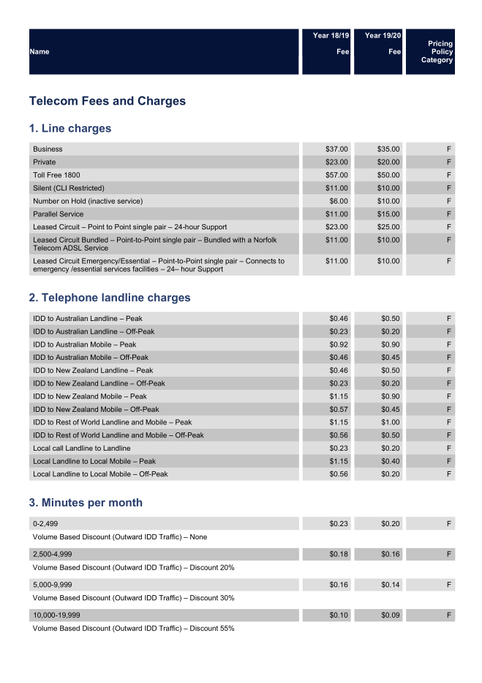
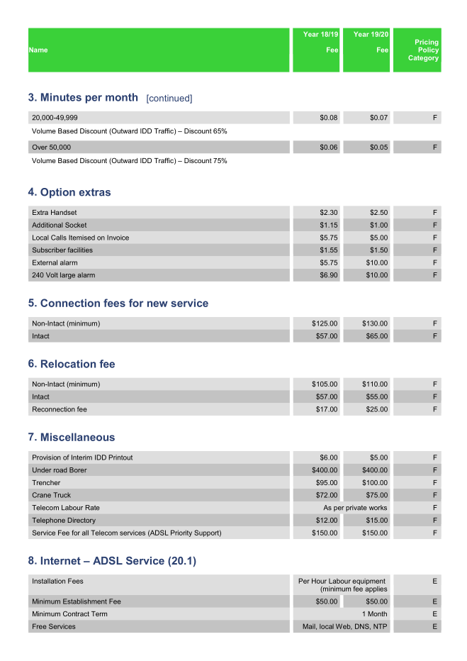
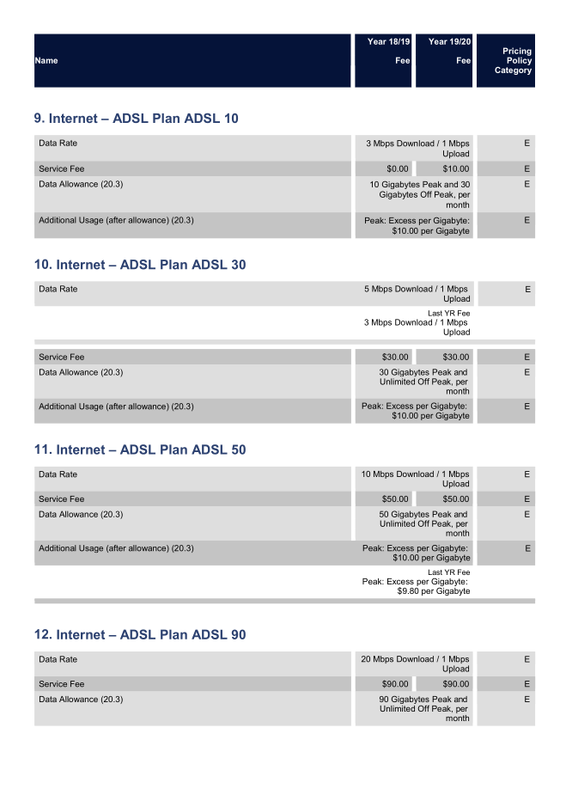
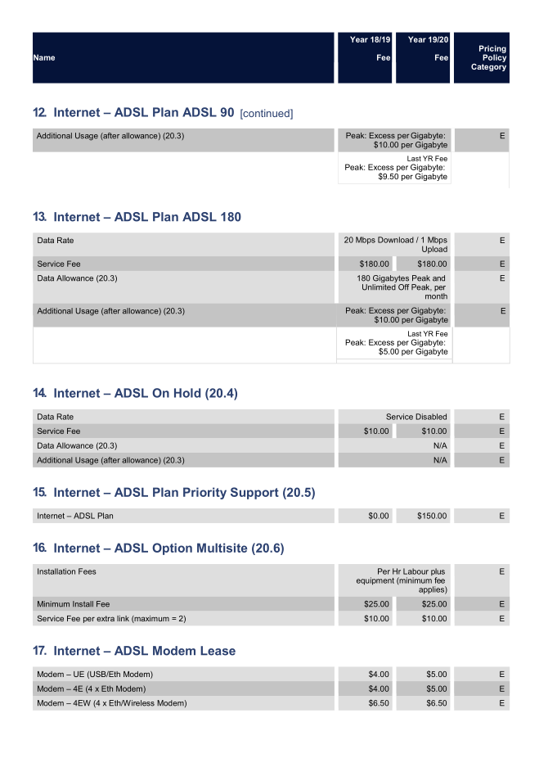
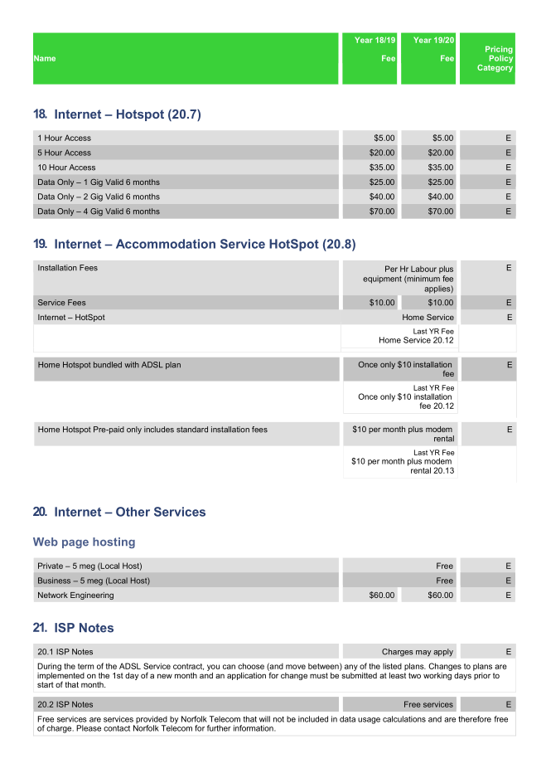
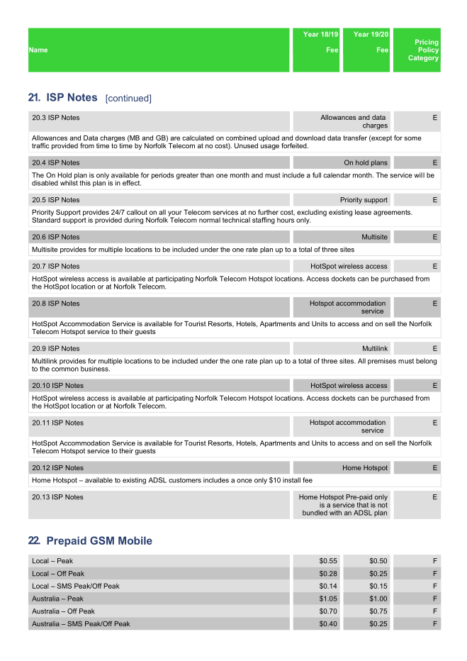
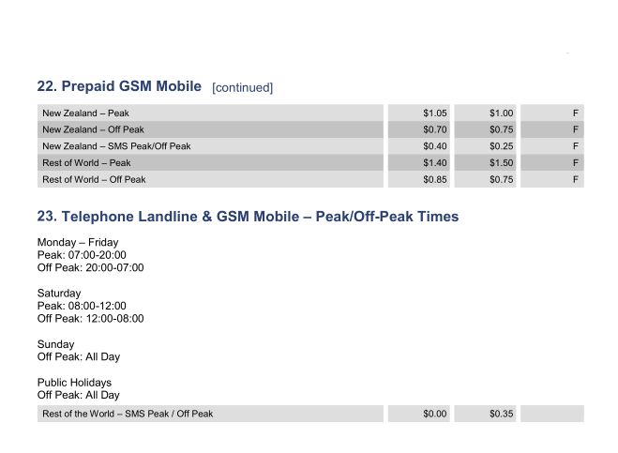

    - Bill Information
Below are invoice copies for the current postpaid service. Current Design will be adopted on the new billing system with pointers below:
    - Considerations
a. ABN number. is Static
b. Single subscriber can have multiple service in a single invoice with offering below:
*Phone
*ADSL
*LeasedCirc
c. CR means Credited Payments
d. A onetime billable items that are manually charged should be visible in invoice (Ex: Modem, handset...)
e. Recurring fees are present in invoice.
f. All transaction records are displayed on the invoice.

Notes:
Examples to look for on the invoices are as follows:

- PSTN rental Charges Private/business and rental period (Future month)
- IDD data captured
- ITF (Inward Toll Free) calls
- Calls made to AUD NZ (Landline & Mobile) & rest of world from landline
- Landline data captured
- Calls made to local mobiles duration and cost
- Number of Landline to Landline calls and duration for Current month
- Rental for PABX systems (manually entered as the price varies)
- Rental & Charges for features
- Call Div immediate
- Call Div Busy
- Additional handset
- ADSL & Modem Rental for future month (wireless & Fixed Modems)
- ADSL Excess charges for the current month.
- Dark Fibre
- Silent Rental charges
- Invoice & Payment details for previous month
- Previous balance
- Receipt/refund
- Invoice/Credit notes
- Other adjustments
- Balance
- Total of this invoice
- Total due now

Sample New Invoice

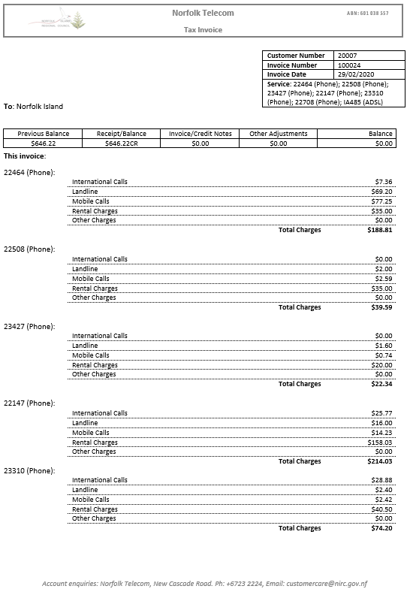

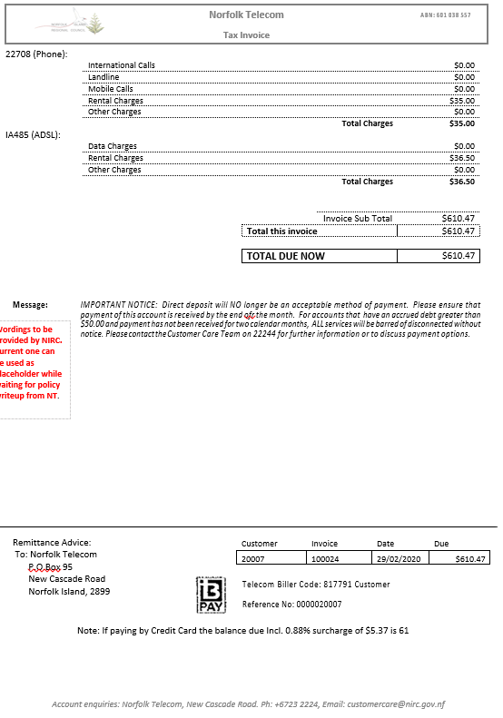

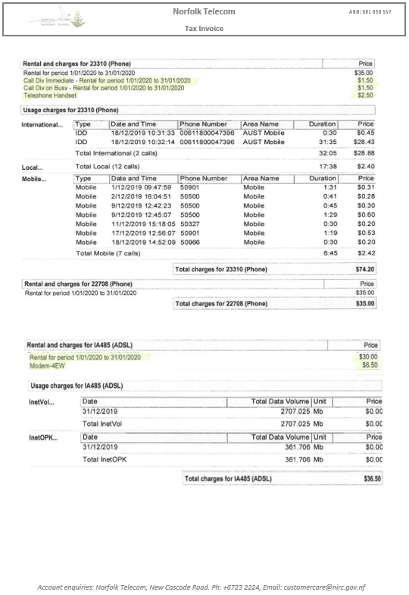

Sample Old Invoice 1
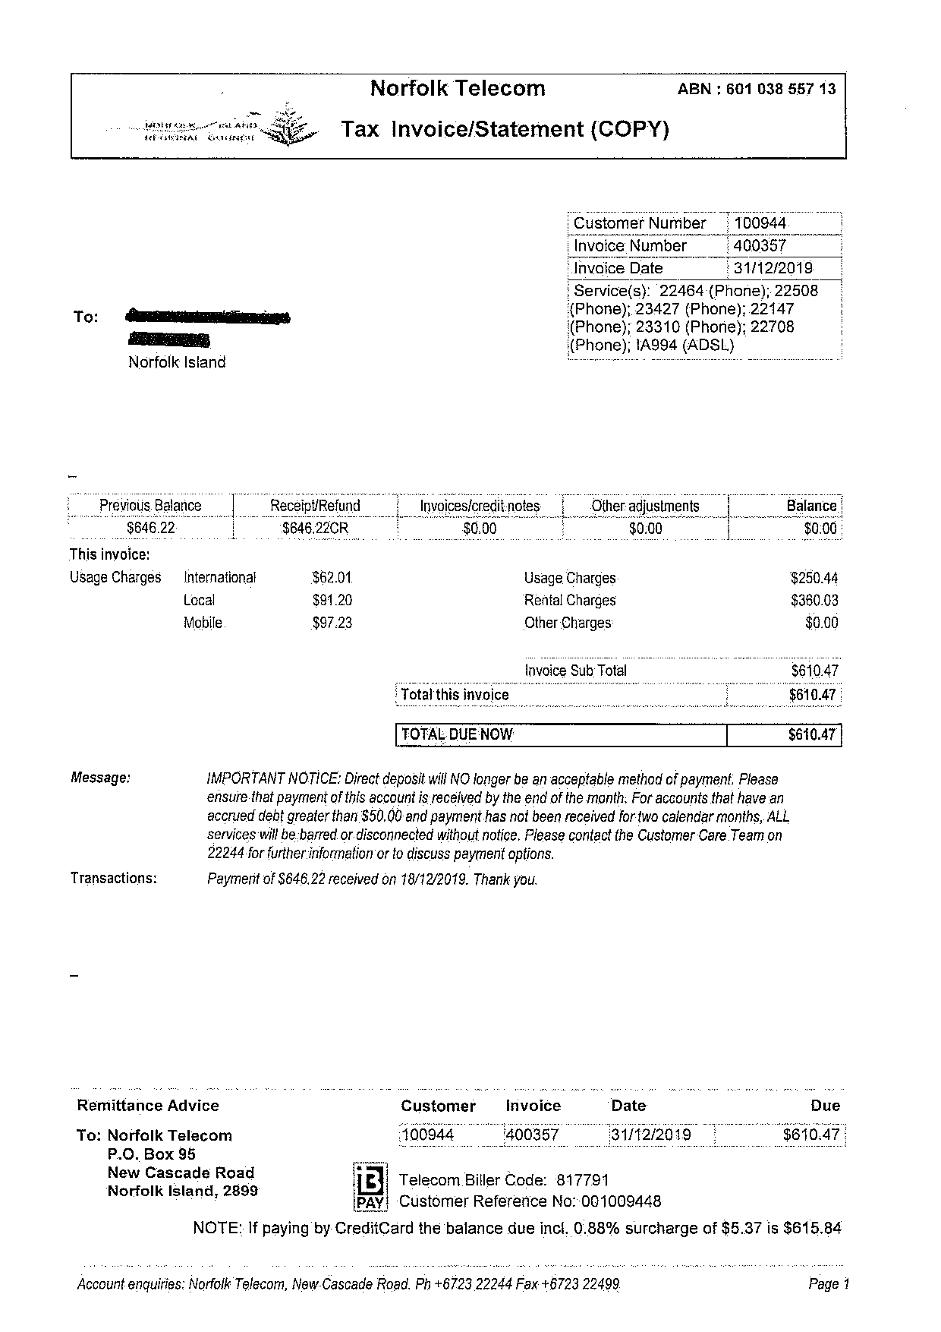

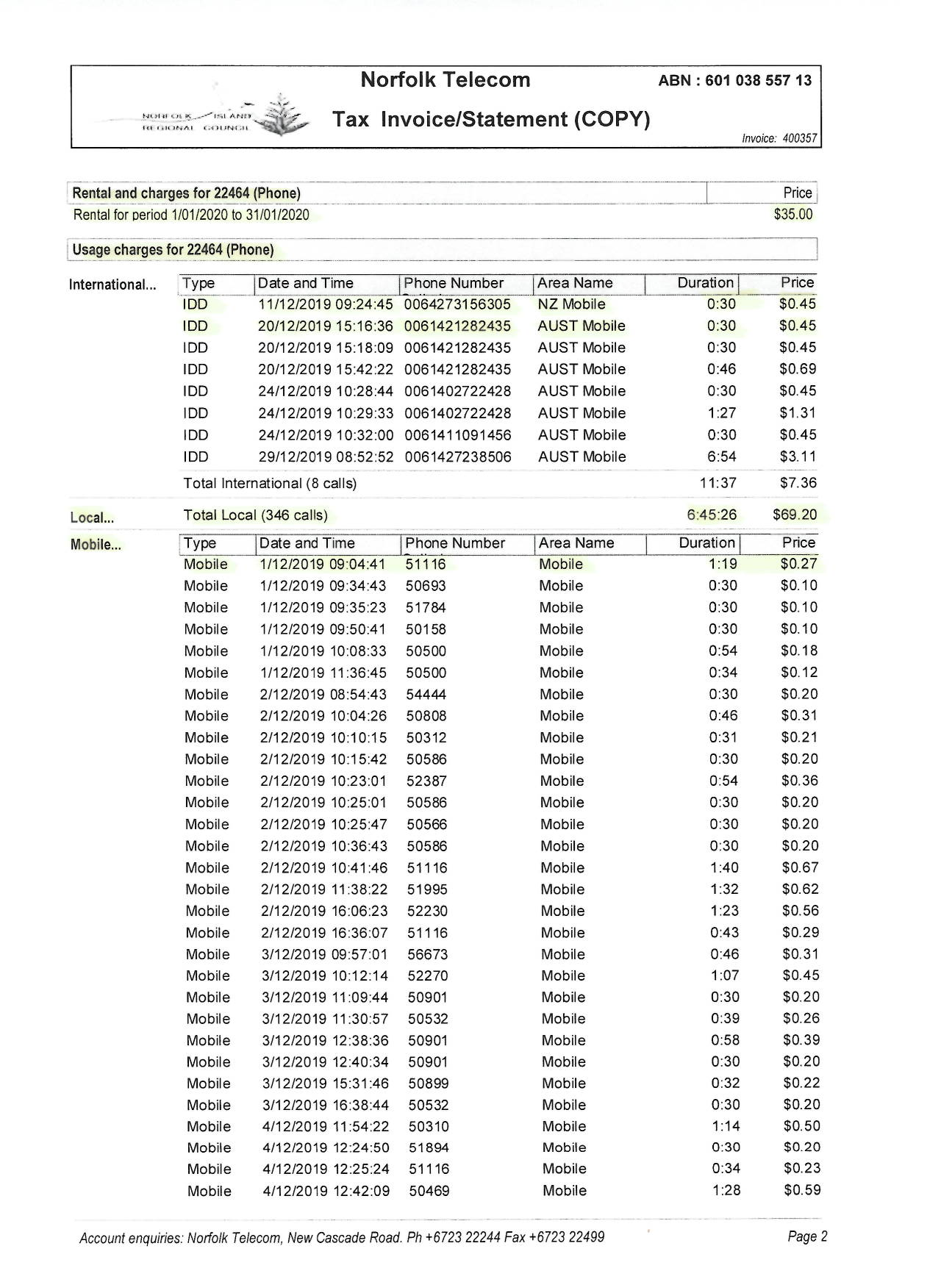

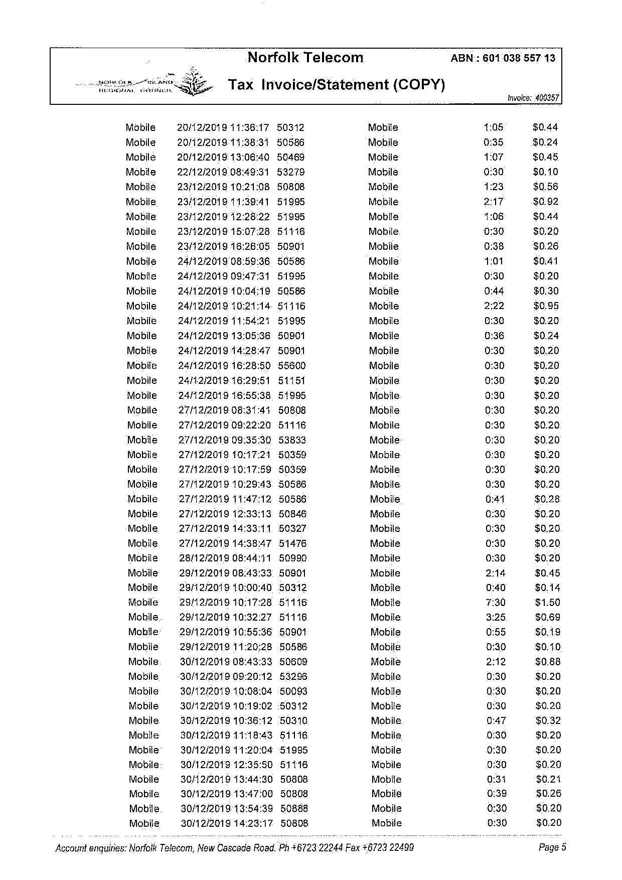

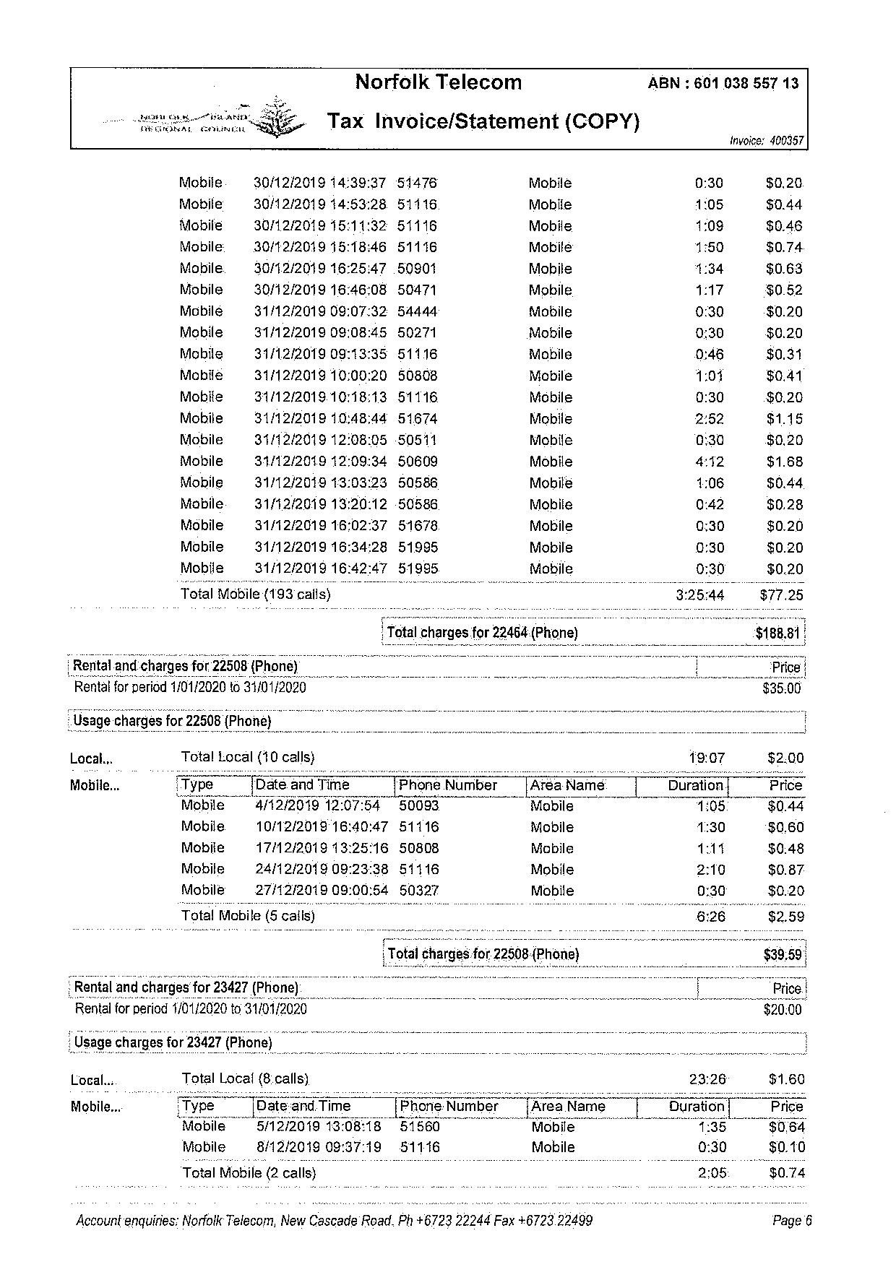

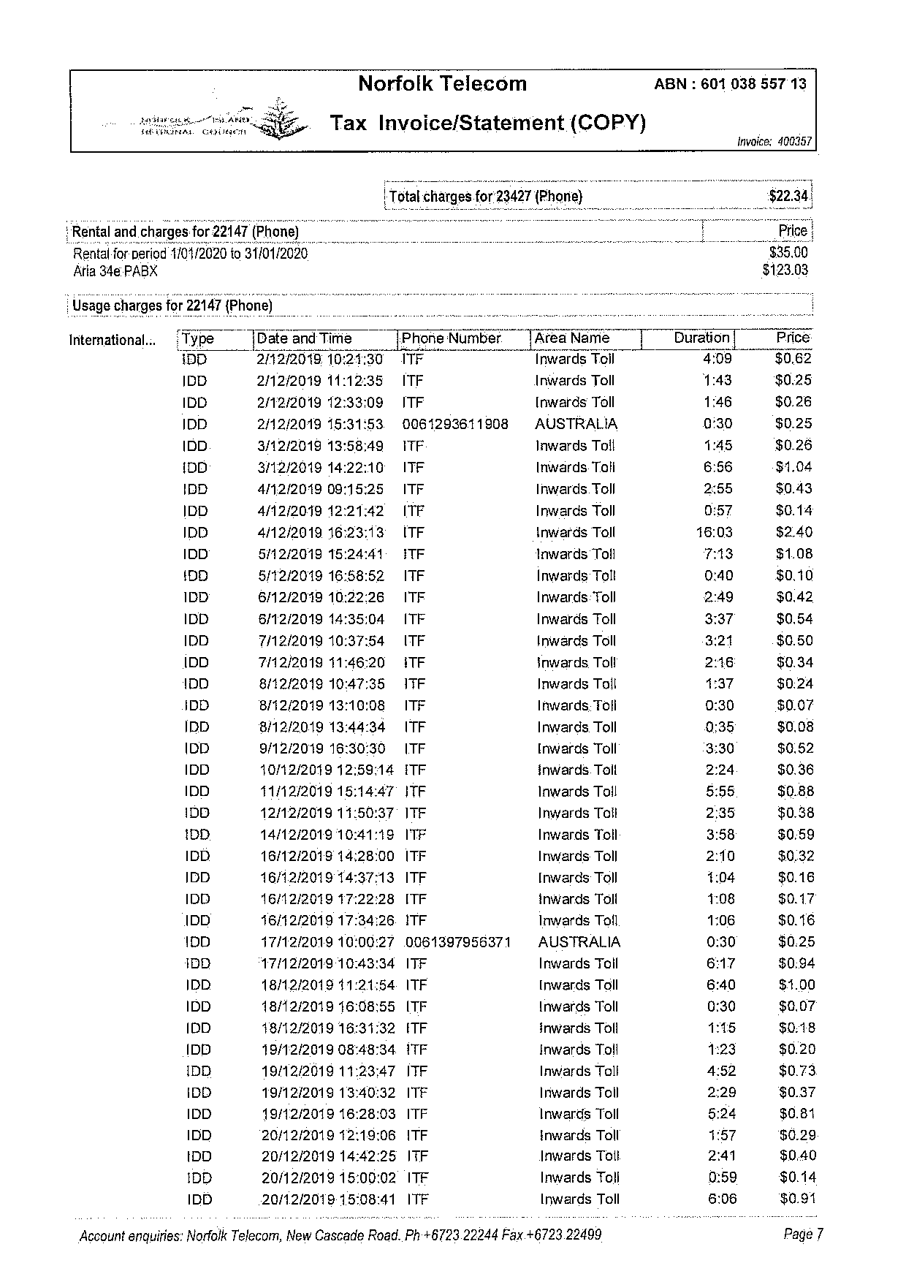

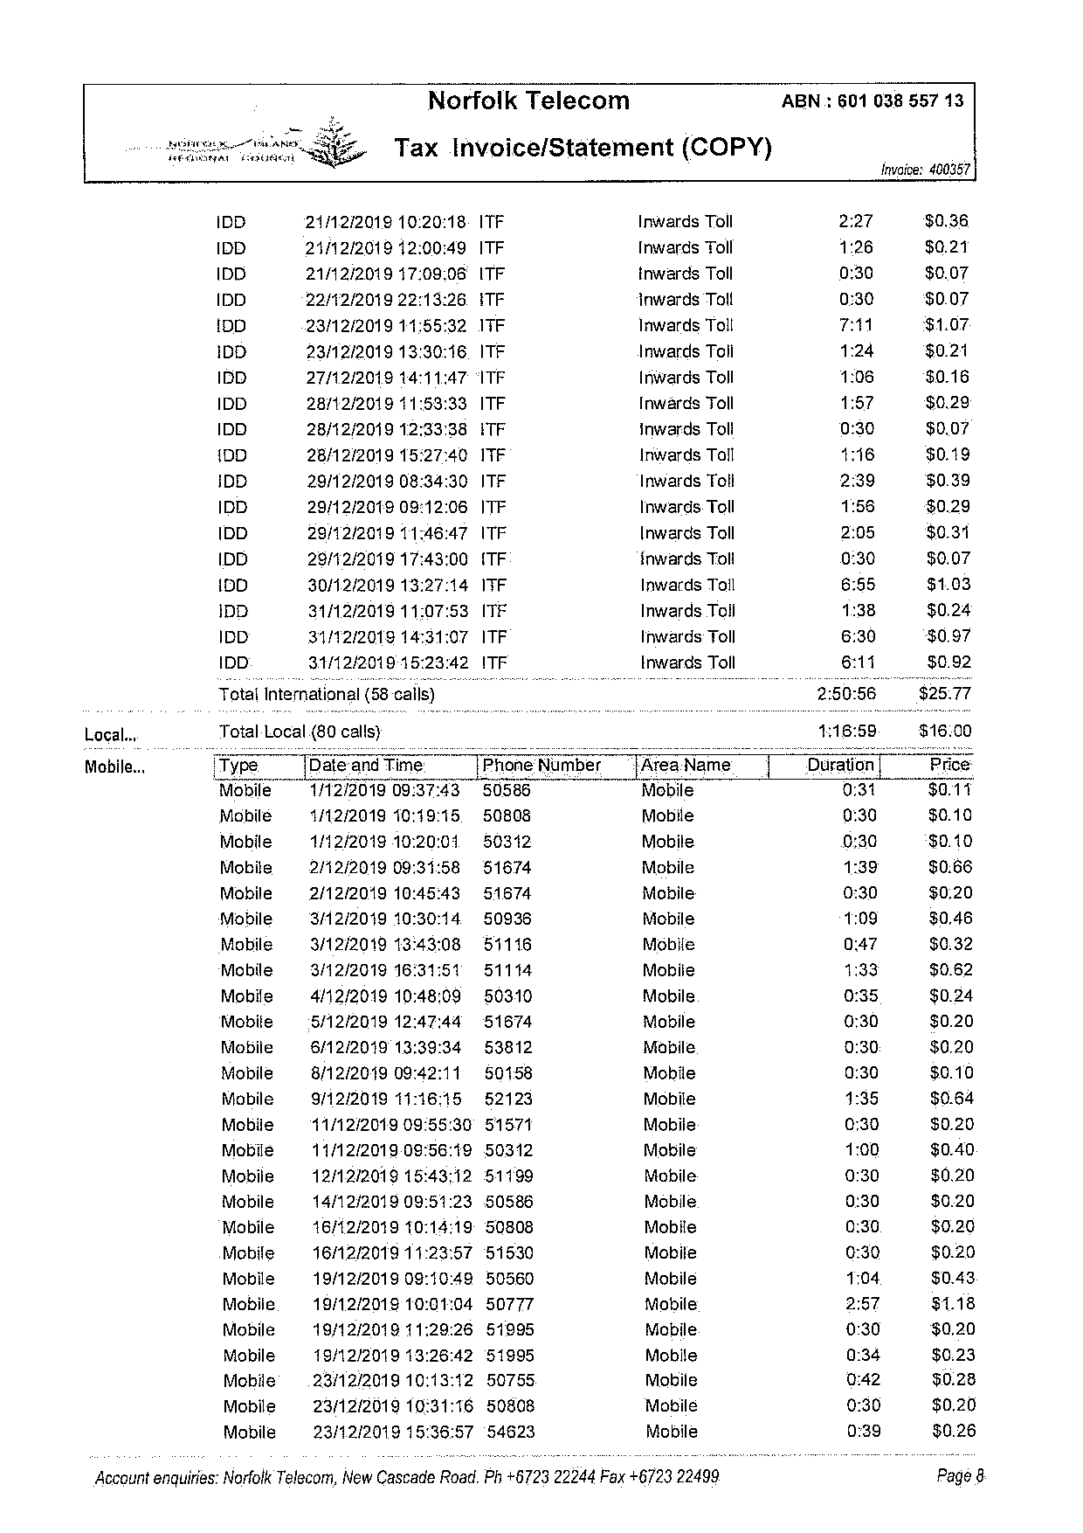
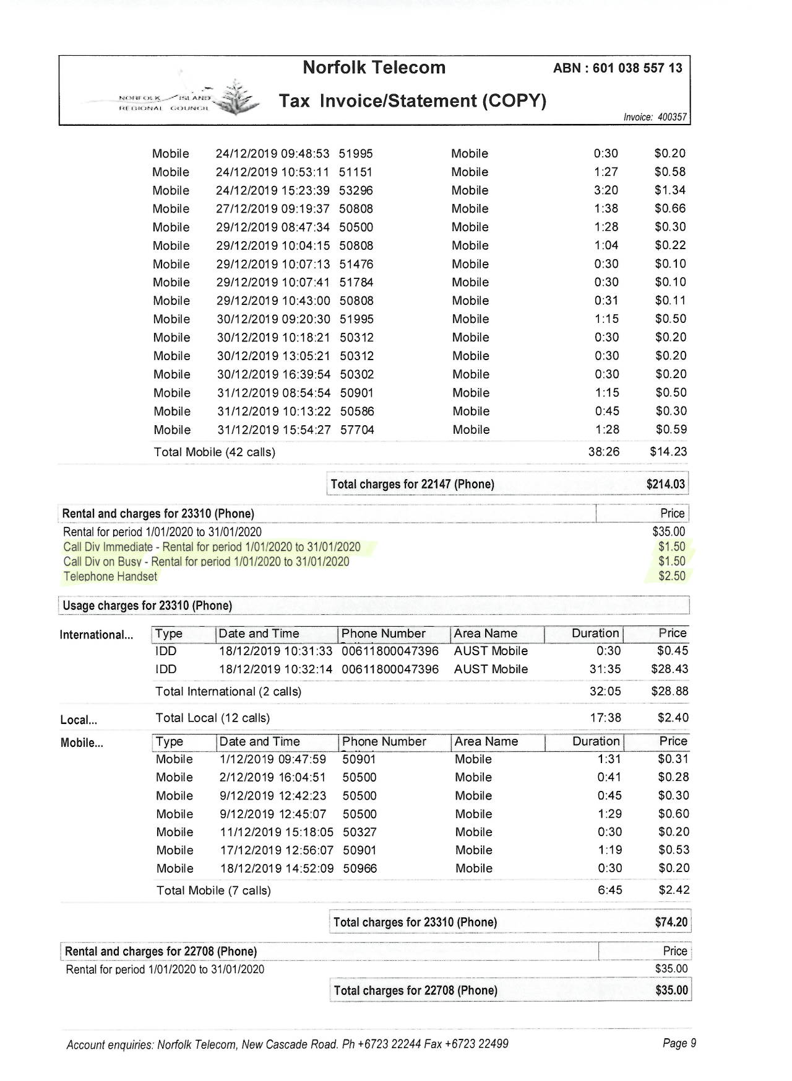
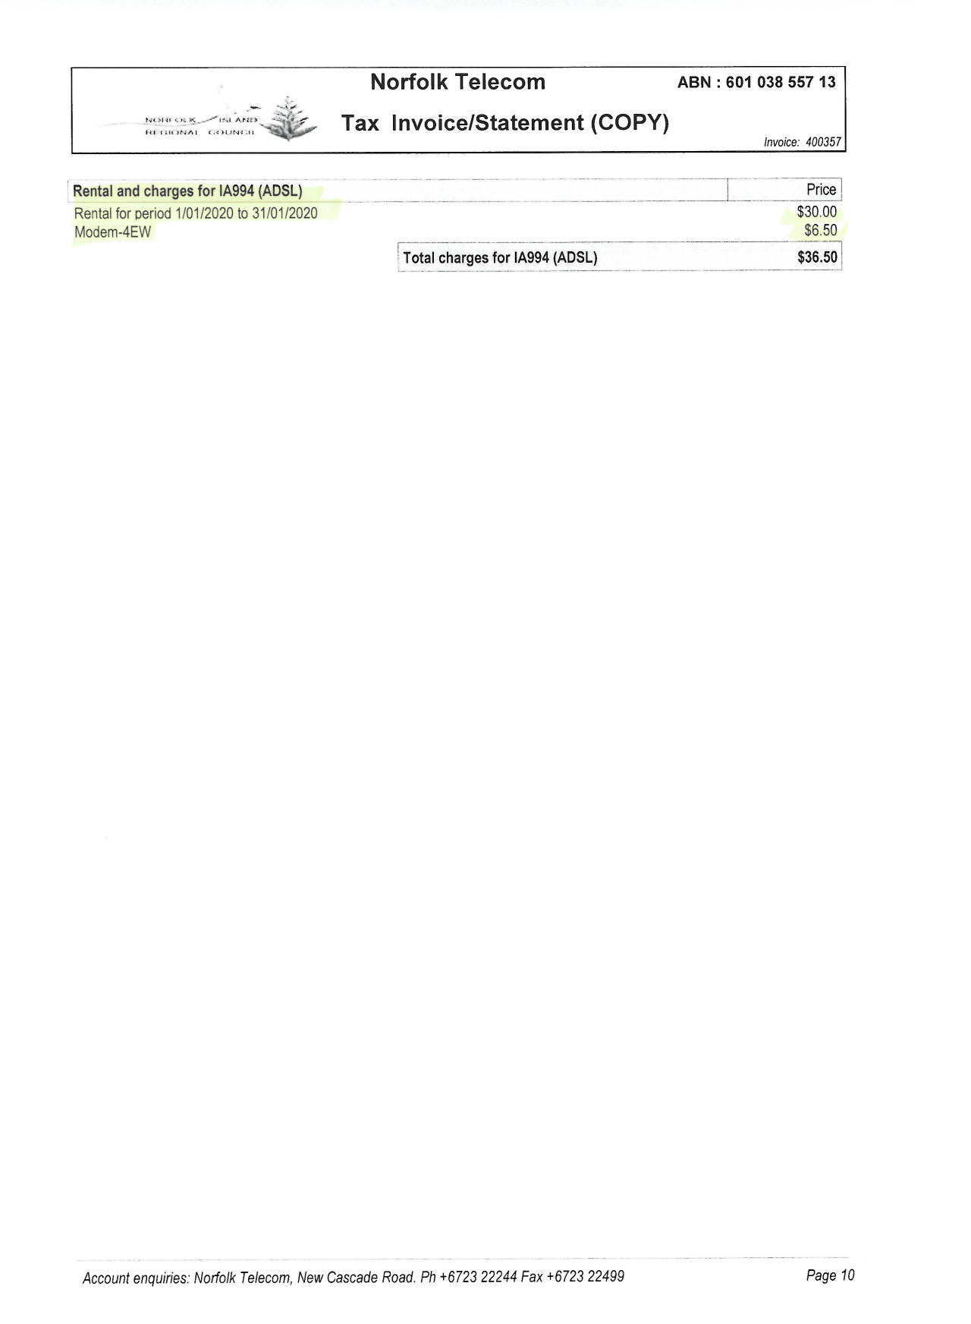

Sample Old Invoice 2
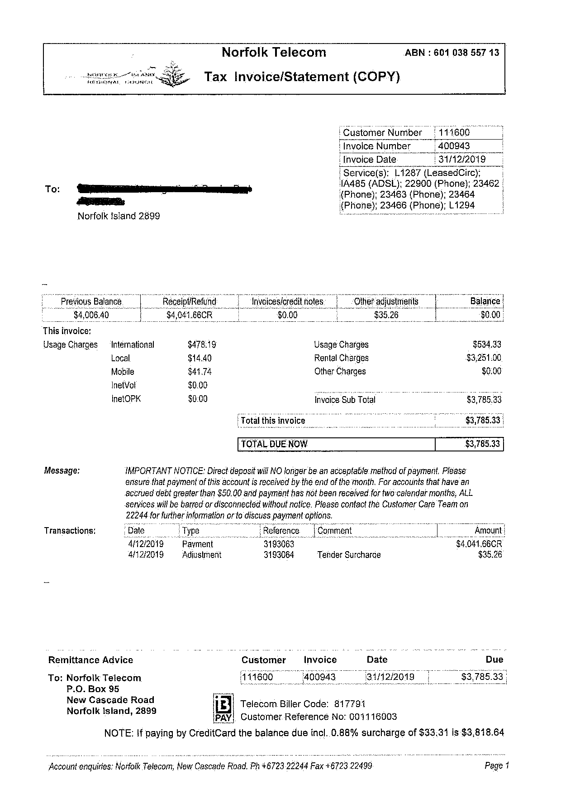
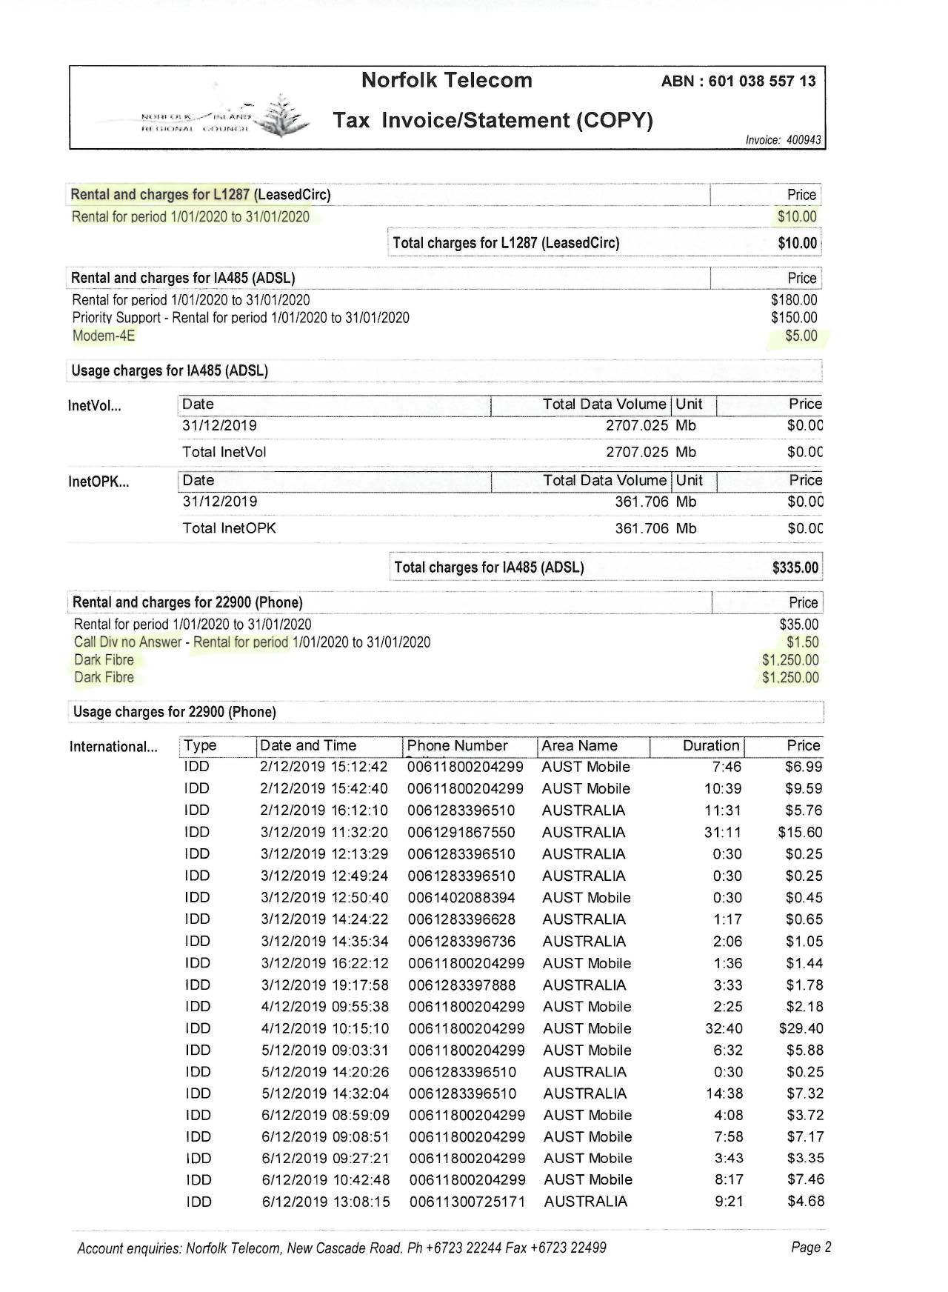
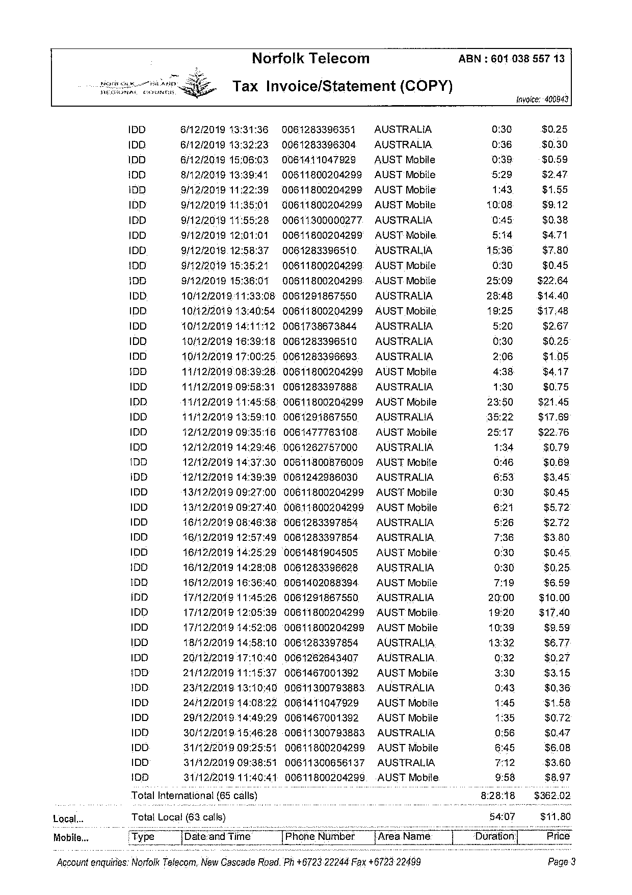
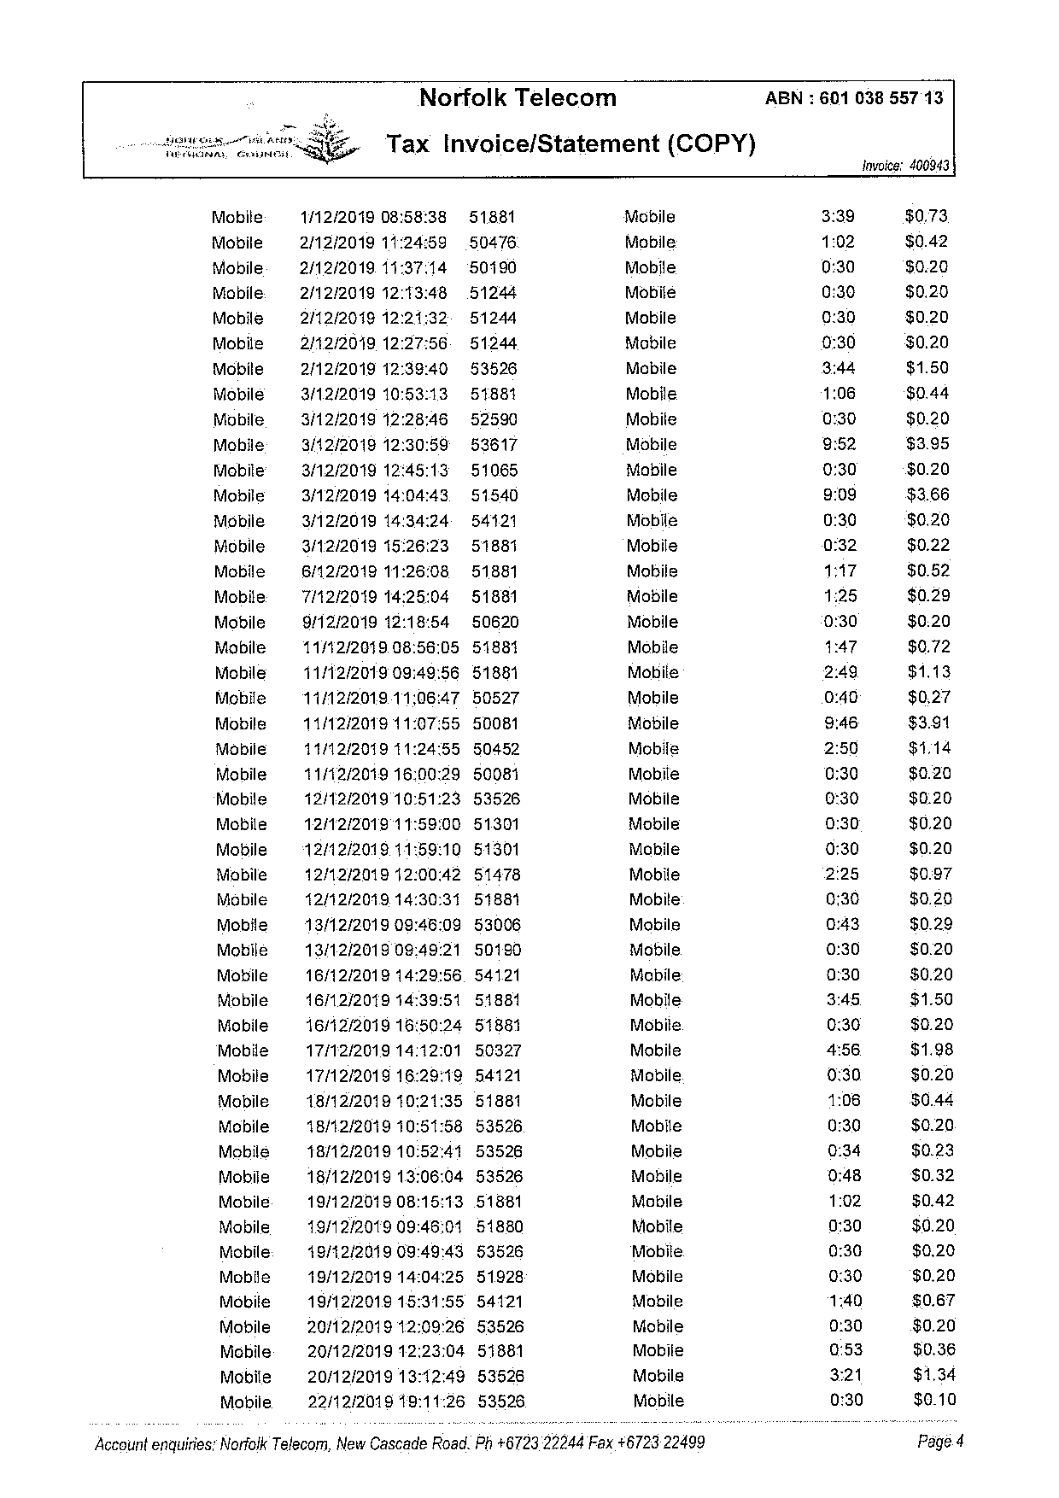
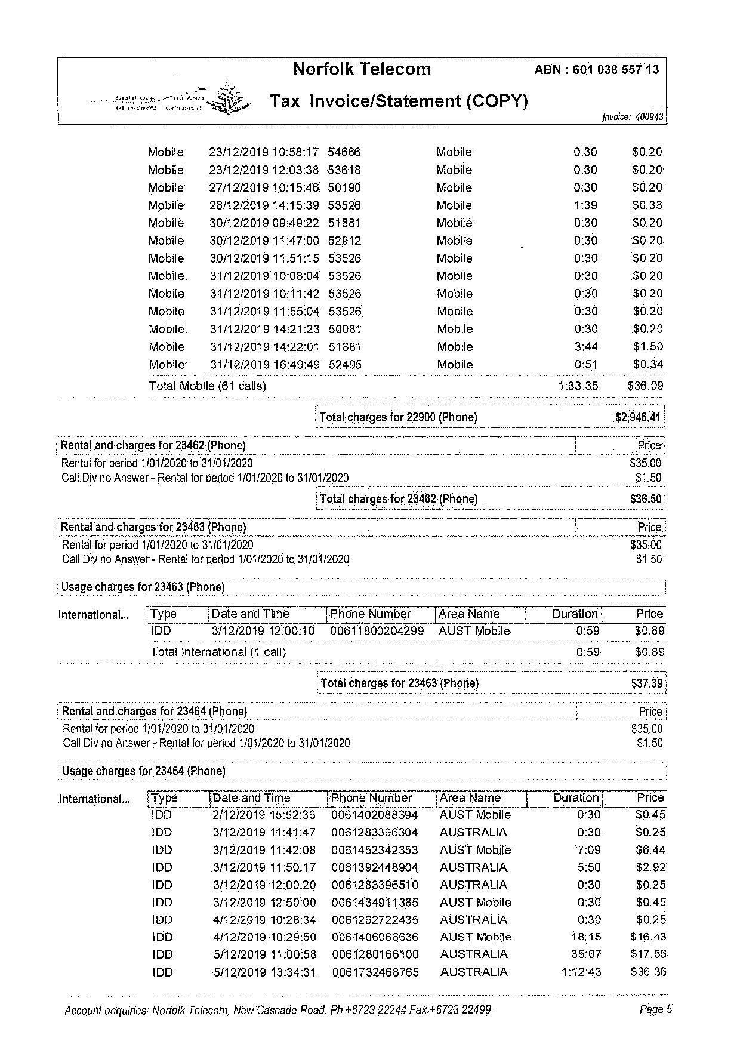
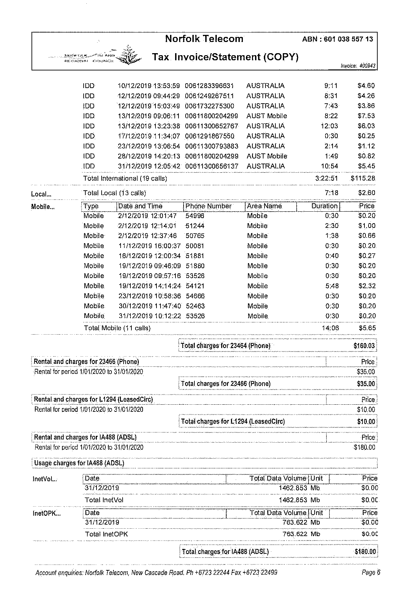
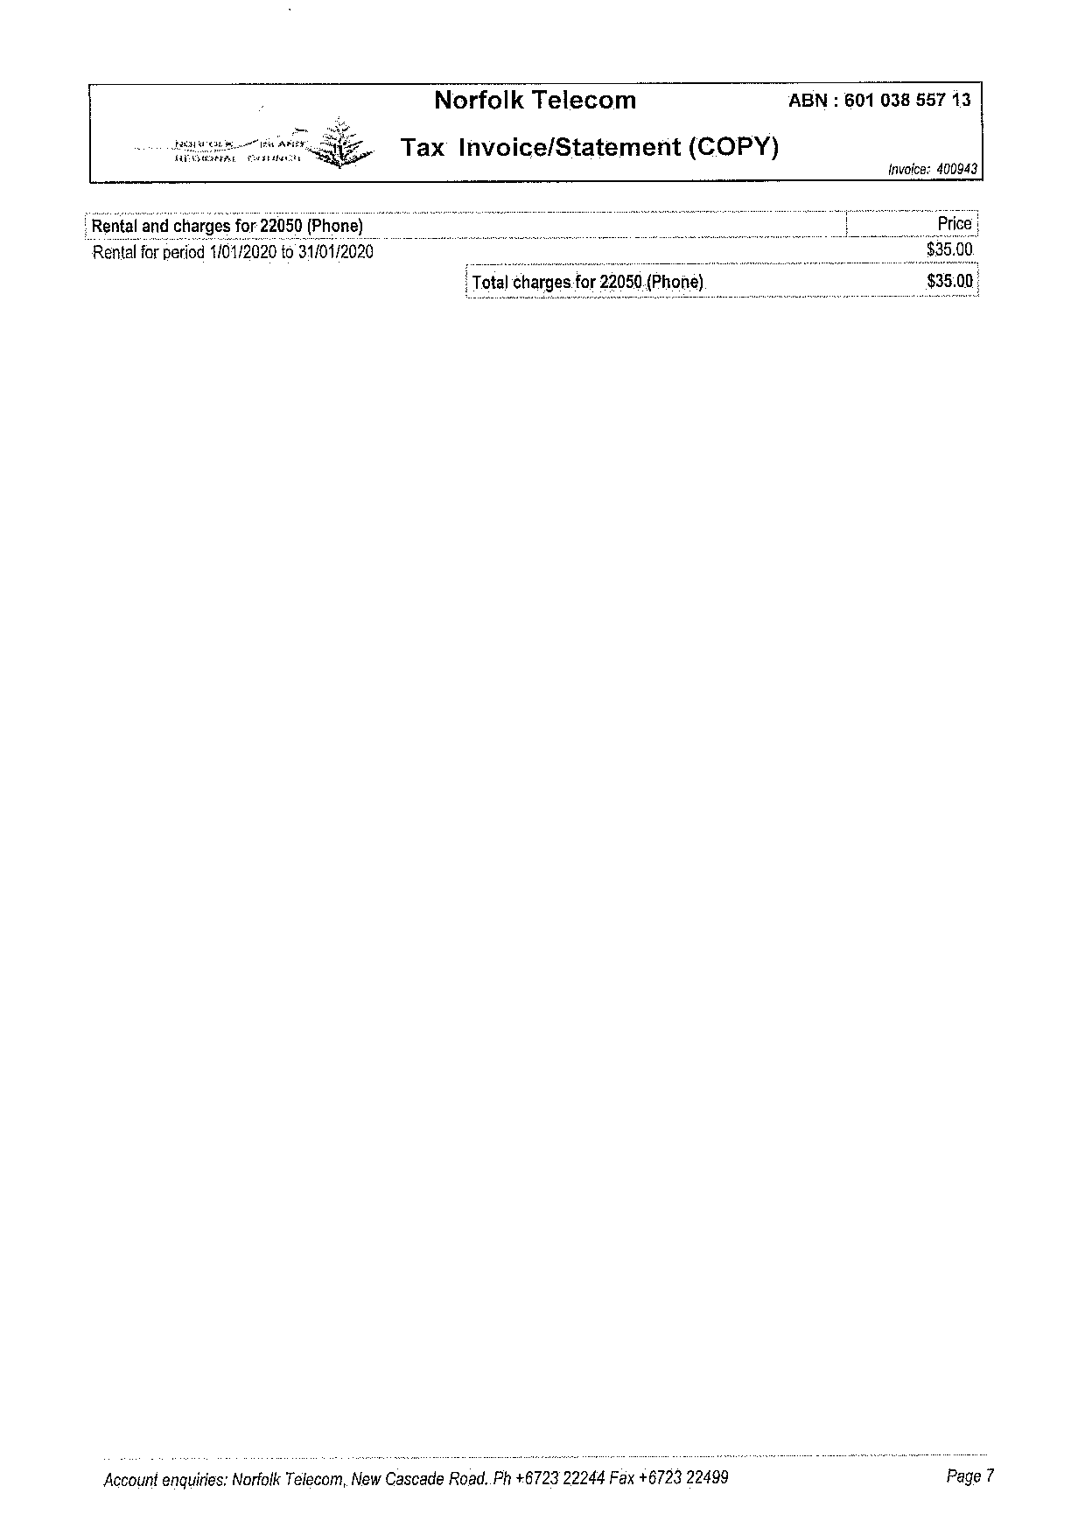
Sample Old Invoice 3
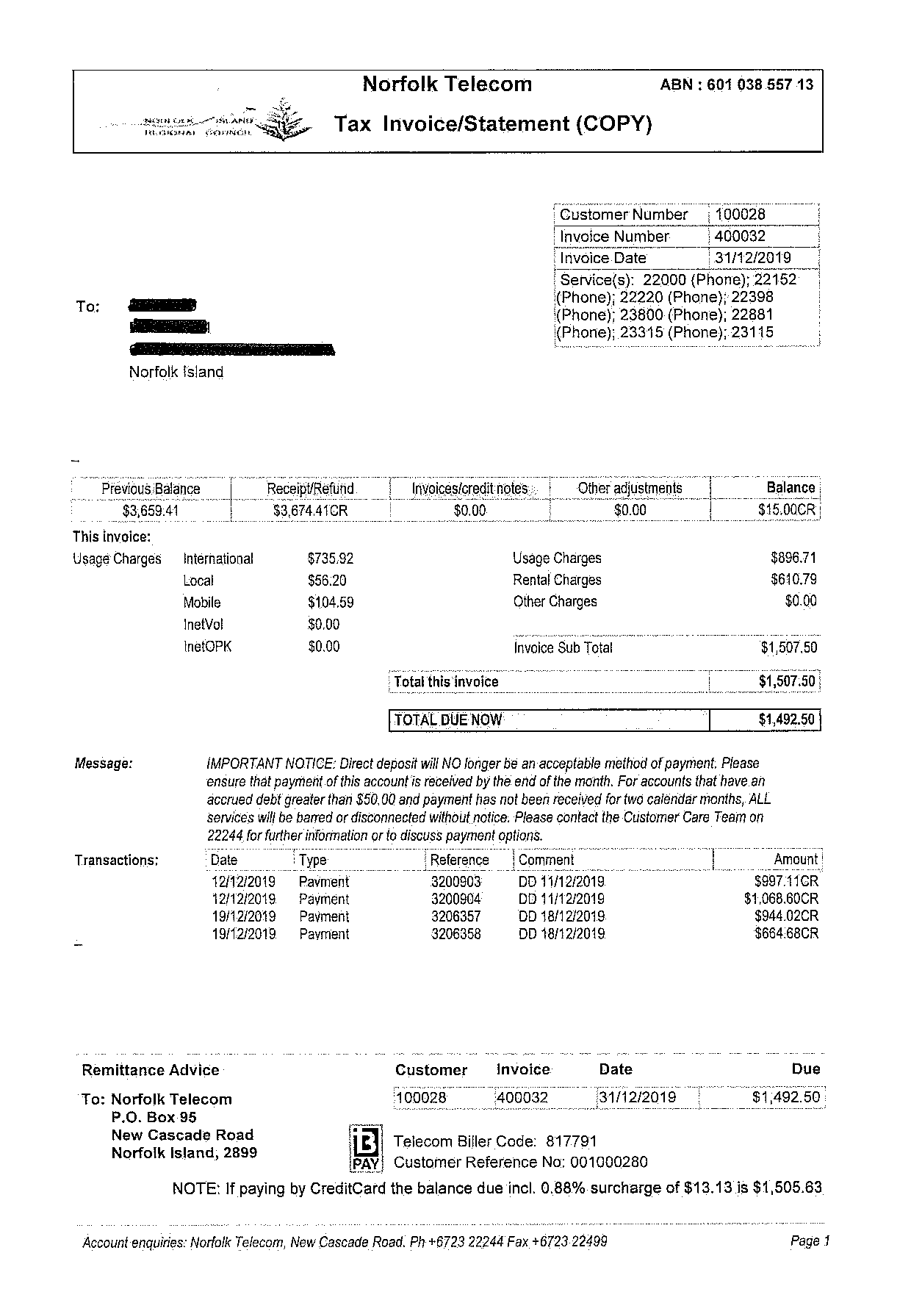
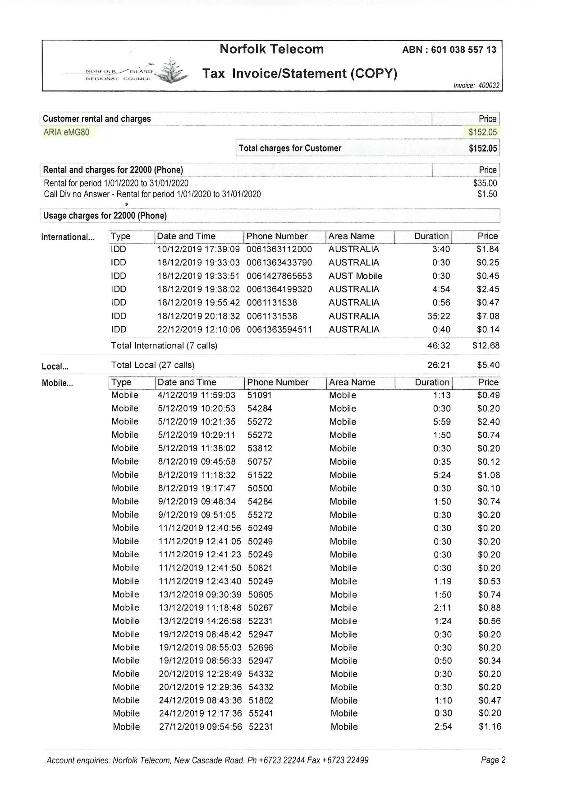
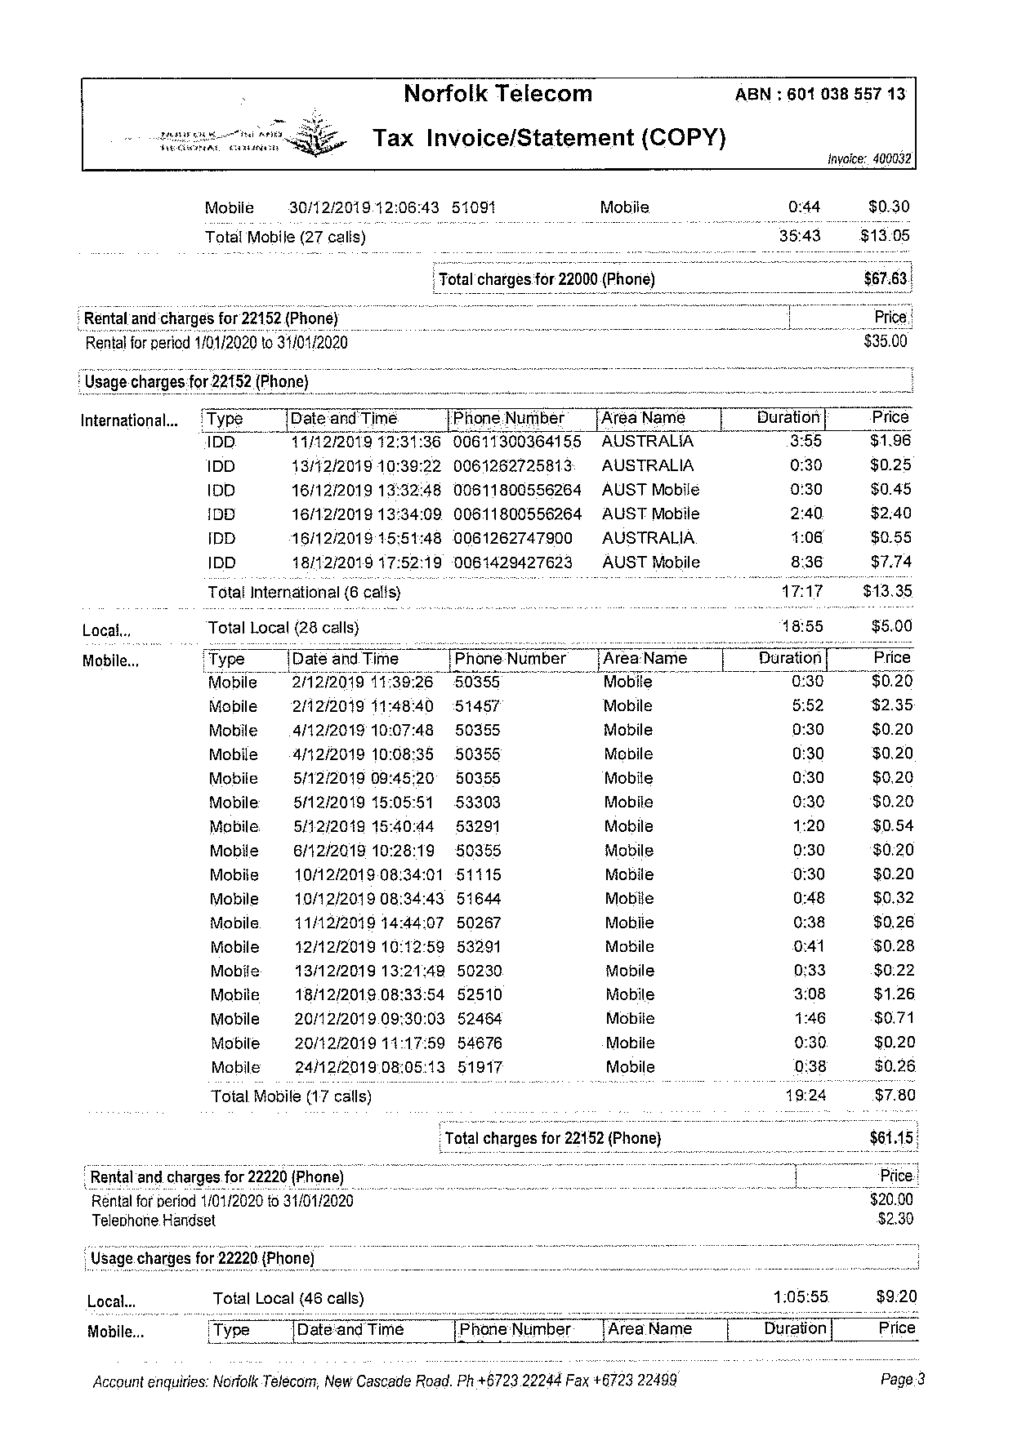
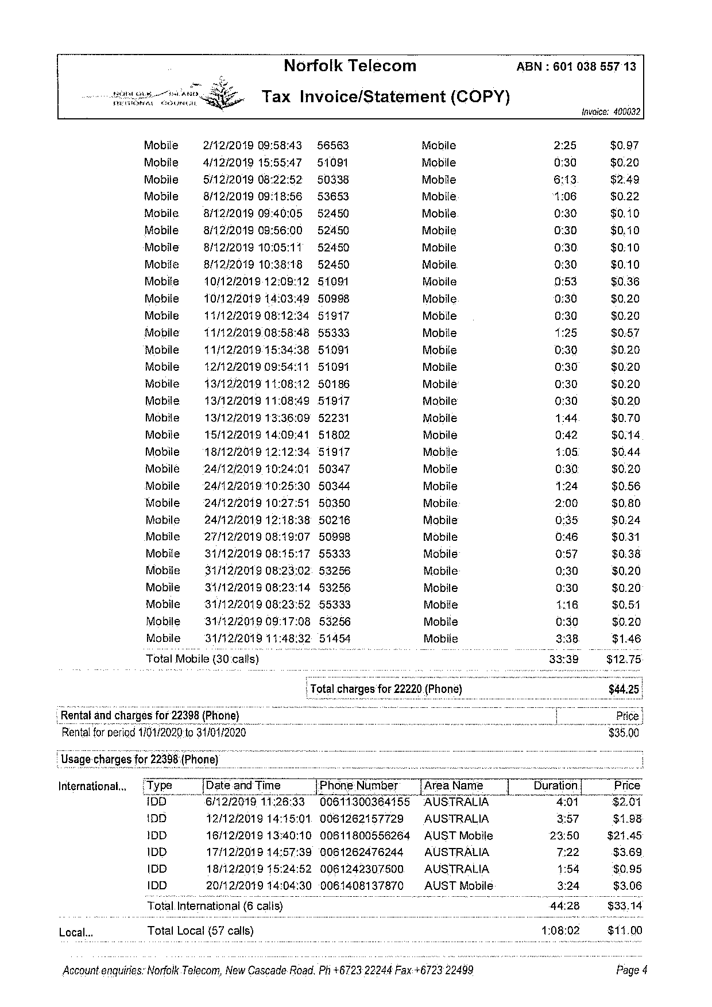
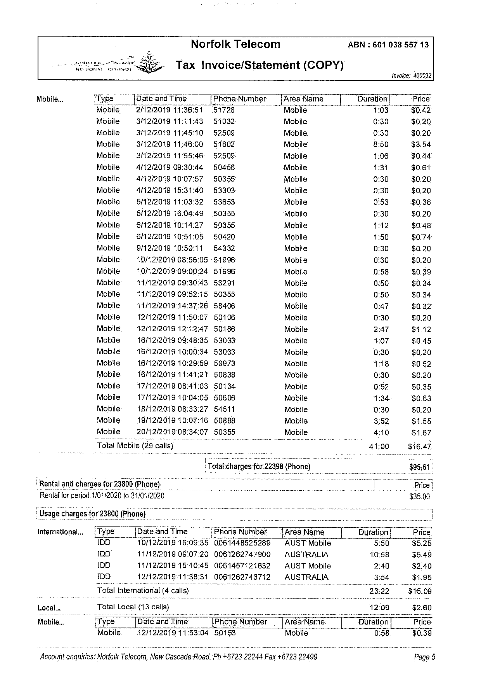
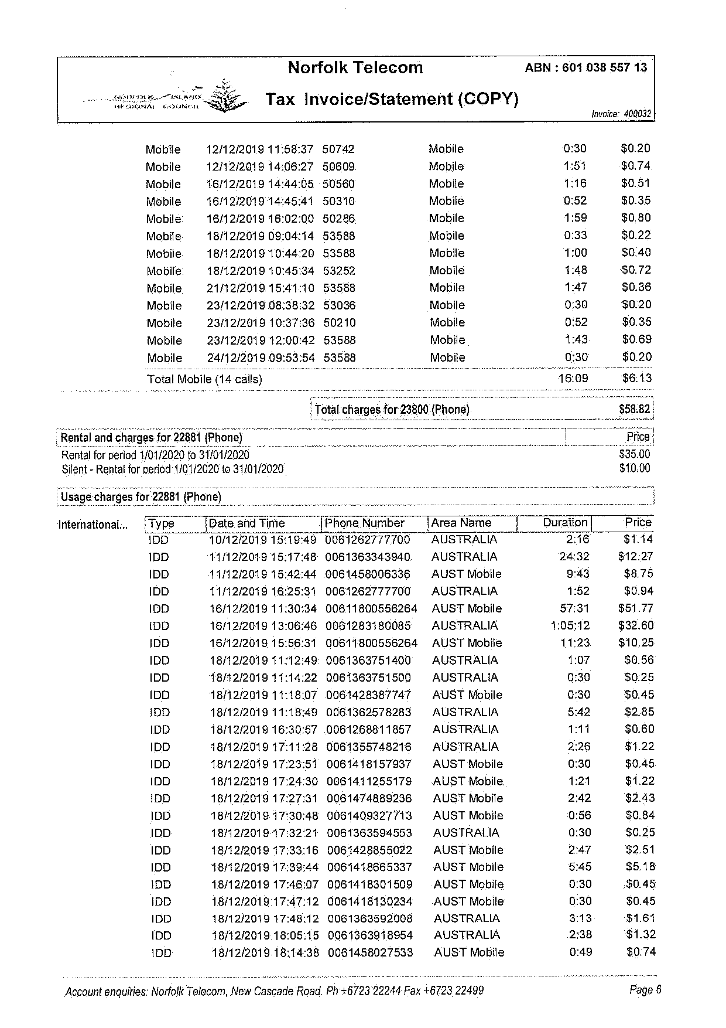
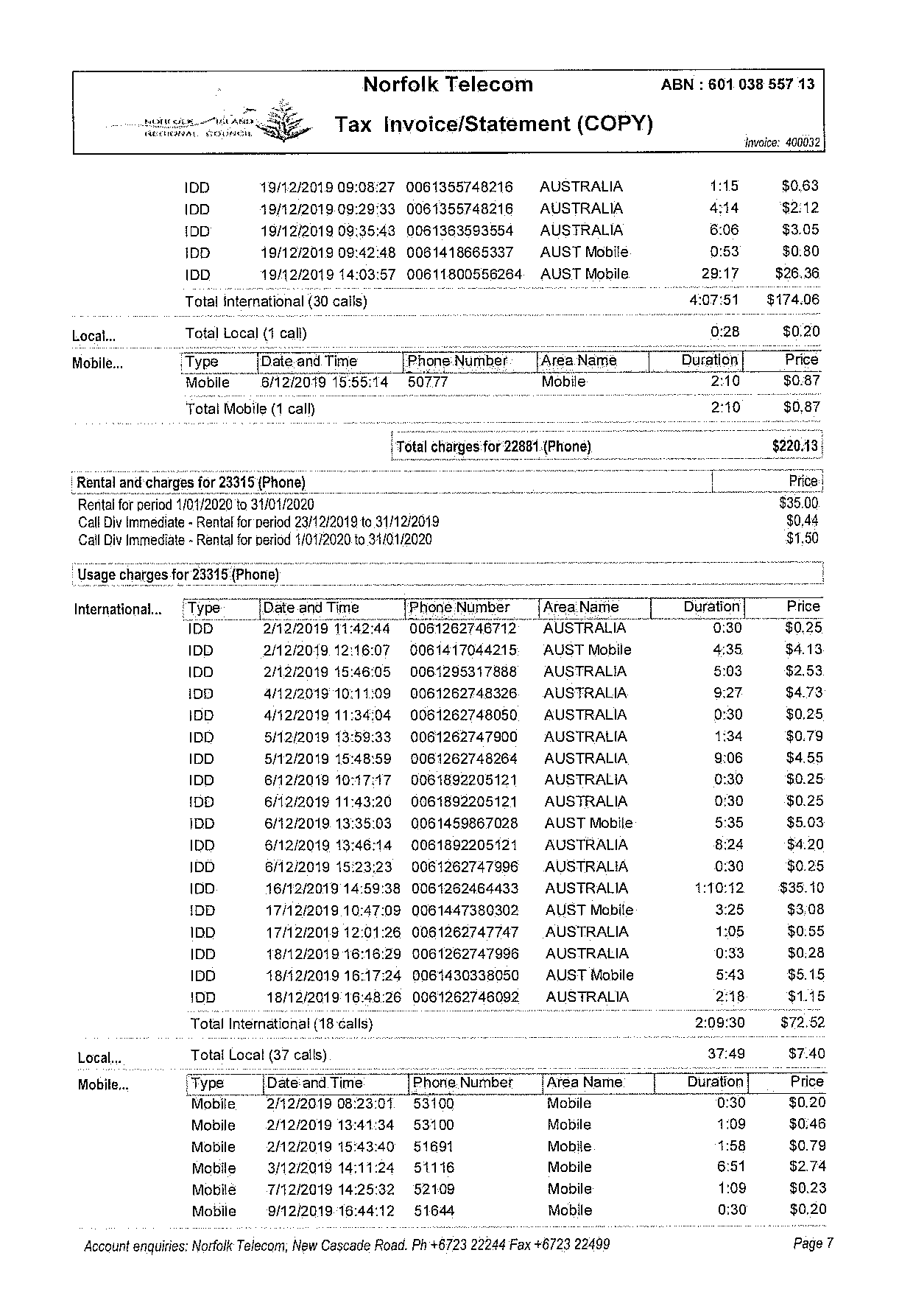
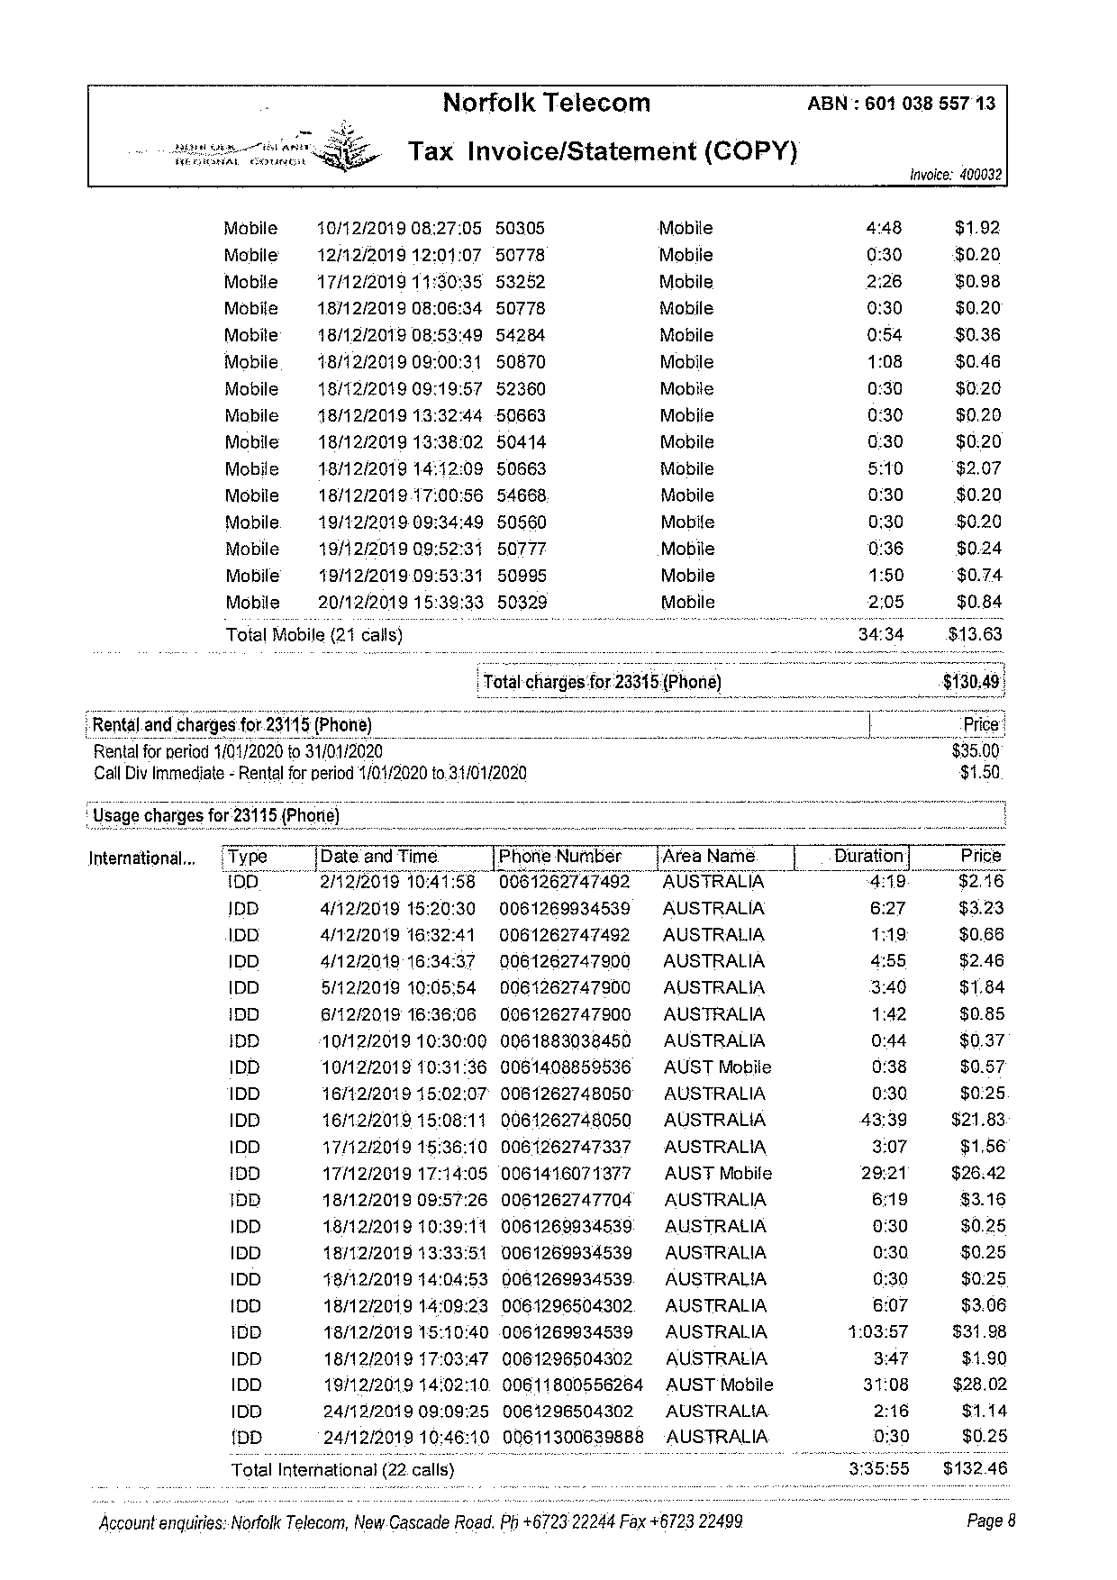
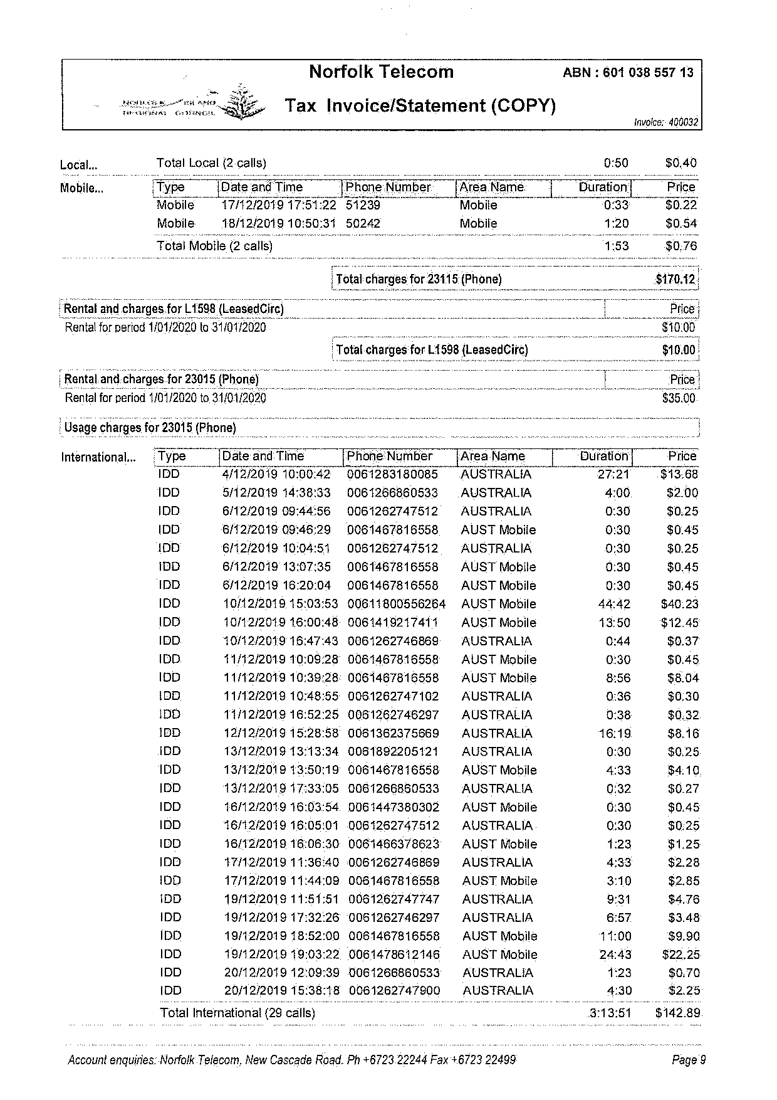
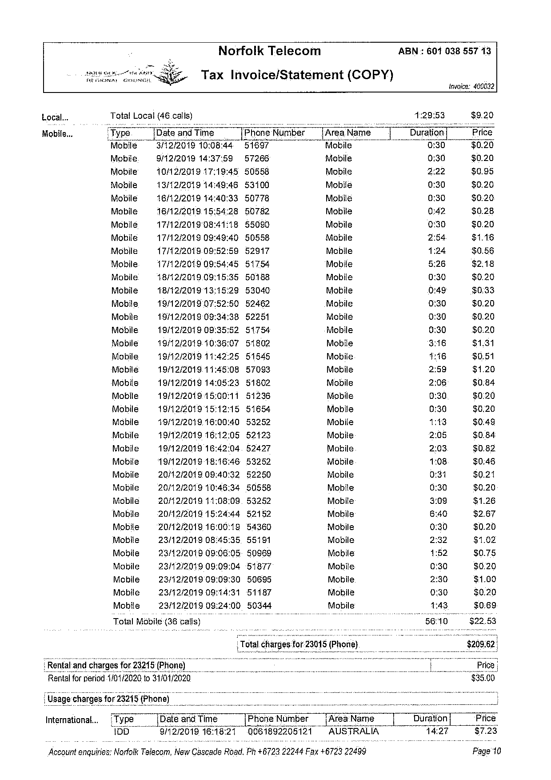
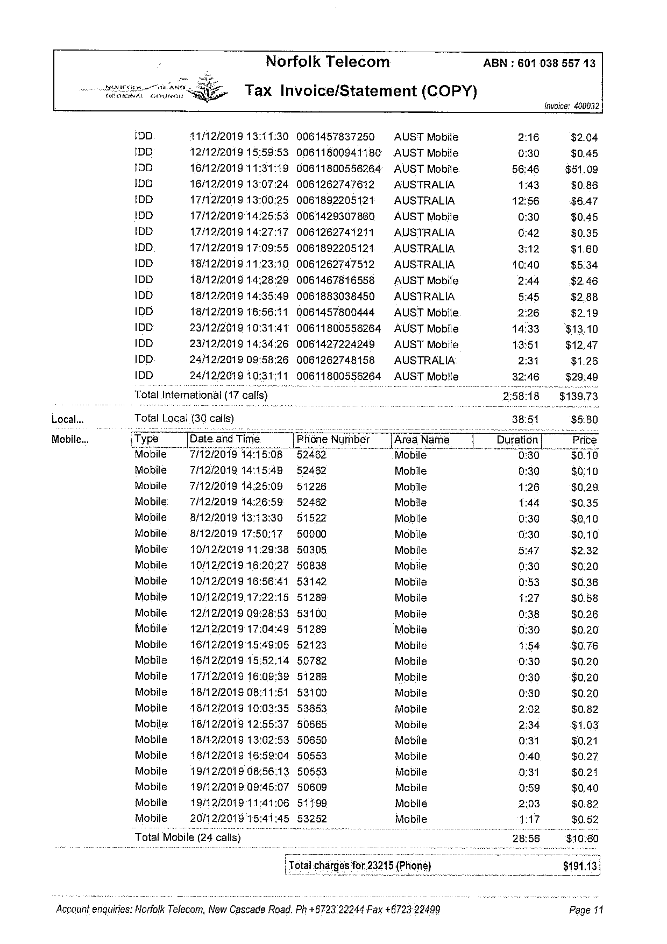
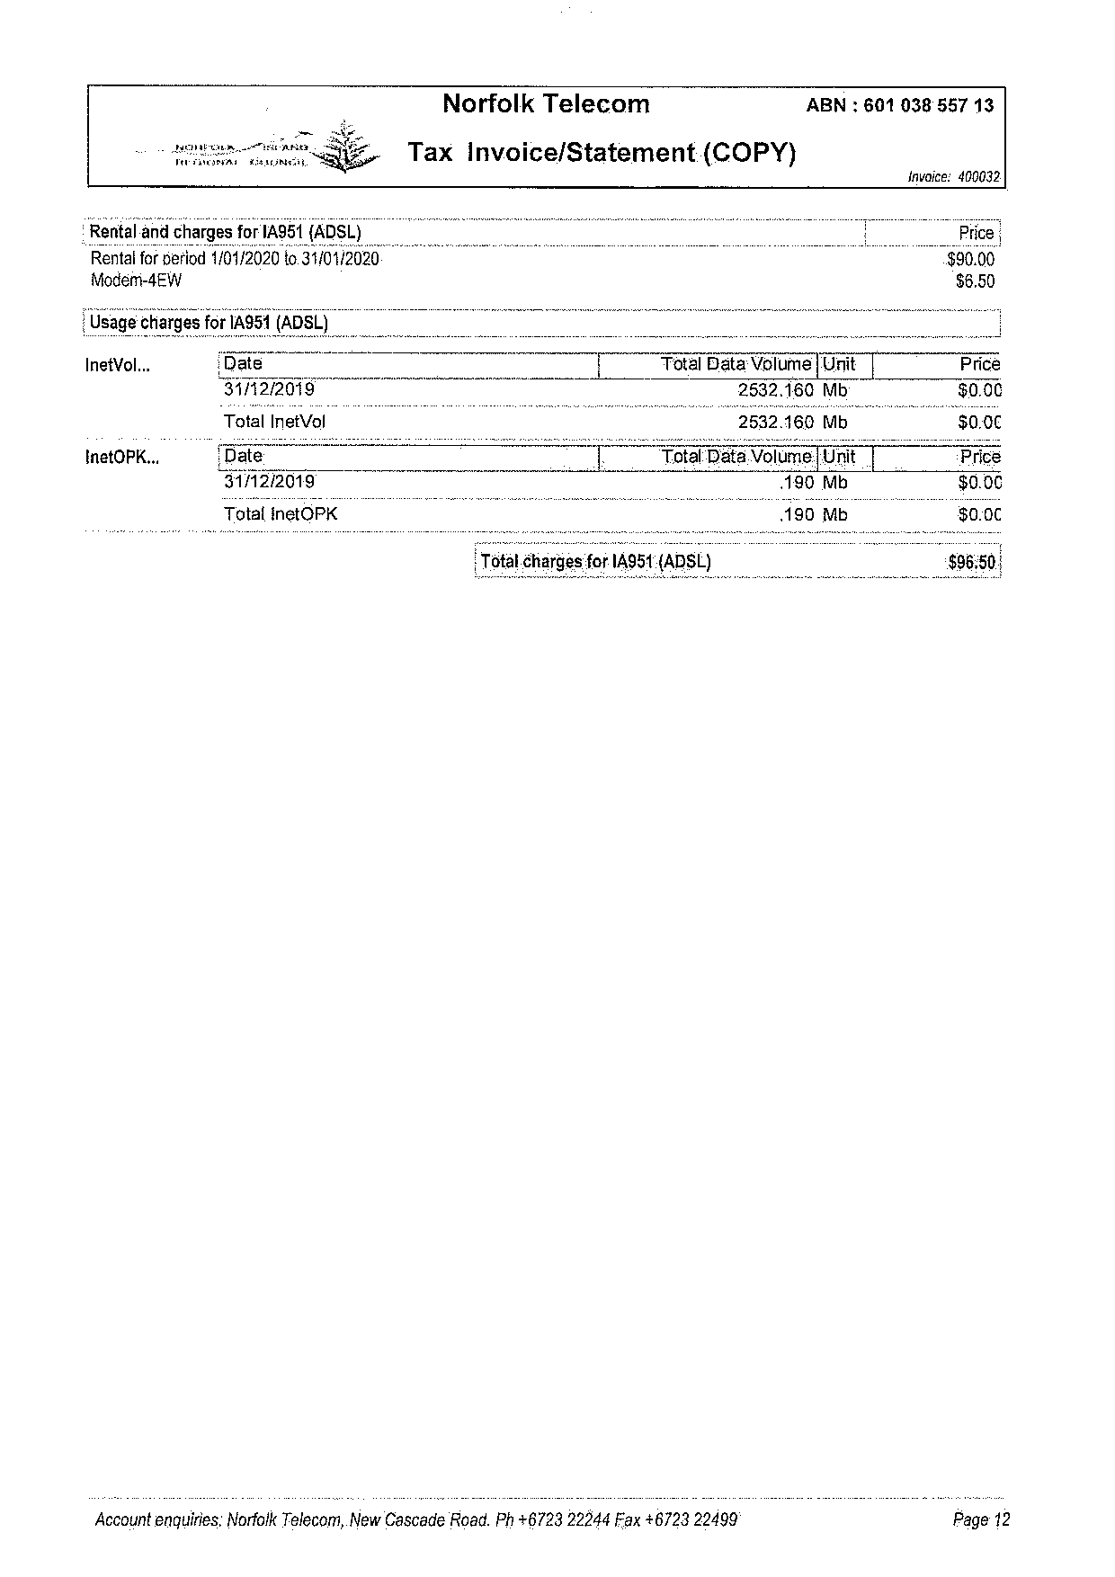
Sample Old Invoice 4
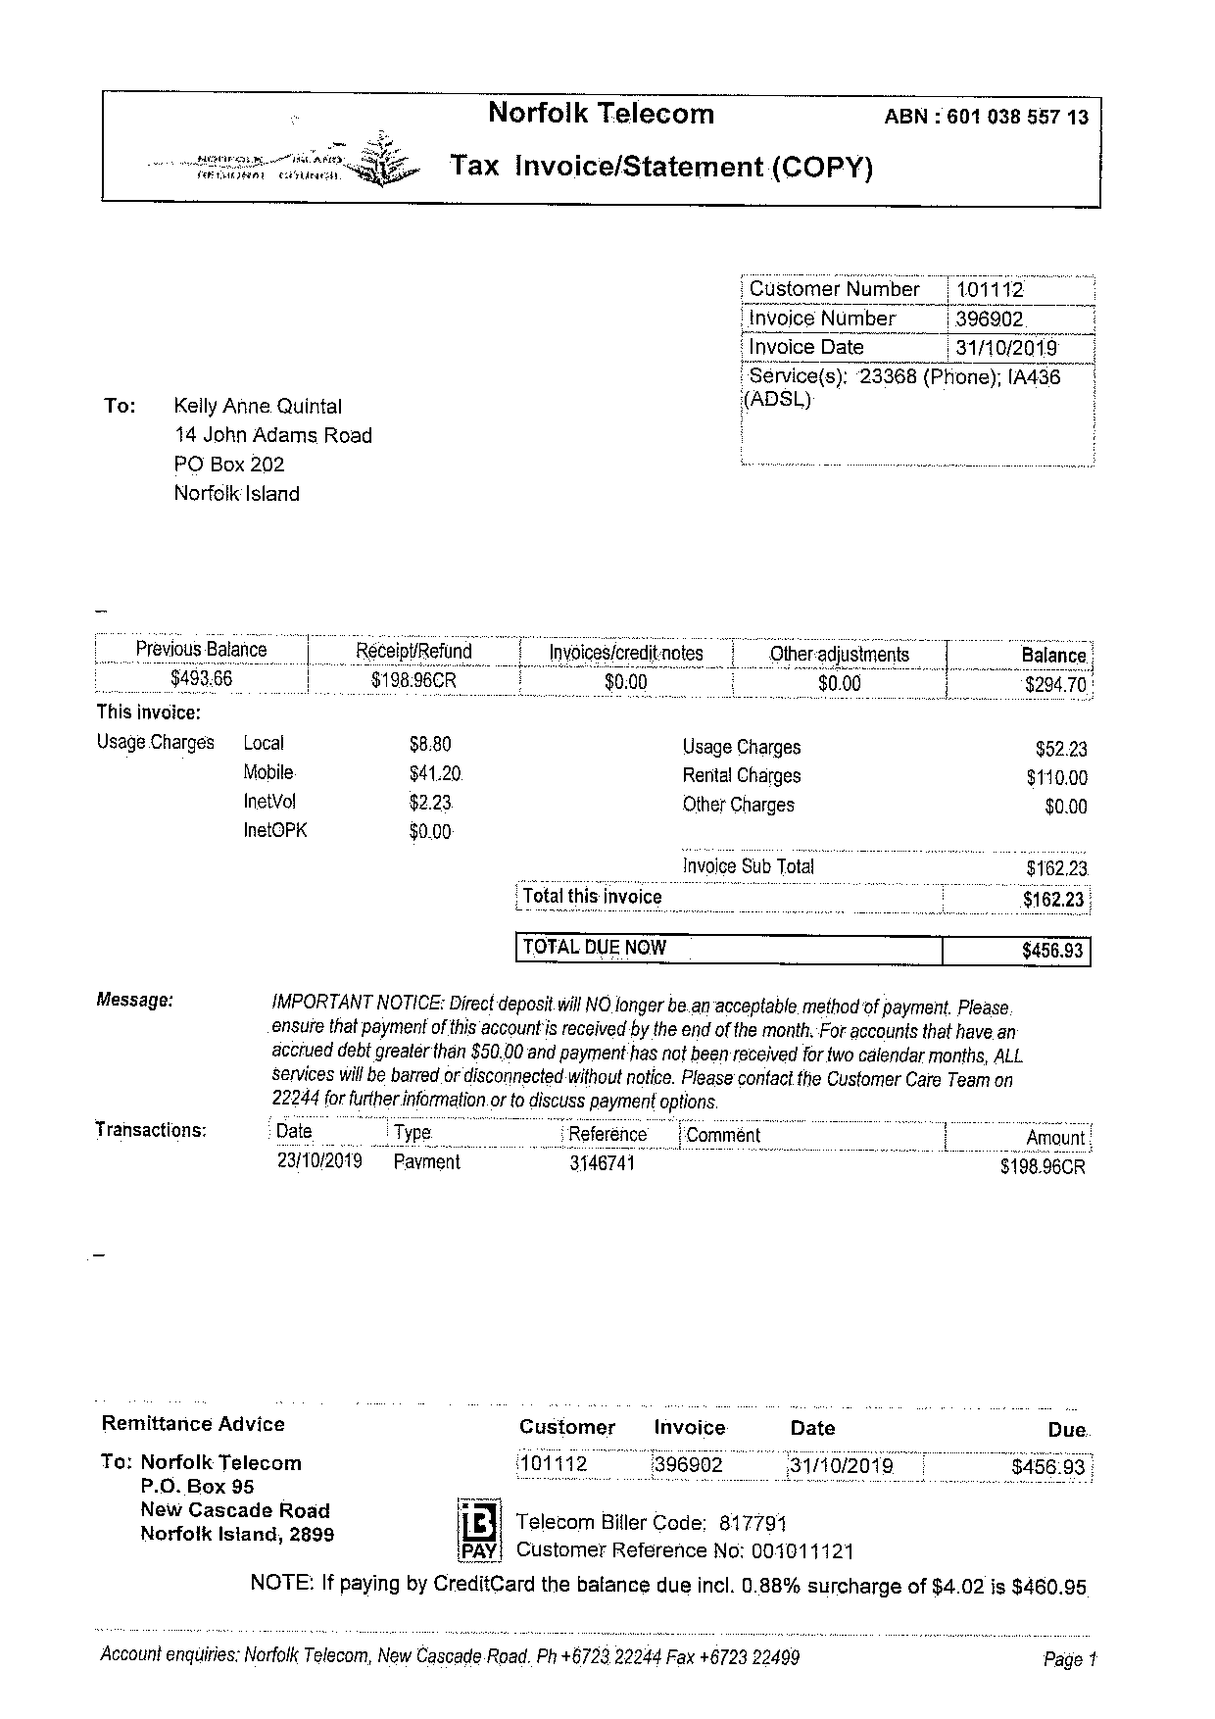
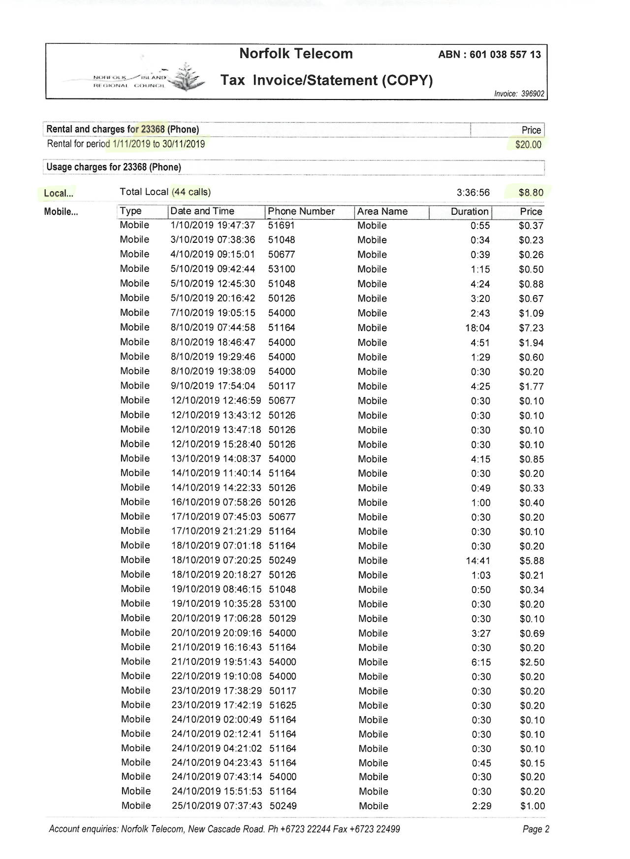
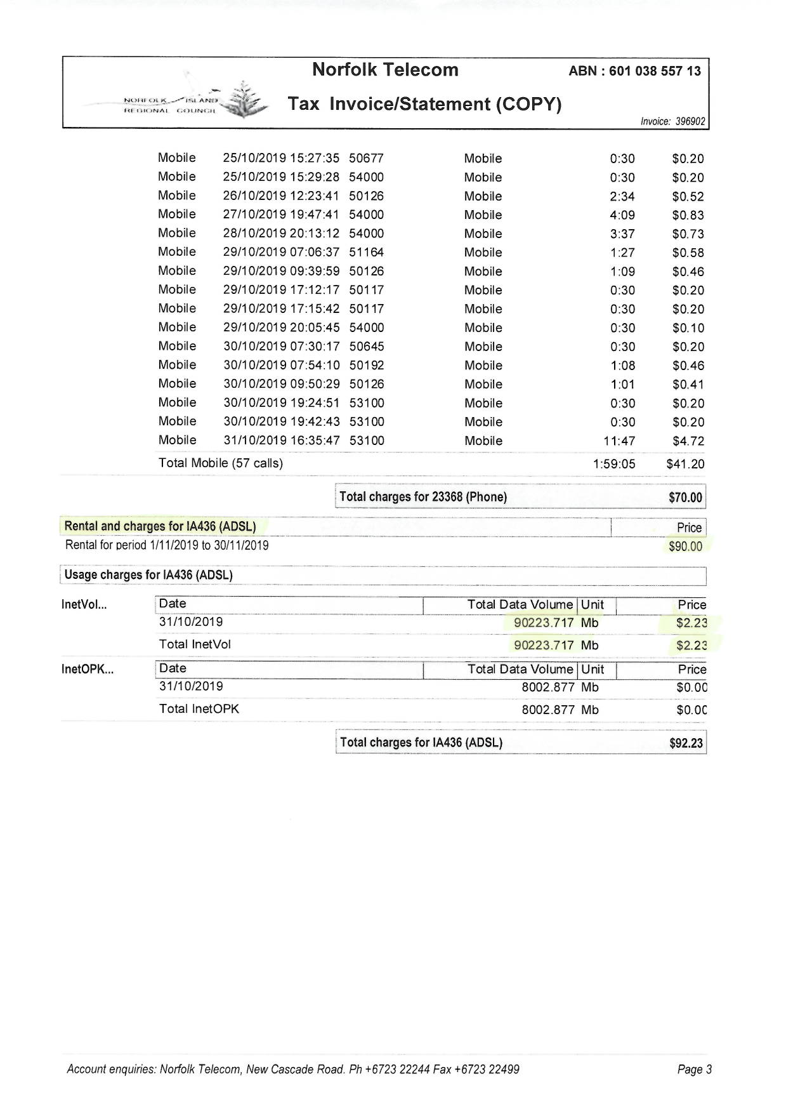

    - Voucher Management
There will be no Voucher or scratch cards used during initial ready for service

    - Payment Channels
- Via CRM thru Customer Care will be the initial payment channel and can be recorded via cash, credit card, or debit card
- No credit top up via vouchers
- Initial online payment middleman that was suggested is Secure Pay. For NT concurrence followed by Secure Pay. merchant account creation and sandbox request with protocol information

  - Self-care
- As part of the BOSS system, Customer Self-care will be deployed using two mediums. The web self-care which is designed for desktop use and larger screens and the Mobile Self-care which is available on Android and IOS. This BOSS features will enable customers access and manage their account with several features below.

    - Web Self-Care
No. | Features | Description | Required (Y/N)
1 | Real-time Balance Inquiry | Real-time Balance display on Credit, Voice, SMS and Data Bundles | Y
2 | Bundle Purchase | Section with the ability for customer to purchase bundles available for commercial use | Y
3 | Account Balance | This is the monetary equivalent of add credits. If wallet balance is available, user needs to transfer credits from Account Balance to wallet balance to be able to purchase bundles and billed for PYG. If Wallet Balance feature is unavailable, PYG and other billable transactions will be deducted on this balance. This usually don’t expire given the availability of Wallet Balance | Y
4 | Wallet Balance | This is an optional feature that will be deducted for any chargeable transactions. Customer need to transfer credits from Account balance to wallet balance. | N
5 | Online Payment | This features enables customer to add credits online via a payment gateway. | Y
6 | Profile Edit | This feature enables customer to edit their profile  - Name  - Address  - Gender  - Birthday  It also displays current plan, mobile number and selfcare username | Y
7 | Credit Transfer | Ability for subscriber to transfer existing credit to other subscriber | Y
8 | Complaints Section | This feature enables customers to submit tickets and concerns to designated complaint recipient within the operations team | N
9 | Network Notice | This section allows customers to receive NT notice and announcements | Y
10 | Password Change | This feature enables customer to change their self-care password | Y
11 | Data Consumption Records | This section shows the total data consumed  - Session Start Date  - Data used (Bits) | Y
12 | Call Records | This shows customer call history and charge  - Call Date Time  - Called Number  - Duration  - Charge | Y
13 | SMS Records | This shows customer SMS history and charge  - SMS Date Time  - SMS Recipient Number  - Charge | Y
14 | Balance History | This Section shows customer the balance history and any recharge information done on the customer account | Y
15 | Banner / Advertisement Placement | This enables the network provider to insert a banner for advertisement on customer self-care page | Y

    - Mobile Self-Care
For NT compliance
No. | Features | Description | Required (Y/N)
1 | Real-time Balance Inquiry | Real-time Balance display on Credit, Voice, SMS and Data Bundles | Y
2 | Bundle Purchase | Section with the ability for customer to purchase bundles available for commercial use | Y
3 | Account Balance | This is the monetary equivalent of add credits. If wallet balance is available, user needs to transfer credits from Account Balance to wallet balance to be able to purchase bundles and billed for PYG. If Wallet Balance feature is unavailable, PYG and other billable transactions will be deducted on this balance. This usually don’t expire given the availability of Wallet Balance | Y
4 | Wallet Balance | This is an optional feature that will be deducted for any chargeable transactions. Customer need to transfer credits from Account balance to wallet balance. | N
5 | Online Payment | This features enables customer to add credits online via a payment gateway. | Y
6 | Profile Edit | This feature enables customer to edit their profile  - Name  - Address  - Gender  - Birthday  It also displays current plan, mobile number and selfcare username | Y
7 | Credit Transfer | Ability for subscriber to transfer existing credit to other subscriber | Y
8 | Complains Section | This feature enables customers to submit tickets and concerns to designated complaint recipient within the operations team | N
9 | Network Notice | This section allows customers to receive NT notice and announcements | Y
10 | Password Change | This feature enables customer to change their self-care password | Y
11 | Data Consumption Records | This section shows the total data consumed  - Session Start Date  - Data used (Bits) | Y
12 | Call Records | This shows customer call history and charge  - Call Date Time  - Called Number  - Duration  - Charge | Y
13 | SMS Records | This shows customer SMS history and charge  - SMS Date Time  - SMS Recipient Number  - Charge | Y
14 | Balance History | This Section shows customer the balance history and any recharge information done on the customer account | Y
15 | Banner / Advertisement Placement | This enables the network provider to insert a banner for advertisement on customer self-care page | Y

  - Reports
Out of the box reports is available for the BOSS System. This displays important data needed for analysis by different domains. Data can be extracted with PDF or XLSX format. Raw Data CDR is also available for download. Below are detailed out of the box reports available.

*Any needed report will be raised by NT for assessment

No. | Business Unit | BOSS Standard Reports | Details
1 | Finance | Revenue Reports | Total Prepaid Revenue within a set date range  bifurcated by transaction type
2 | Finance | Payment Statistics Report | Total Payment Statistics based on payment method. (Ex CSR top-up, Online Payment, Credit Transfer)
3 | Finance | Total Monthly Product Revenue Report | Monthly Report with total product revenue  Ex: DSL, Leased line, and other inventory Items
4 | Finance | Billing Cycle revenue (Postpaid) | Consolidated total amount of billing invoice within the set billing cycle
5 | Operation | Traffic Report | Total transaction traffic for data, sms and voice within a set range. Both for local and international transactions for voice and SMS
6 | Operation | Customer CDR | CDR report per costumer on a specified date range. ( Voice, SMS, Data)
7 | Operation | Subscriber Report | Report showing total subscriber with active and inactive status for different service.
8 | Operation | Ticketing | Display internal faults raised with corresponding status within a set date range.
9 | Sales and Marketing | Top User reports | Report showing top users with most consumption within a set date range
10 | Sales and Marketing | Bundle Purchase Reports | Total bundle purchases within a set date range
    - Finance Revenue Report Sample
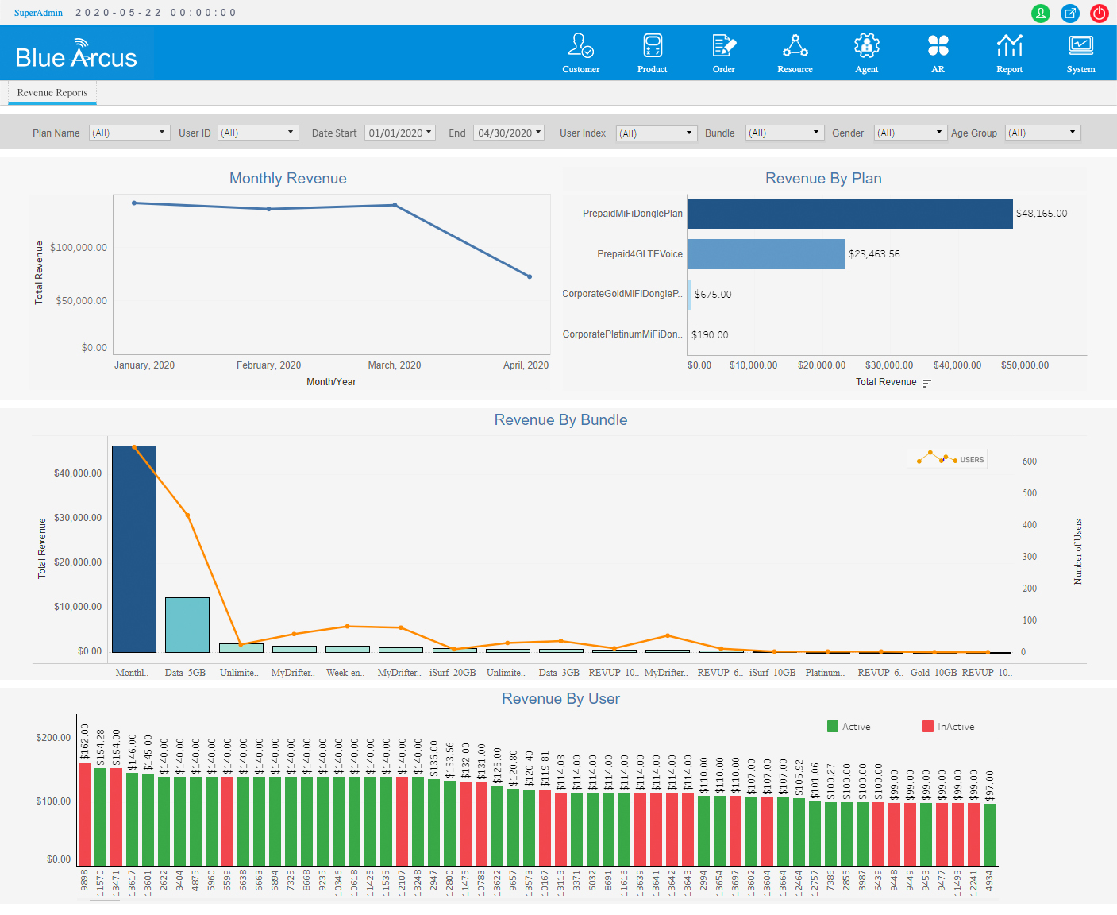

    - Finance Payment Statistics Report Sample
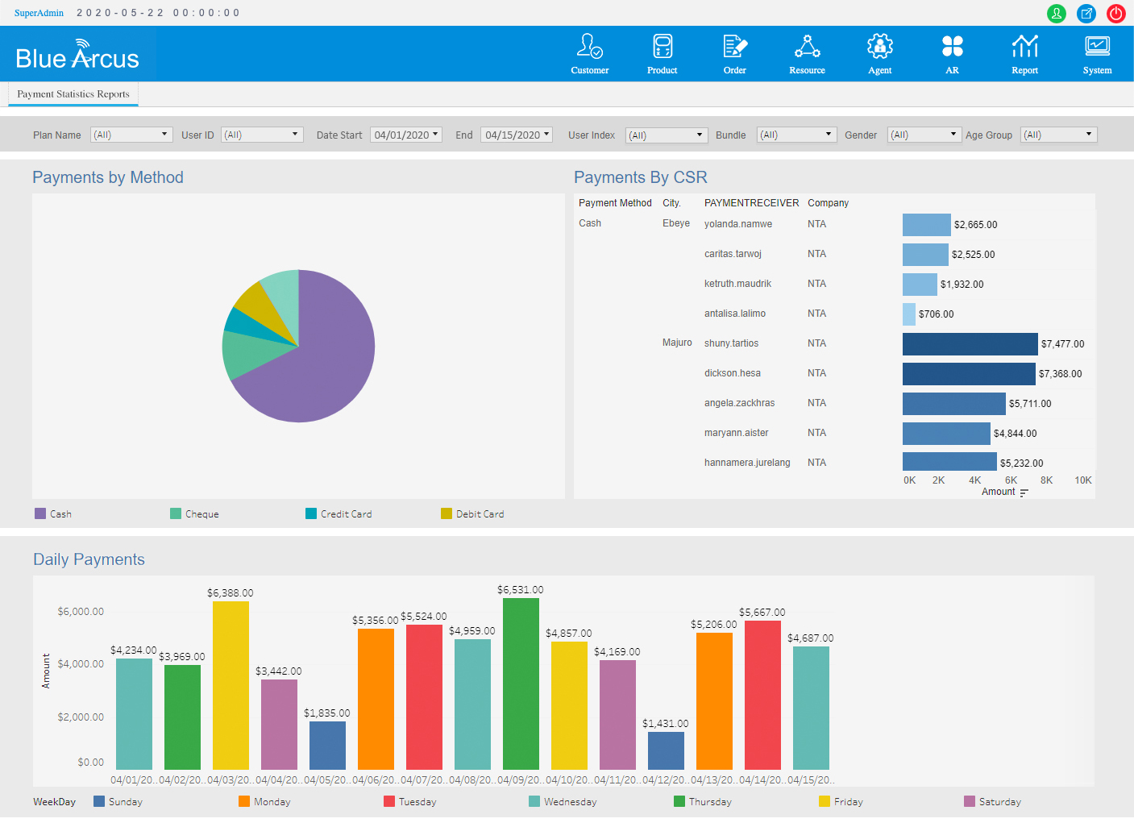

    - Finance Total Monthly Product Revenue Report Sample

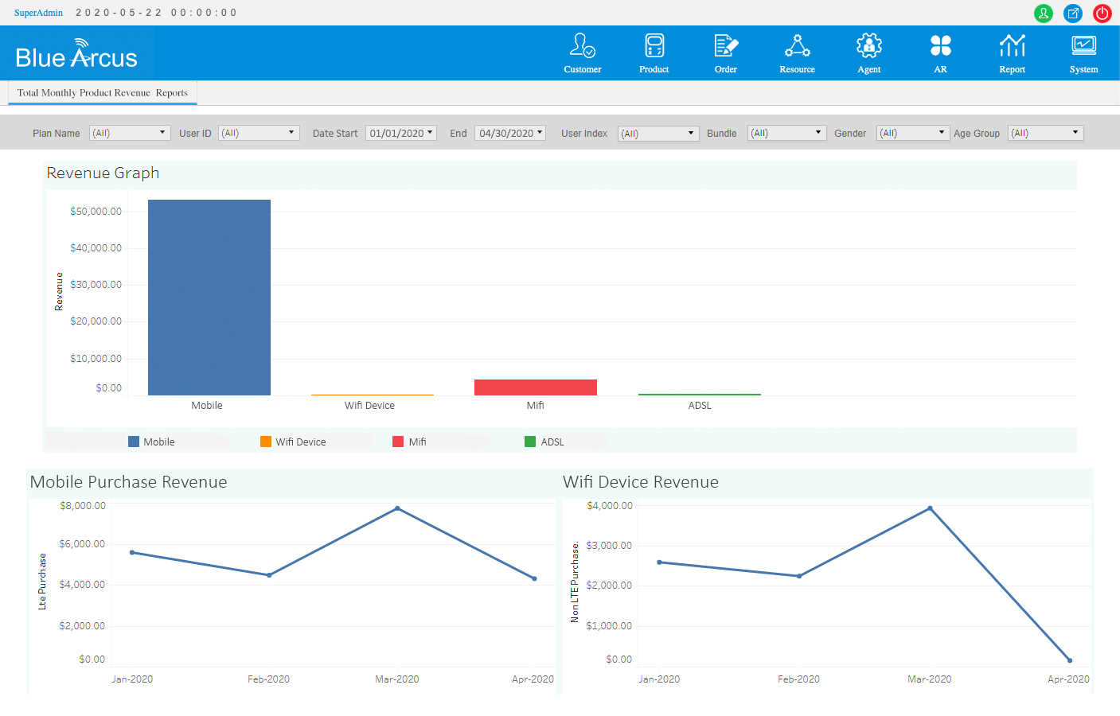

    - Finance Billing Cycle Revenue Report Sample

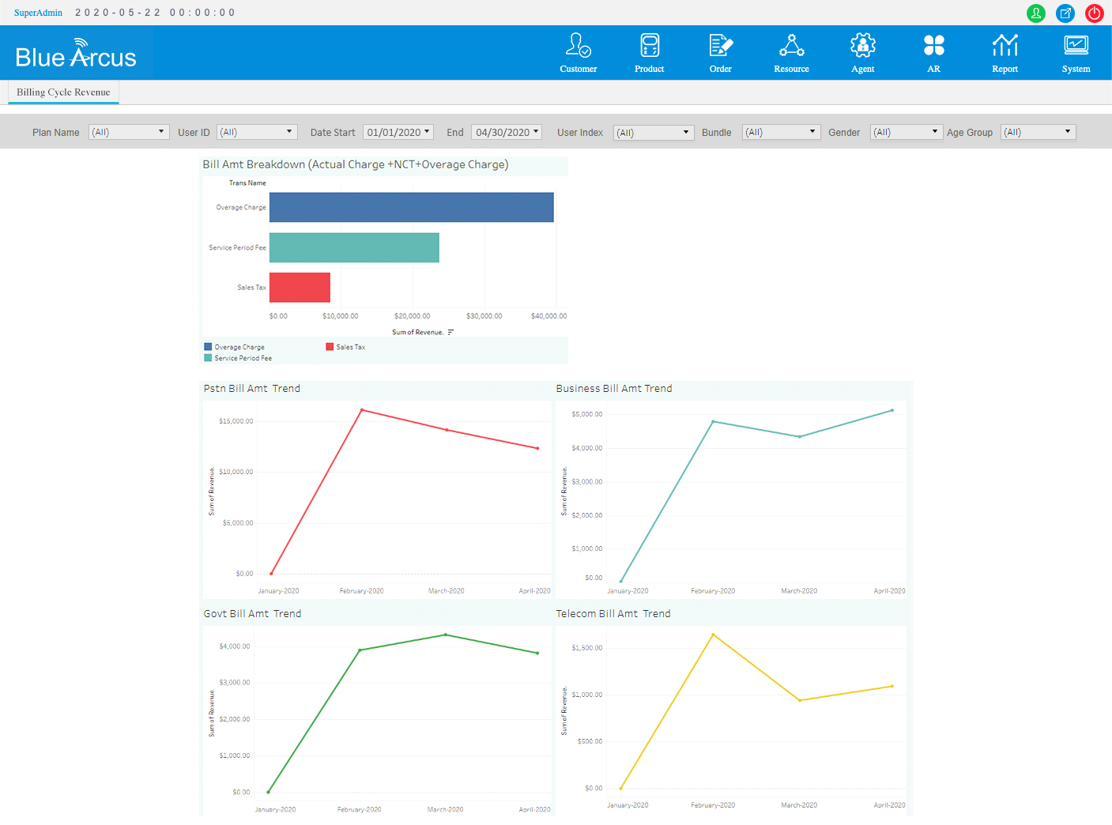

    - Operation Traffic Report Sample
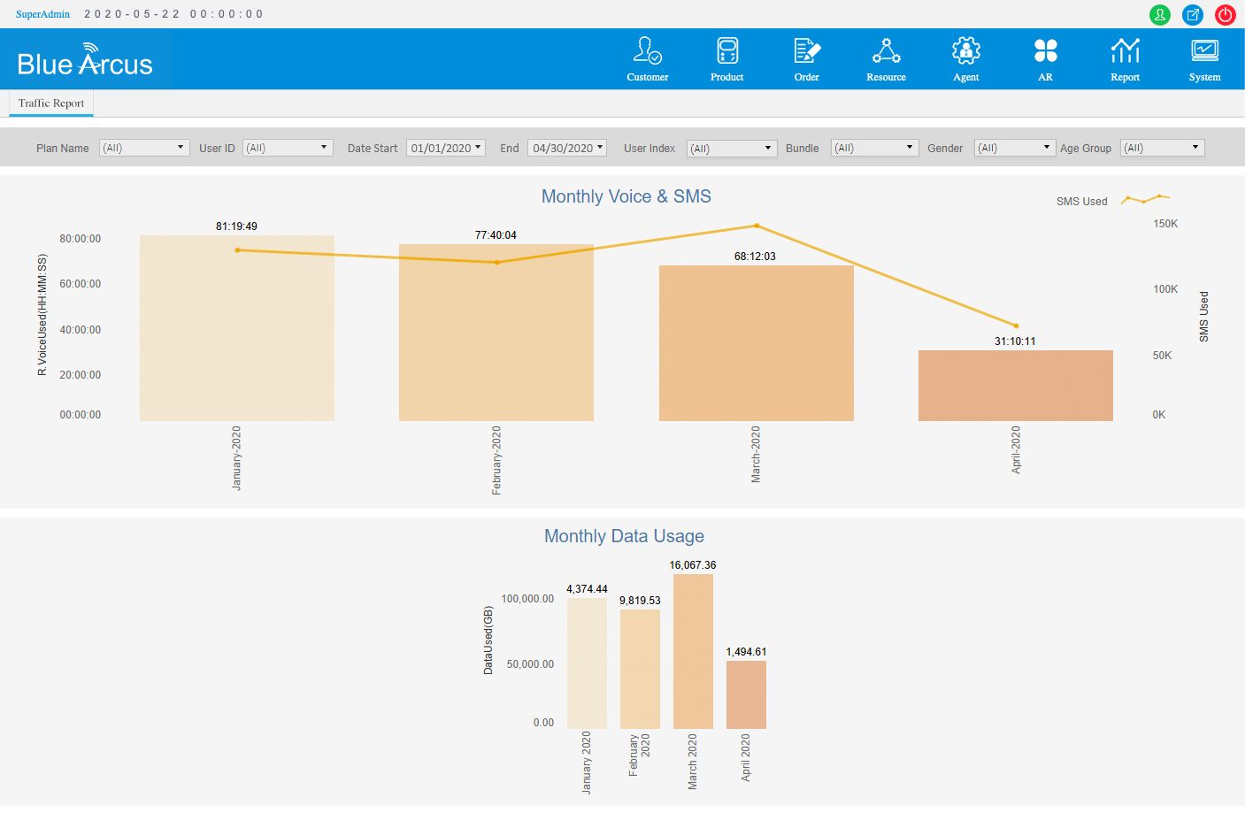
    - Operation Customer CDR Report Sample
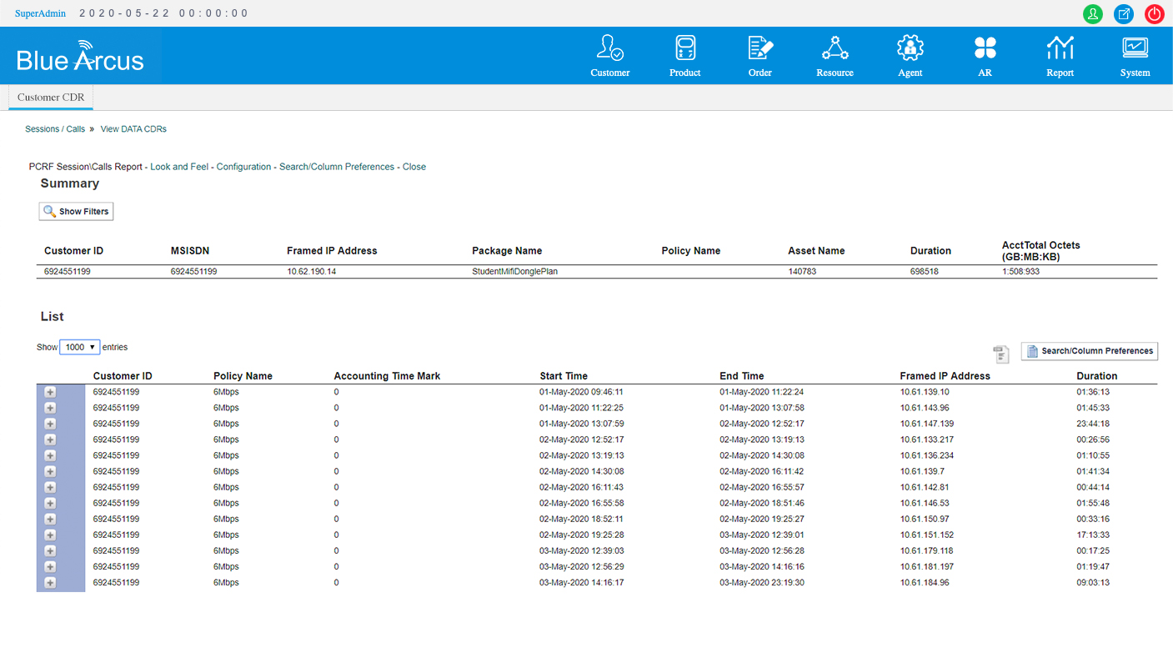
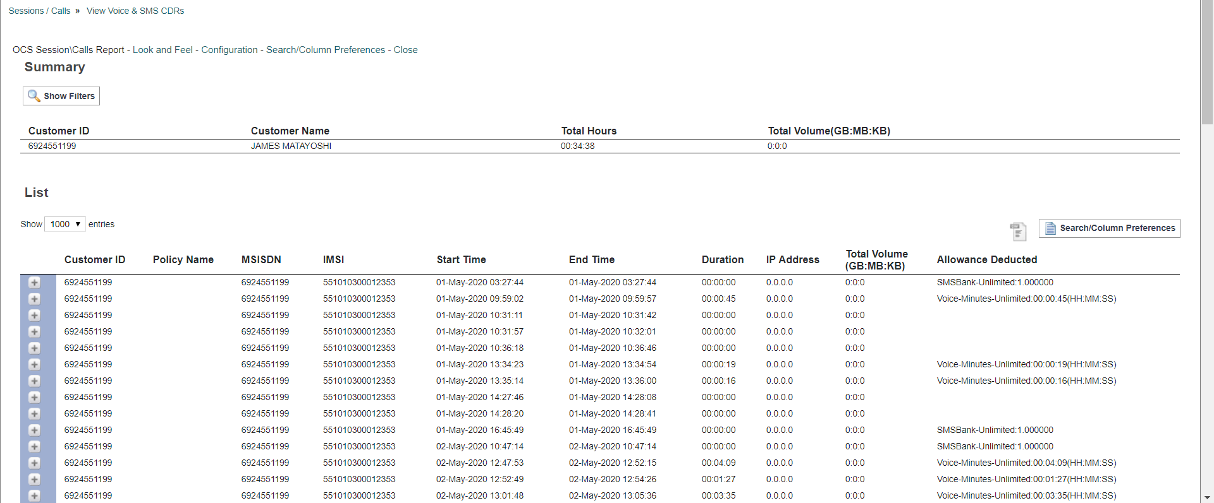

    - Operation Subscriber Report Sample
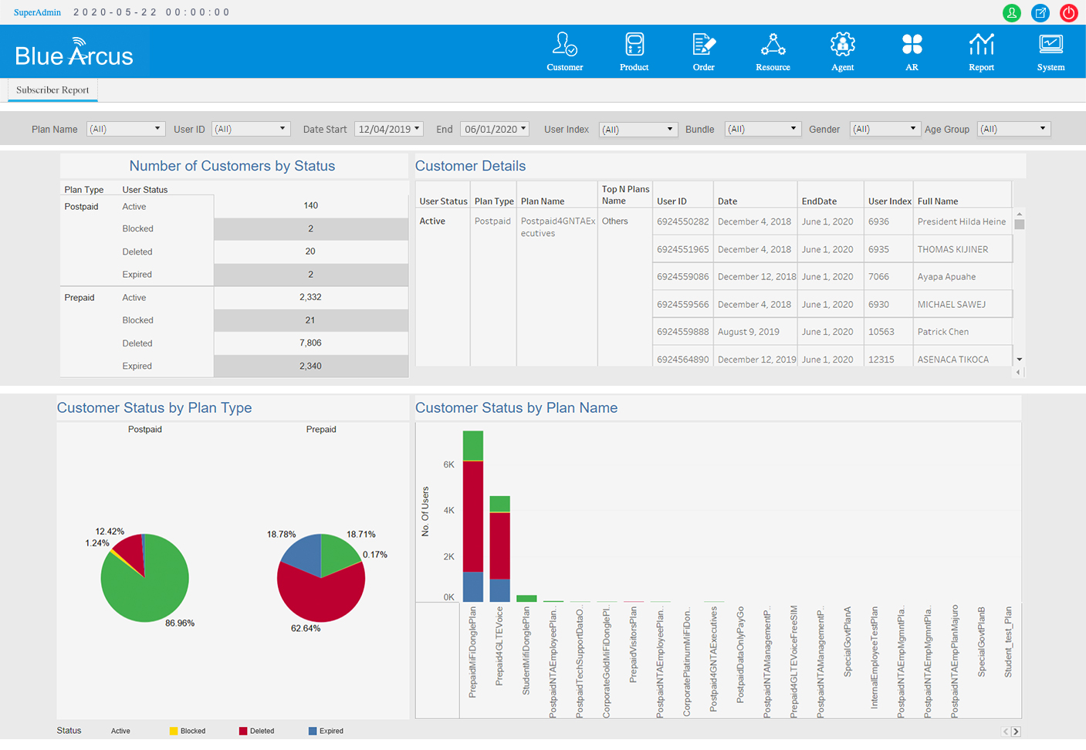

    - Sales and Marketing Top Users Report Sample
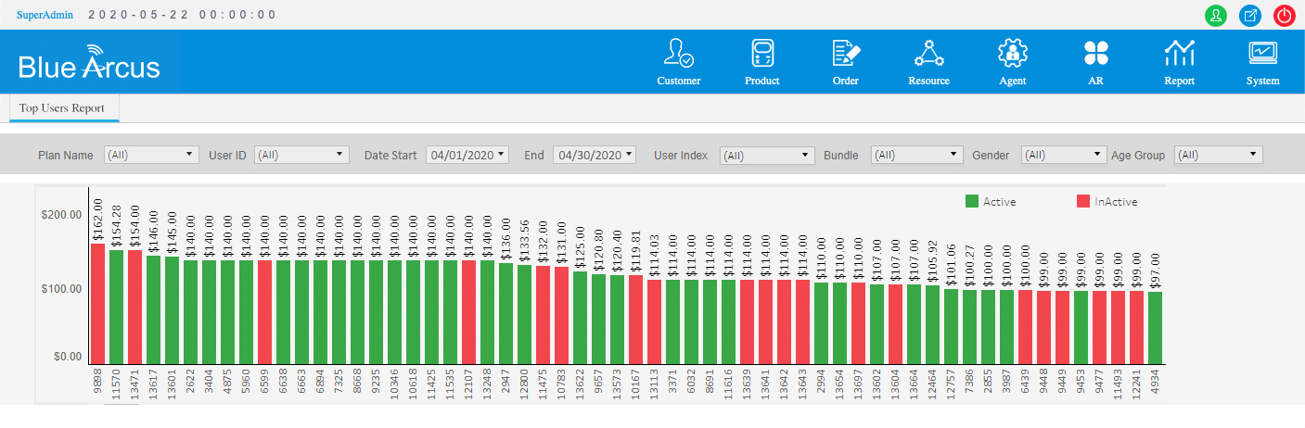
    - Sales and Marketing Bundle Purchase Report Sample
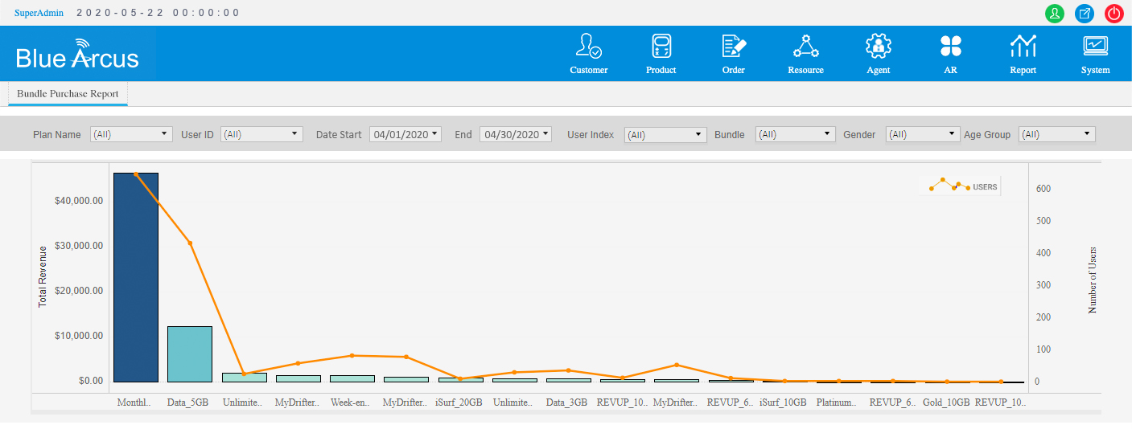

  - Aesthetics

This section records agreed aesthetic required for all user interfaces especially customer facing to be synchronized with Norfolk Telecom Standard branding

    - Color Scheme
- As part of standardization and branding, requesting NT to share preferred colour scheme on all user interfaces.
- Will be provided once NT branding is finalized
    - Logo
- NT to share Logo to be used on User interfaces
- Will be provided once NT branding is finalized

